**A New Non-Linear Two-Time-Level Central Leapfrog Scheme in Staggered Conservation-Flux Variables for Fluctuating Hydrodynamics Equations with GPU Implementation**

**A.P. Markesteijn, S.A. Karabasov, V.Yu. Glotov, and V.M. Goloviznin**

**Abstract:** For solving Landau-Lifshitz Navier-Stokes Fluctuating Hydrodynamics equations, a two-time-level modification of the classical Central Leapfrog scheme with non-linear flux correction is developed. The new algorithm is simple for implementation and demonstrates high accuracy in satisfying the fluctuation-dissipation theorem. The numerical results for equilibrium and non-equilibrium problems in one-dimensional and three-dimensional settings are compared with theoretical predictions, the results from direct molecular dynamics simulations and also with those of several popular computational schemes in the literature. Because of simplicity and locality of the computational stencil, the new algorithm can be efficiently implemented on the GPU, which accelerates the calculation in comparison with a single-CPU-core computation by a factor of 300.

**Key words**: Landau-Lifshitz Navier-Stokes equations, Fluctuating Hydrodynamics, multiscale, Central Leapfrog scheme, staggered variables, flux-correction

**Introduction**

The Landau-Lifshitz Fluctuating Hydrodynamics Equations [1] are the Navier-Stokes (NS) equations with fluctuating stochastic sources in the momentum and energy equations. The intensity of the fluctuating sources depends on the temperature and on the space-time scale of the system. The fluctuations correspond to a continuum description of the thermal velocity fluctuations, which statistics is governed by the fluctuation-dissipation theorem [2, 3]. At the atomistic level, the thermal fluctuations are caused by the collisions of atoms, which can, for example, be numerically solved with Molecular Dynamics (MD) methods, which are usually quite computationally expensive. Indeed, MD computes the trajectories for each atom, for which inter-atomic interactions need to be computed between each and all other atoms each time step. Because of large inter-atomic repulsive forces the MD time step is typically very small (femtoseconds). On the other hand, the ultimately wanted results of MD simulations are usually not the trajectories and velocities of all atoms, but their integral ensemble averaged values. The latter include ensemble averaged values of density, momentum, and energy which leads to the definition of thermodynamic temperature and pressure. For dense fluids such as liquids or gases at normal conditions, the conservation laws for the mass, momentum and energy of atoms per macroscopic control volumes, lead to the Navier-Stokes equations. For mesoscopic control volumes, the limited number of atoms in the control volume, the temperature fluctuations are beginning to play a critical role. For instance, Gaussian diffusion associated with Brownian motion is one prominent feature of the latter.

From the view point of collective dynamics, the molecular environment can be replaced by a continuum stochastic flow which has the same statistics as the ensemble averaged molecular dynamics. For the case of Gaussian statistics, this corresponding continuum flow is governed by Landau-Lifshitz Fluctuating Hydrodynamics (LL-FH) equations.

Fluctuating Hydrodynamics has been an active area of research in since late 80s, both in the Eulerian [17] and in the Lagrangian framework [18]. Fluctuating hydrodynamics models have been very popular for modelling colloids and suspensions. For example, a successful implementation the LL-FH model using the Lattice-Boltzmann method was developed by Ladd [6,7] and for dissipative particle dynamics by Hoogerbrugge et al [8] and also by Español and co-workers [9,10]. One of the reasons of its popularity is that the LL-FH model can be used as an implicit solvent to replace the explicit simulation of molecular dynamics equations by a continuum approach, which is especially valuable to study the dynamics of polymers [11-13] for instance, where the method helps to extend the accessible time scales.

The LL-FH model allows accurate modelling of statistical properties of the atomistic system, such as the standard deviation of mass, momentum and kinetic energy, for control volumes as small from 5-10 atoms [14] to 15-20 atoms per cell size [X1,X2,24].

In the limit of large control volumes, the LL-FH model naturally transitions to the conventional Navier-Stokes equations. The LL-FH equations can be efficiently solved with Eulerian methods which have reached a mature state in Computational Fluid Dynamics (CFD) including the application for stochastic flows such as turbulent flows or advection in random velocity fields [X4]. One example of an application of such schemes to fluctuating hydrodynamics equations is the Time Asynchronous Relative Dimension In Space (TARDIS) scheme of Markesteijn and Karabasov [15]. The idea of TARDIS is the extension of modern multi-time-step multi-grid-size algorithms developed in the CFD community [16] for multiscale modelling in fluid dynamics, especially when the size of the system itself is a parameter that influences the governing equations, as for the case of the LL-FH equations.

Similar to the NS equations, the LL-FH equations are non-linear partial-differential equations of mixed hyperbolic-parabolic type, which solution for a general initial boundary value problem can be only found numerically. Over the last decade, considerable attention has been given to the development, verification, and validation of computational methods for Fluctuating Hydrodynamics problems, e.g. see [14,17-19] to name but a few.

One of the important features of a numerical method to be preserved at the discrete level is the balance between dissipation and fluctuations in accordance with the Fluctuation Dissipation Theorem. For example, Serrano et al [20] showed that not every finite-difference approximation satisfies this property. Furthermore, Bell et al [17] showed that not every computational method is suitable for solving the LL-FH equations accurately. In particular, they showed that using classical second-order approximation schemes, such as MacCormack, leads to significant (~ 14%) errors in the definition of root-mean-square (r.m.s) values of velocity and density fluctuations at the micro level. This error occurs because of the numerical dissipation error of the scheme which adds up to the physical viscosity.

To integrate the governing stochastic equations with accuracy comparable to the Direct Simulation Monte Carlo (DSMC) solution in [17], this motivated the development of a sophisticated third-order Runge-Kutta in time and central difference in space method. In [21] a similar computational method has been extended to 3D fluctuating hydrodynamics equations and implemented on GPU. The Runge-Kutta (RK) scheme used in the latter work has an advantage of not-violating the Total Variation Diminishing property which helps to keep numerical oscillations under control [22, 23]. However, the third-order RK scheme typically is 3 times more expensive in comparison with the first-order Euler methods because of computing numerical fluxes 3 times more often. Notably, the usual advantage of Runge-Kutta methods of increasing the numerical scheme stability radius does not compensate for the extra computing expense in case of the fluctuating hydrodynamics equations because of the small time step restriction for accuracy. On the other hand, De Fabritiis et al [24] found that the first-order Euler scheme combined with a central finite difference in space is sufficient for solving fluctuating hydrodynamics equations with a required accuracy. However, the advection scheme they used corresponds to a negative diffusion, hence; its solution is unstable in the limit of small viscosity. Notably, the unsuitability of the first-order Euler scheme for general fluctuating hydrodynamics problems has also been discussed in [19].

The goal of the present article is to develop an efficient computational method for solving fluctuating hydrodynamics equations which not only shares simplicity and low computational cost of the Euler method [24] but also is readily applicable to general computational frameworks. Specifically, we will seek to develop a method with the following properties in mind:

* Preservation of the correct balance between dissipation and fluctuations, as dictated by the fluctuation dissipation theorem and in accordance with the results of direct molecular dynamics simulation;
* Robustness for a wide range of space-time control volume sizes, from microscopic to hydrodynamic scales where inertia effects of the fluid become important;
* The space-time stencil of the method should be as simple, compact and low-storage as possible to facilitate its extension to multi-space-time stepping algorithms, such as TARDIS, for multiscale modelling and multi-process implementation in the framework of Graphics Processing Units (GPU) implementation.

The article is organised as the following. In Section 1, the LLNS equations are set and the connection between their parameters and the molecular dynamics simulations are discussed. In Section 2, the new staggered Central Leapfrog scheme with non-linear flux correction is introduced, its numerical properties are analysed and the CUDA implementation is discussed. In Section 3, numerical examples are provided.

**1. The equations of fluctuating hydrodynamics**

**1.1 Landau-Lifshitz Navier-Stokes equations**

The Landau-Lifshitz Navier-Stokes Fluctuating Hydrodynamics equations [1], which describe statistics of thermal fluctuations at small scale, are given below:

 (1.1)

where  is the specific energy density,  – the heat capacity at constant volume,  – is the gas constant, and terms on the right-hand-side consist of an averaged part and a stochastic fluctuation part denoted with tilde.

The average term on the RHS of equations (1.1) is the standard stress tensor:

 (1.2)

and heat flow:

, (1.3)

where  and  are the shear and bulk viscosity,  is the spatial dimension,  is coefficient of thermal conductivity, and  is the temperature.

To close the system of equations (1.1) a macroscopic equation of state is specified. For example, in the case of an ideal gas: , which for isothermal flows reduces to a function relating pressure with density, and which can be obtained from molecular dynamics simulations for instance. In case of liquids for which the adiabatic heat ratio approaches to unity, the first two equations for mass and momentum in (1) can be solved separately from the energy equation [24].

**1.2 Stochastic stress tensor and stochastic heat flow**

The coefficients of the stochastic tensors can be determined using the stochastic fluctuation-dissipation theorem [2], which governs the balance between the fluctuations in the system and its dissipative properties. For any numerical simulation of fluctuating hydrodynamics it is essential to maintain this balance, because any overestimation of the fluctuations will lead to instabilities, while underestimation will result in a system that is too dissipative.

The stochastic stress tensor  is described as a random Gaussian matrix with zero mean and covariance, given by the formula:

 (1.4)

Using this correlation the stochastic stress tensor can be expressed explicitly as [25]:

 (1.5)

where  is a random Gaussian matrix with zero mean and covariance ,  is a random symmetric matrix with zero trace,  is the identity matrix, and  is the trace of a matrix .

The stochastic heat flow also has a zero average, while the covariance component is determined by the expression:

 (1.6)

Or explicitly:

 (1.7)

where  is a random Gaussian vector with zero mean and covariance . Furthermore, the stochastic stress tensor and stochastic heat flows are not correlated.

## 1.3 Isothermal equations and determination of the equation of state

When the principle of fluctuating hydrodynamics is applied to liquids at isothermal conditions, the governing equations can be simplified. Effectively, only the mass and momentum equations needs to be solved now, the equation of state is a function relating the pressure with density only, and there is a single stochastic term, located in the stress tensor of the momentum equation. Furthermore, the speed of sound, which is an important variable for the method used to solve the non-linear equations (discussed in the next sections), is directly related to the equation of state as c2=dP/dρ. Therefore, the choice of the equation of state is very important for mimicking the results of molecular dynamics at the macroscopic level [24].

Despite several analytical equations of state are available in the literature for different validity ranges, e.g. see [26], in the present work a separate molecular dynamics (MD) simulation is used to obtain the equation of state for gaseous and liquid argon over a wide range of density values. For each value of density of argon, which is proportional to the number of MD atoms in a certain computational “box”, the pressure is sampled using the Irving and Kirkwood expression for pressure [27]. The MD simulation using the Lennard-Jones 12-6 potential is done within the canonical (NVT) ensemble with periodic boundary conditions. The temperature is fixed using the Nose-Hoover thermostat [28,29] at T=300K. The volume is chosen such that at the lowest sampled density about 2,000 atoms are present in the volume, while for the largest sampled density the volume contains 15,000 atoms. The cut-off radius for the MD potential is chosen at 4.5 reduced units, corresponding to 1.5 nanometre in physical units. The time step of the simulation is set to 0.005 reduced units, which is 10.8 femtoseconds in physical units. The MD domain is equilibrated for 20,000 time steps, after which the pressure is sampled for 200,000 time steps. Figure 1.1a shows the results from the MD simulation (circles), relating the pressure versus the density.

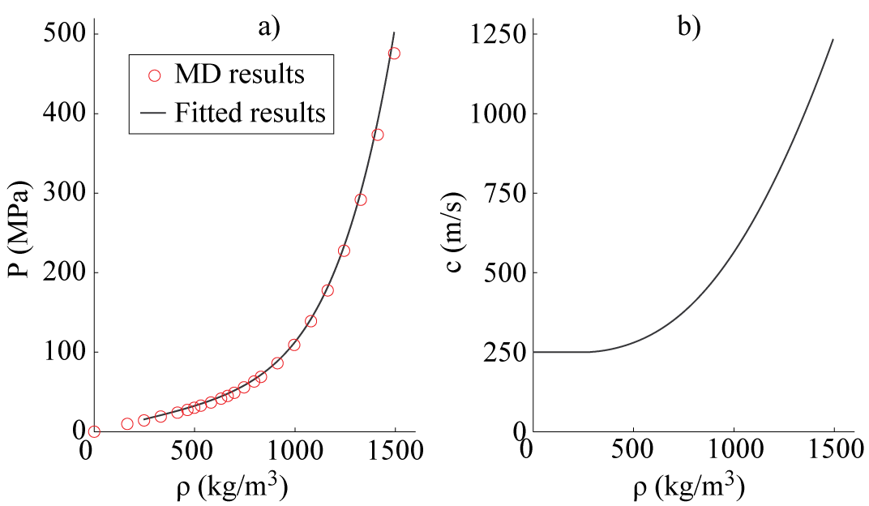

**Fig. 1.1** – a) The equation of state relating pressure versus density obtained from the MD simulations and a fit to the data (see text for explanation). As can be observed, the ideal gas law can be seen at the lower densities, where the pressure increases linearly with the value of the density. After that the pressure increases more sharply, going into the liquid phase. b) The speed of sound according to the equation of state (c2=dP/dρ), where the speed of sound is constant in the ideal gas limit.

In order to use the equation of state for the fluctuating hydrodynamic simulation from MD it is convenient to use a fitted analytical equation. It is very challenging to fit the results into a single analytical equation of state for argon over the entire range of density values, especially because it has to include the linear part that corresponds to the ideal gas limit. Instead, the MD data is split into two parts, i.e. a linear fit satisfying the ideal gas limit (ρ <246.15 kg/m3) and a fifth-order polynomial fit for the remainder of the data. Although a lower order polynomial fit could be used, here the fifth-order polynomial fit is necessary because several constraints are put on the fit. These constraints include the connectivity with the ideal gas limit and at least one experimentally tabulated value of the speed of sound. The result of these constraints is that only two independent variables need to be fitted to the data. The used constraints and values, including the resulting fit are given in Table 1 and Table 2. Furthermore, Figure 1.1a and b also show the curve fit to the data and the resulting speed of sound obtained from the fit, respectively.

**Table 1** – Fit constraints for the equation of state of argon. The ideal gas law holds from density range [0-ρ0] kg/m3, while the polynomial fit is valid for [ρ0- 1661] kg/m3, where ρ0 is chosen to be 246.15 kg/m3.

|  |  |  |
| --- | --- | --- |
| **Condition** | **Type of fit** | **Parameters** |
| x< ρ0 | pgas(x)=xRgasT (Pa) | - |
| x> ρ0 | p(x)=fx5+ax4+bx3+cx2+dx+e (Pa) | a,b,c,d,e,f |
| c0 (ρ0) = cgas | Speed of sound from ideal gas law | 🡪d |
| p (ρ0)= pgas | Pressure must match | 🡪e |
| d2p/dx2=0 (ρ0) | Speed of sound is constant at ideal gas limit (d2p/dx2 == dc/dx = 0) | 🡪c |
| c(ρ1)=c1 | Speed of sound c1 at ρ1 is known, used value: c1=561.4 m/s at ρ1= 996.3 kg/m3[9] | 🡪b |
|  | Parameters to fit | a and f |

**Table 2** – the resulting fit for the equation of state valid for x = 246.15-1661 kg/m3, p(x(kg/m3))=fx5+ax4+bx3+cx2+dx+e (Pa)

|  |  |
| --- | --- |
| **Parameter** | **Fitted result** |
| A | -1.8679e-004 |
| B | +1.9878e-001 |
| C | -9.6160e+001 |
| D | +8.2666e+004 |
| E | -1.5356e+006 |
| F | +1.1584e-007 |

Another motivation behind obtaining the equation of state from a molecular dynamics simulation is to ensure the continuum and atomistic solutions correspond to the same fluid properties. This is important when it comes to coupling the two models in a single framework, which is going to be our goal in a future work. Besides the correct mapping of molecular dynamics trajectories into a continuum representation, for example as explained in [14] and [30], it is also important to match the macroscopic properties. For example, a multitude of molecular dynamics models exist for water, each corresponding to somewhat different macroscopic transport characteristics such as viscosity [31]. For the FH computations with liquid argon in this work, the parameters of De Fabritiis [24] are used which are: (shear viscosity) η = 9.0898e-005 Pas and (bulk viscosity) ζ = 3.0272e-005 Pas.

**2. Two-time-level Central Leapfrog Scheme with non-linear flux correction**

**2.1 Linear advection scheme**

Let us consider the one-dimensional computational domain , discretised using a uniform grid , where  is the coordinates of the mesh points. The simple linear advection equation  can, for example, be approximated with the following Central Leapfrog method:

, (2.1)

which scheme is a second order approximation in space and time on uniform grids, non-dissipative and stable for Courant–Friedrichs–Lewy (CFL) number , .

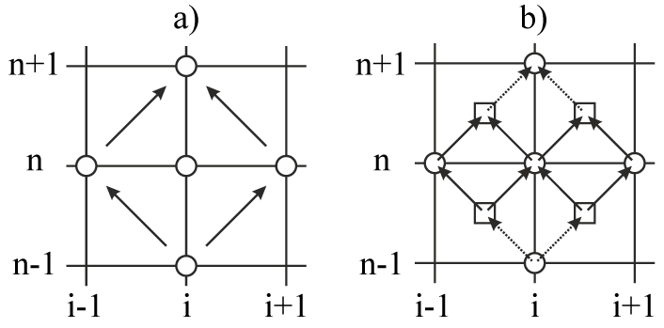

**Fig. 2.1** – Computational stencil of Central Leapfrog scheme with (a) collocated and (b) staggered variables

By introducing staggered variables in space and time, the same scheme can be rearranged into the following two-time-level form (Fig. 2.1. (b)).

 (2.2)

where  denotes the conservation variables referred to the computational volume centres and  denotes the flux variables referred to the cell faces, similar to the computational framework outlined in [32] and [33]. Because of the compactness of its stencil in time, the Central Leapfrog scheme in staggered variables (2.2) is second-order for non-uniforms time steps. On uniform grids in space and time, the dispersion and dissipation properties of the scheme coincide with the classical three-time-level Central Leapfrog scheme. Details of the von Neumann linear dispersion and dissipation analysis for the staggered scheme are given in Appendix A and the results are presented in Figure 2.2. The latter shows the dispersion  and dissipation  surfaces for the first solution root, . As discussed in the Appendix, the second root,  has non-physical behaviour and manifests itself only when the initial conditions  and  have not been specified consistently.

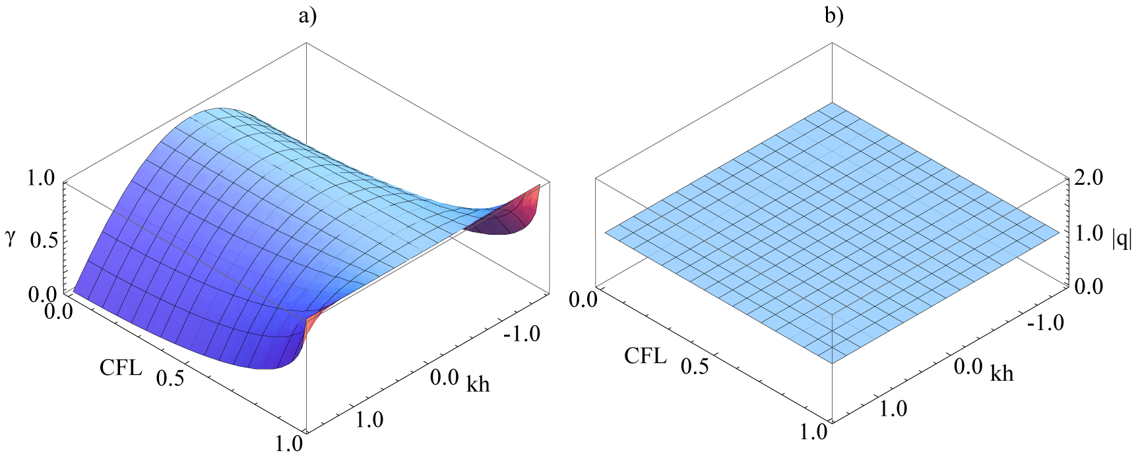

**Fig. 2.2** – Dispersion (a) and dissipation (b) surfaces of the two-time-level Central Leapfrog scheme.

## 2.2 Nonlinear advection scheme

For solving non-linear problems, the so-called high-resolution methods have been used in the literature [34-38], which are based on non-linear flux reconstruction to preserve non-oscillatory solution. For example, in the frame-work of Total Variation Diminishing schemes (TVD) the flux reconstruction is done so that high-order approximation increments of the solution are limited in the high gradient regions. This increases numerical stability for non-linear problems but also leads to artificial dissipation. Alternatively, a non-linear conservation flux correction based on the maximum principle can be used for the same. Following [33], the maximum principle is enforced for the flux variables in (2.2) of the linear advection equation so that the solution at the new time level always remains bounded within the allowable range of solution variation:

,

 (2.3)

To close the algorithm, the minimum and maximum values must be specified. In accordance with the nature of hyperbolic equations, these should come from the characteristic domain dependency at the previous time step. Given the discreteness of the computational grid, several choices have been considered in the present work for approximating the corresponding limit values of the solutions. For the Central Leapfrog scheme in staggered variables, the best choice in terms of the combination of stability and minimum dissipation is given by the following central approximation of the maximum and minimum states:

, (2.4)

Notably, although the above flux correction reduces spurious oscillations it is not upwind biased, hence, cannot preserve to a strictly monotonic solution. On the other hand, as will be discussed in the last paragraph, this above choice lead to a good control of the numerical solution stability for a range of nonlinear problems with accurately preserving the balance between dissipation and fluctuations that is very essential for fluctuating hydrodynamics.

As discussed in the next section (see also [X3]), for a system of hyperbolic conservation laws the maximum principle can be implemented by using the decomposition of primary variables such as density, velocity and pressure into characteristic fields.

Following [39, 40], the spectral properties of the non-linear Central Leapfrog scheme are analysed by computing how the phase velocities and amplitudes of the solution harmonics depend on the wave number. Fig. 2.3 shows the resulting dissipation and dispersion curves for several values of the time step number. The latter is a numerical parameter of the numerical spectral analysis and it is important to ensure that the results for sufficiently large values of this parameter converge to the same dispersion and dissipation curves. A CFL number of 0.1 is chosen as it corresponds to a typical value used in the fluctuating hydrodynamics calculations for accuracy. In comparison with the linear scheme, the dispersion properties of the non-linear scheme are virtually the same and there is a small amount of dissipation added that does not exceed  for all wave numbers.

|  |  |
| --- | --- |
| IMK_FAU_CFL01_CONVERG | REK_FAU_CFL01_CONVERG |
| (a) | (b) |
| **Fig. 2.3** – *Numerical spectral analysis of the non-linear Central Leapfrog scheme. (a) dissipation, (b) dispersion.* | |

## 2.3 Computational solution of the fluctuating hydrodynamics equations

The two-time-level Central Leapfrog scheme is first considered in a one dimensional setting and then its extension to three dimensions is outlined. At the predictor step, the governing equations (1.1), which details in a one-dimensional setting are given in Appendix B, are solved to update the cell-centre conservation variable at the mid-time level (*n*+1/2):

 (2.5)

where the viscous fluxes on the right-hand-side are computed using the centre-cell variables at the mid-time level (n+1/2).

For the flux computation at the new time level (*n*+1), the following procedure is used. The primary variables  are decomposed into local Riemann invariants  which can be associated with 2 pressure waves and 1 entropy wave. The characteristic invariants are obtained by rearranging the governing equations (1.1) to a characteristic form, which details are outlined in Appendix B.

The computation of the new flux variables at the new time level is conducted in the characteristic variables and consists of two stages.

1. Extrapolation of the local Riemann invariants to the new time level:

 (2.6)

2. Correction of the computed values using the maximum principle (2.3),(2.4)

 , (2.7)

where functions  stand for the part of the original equations which has not been diagonalized during the characteristic decomposition. The latter values are equal to the material derivative of the characteristic variables and can be computed using the following expressions:

, (2.8)

. (2.9)

The same procedure is applied for updating the other two characteristic fields, .

Notably, the above expressions for the source terms in the maximum principle (2.7) fully account for the non-hyperbolic part of fluctuating hydrodynamics equations grouped in the right-hand-side of (2.5). Indeed, it can be easily seen that (2.8) and (2.9) stand for a finite-difference approximation of the characteristic decomposition of the governing equations (2.5), i.e., the result of multiplying (2.5) by the left eigenvector. The resulting diagonal terms, which approximate the material derivative of the corresponding characteristic field, are put to the right-hand-side of (2.8) and (2.9), and the viscous terms are all grouped together in the source vector , and q=1,2, and 3 correspond to the two travelling pressure waves  and the entropy wave  [33]. In case of multiple dimensions, the source  also includes the tangential derivative terms. The non-linear flux correction is essential to ensure the scheme stability for solving the nonlinear equations.

Once the characteristic fields at the new time level are computed, they are used to reconstruct the flux variables on a new time level, . The new flux values are used for the final phase to calculate the conservative variables:

 (2.10)

where  and  are the one-dimensional component of the deterministic viscous stress and the heat flux and  and  are the corresponding stochastic fluctuation parts.

The stability conditions for the above predictor-corrector scheme are as follows:

 (2.11)

where indices  and  denote the maximum and minimum value inside the domain, respectively. In the above, the first condition corresponds to the advection scheme and the second condition corresponds to an explicit approximation of the diffusion term.

For generalisation of the above scheme to three dimensional problems, a staggered hexahedral computational grid is introduced with conservation variables referred to the cell centre and flux variables referred to cell face centres for each grid direction. For example, assuming , the extension of (2.10) to three dimensions is

 (2.12)

where  is the vector of conservation variables corresponding to the prognostic part of the governing equations (1.1),  are the inviscid part of the flux vectors which correspond to the divergence terms in the left-hand-side, and  are the corresponding right-hand-side viscous terms.

For characteristic decomposition and flux update the same formulas (2.6)-(2.9) are used in each grid direction. One difference between the three-dimensional implementation and the one-dimensional algorithm is that in the three-dimensional case there are 2 new Riemann invariants which need to be computed in additional to the previous 2 acoustics and 1 entropy wave . The additional characteristic invariants propagate with the speed equal to the local flow velocity, correspond to the tangential velocity components with respect to the cell-face normal, and can be associated with the vorticity wave components in multiple dimensions.

The other difference between the three-dimensional case in comparison with the 1D algorithm is the presence of the full viscous stress tensor, . For the 3D fluctuating hydrodynamics equations, the components of the deterministic stress tensor are computed based on the cell-centre variables  where the corresponding components of velocity gradient are calculated using a second-order central approximation.

For example, to approximate  velocity gradient component at the control volume centre , the velocity values are first computed for all vertex points of each control volume by interpolation, e.g.,  where  is the cell-centre velocity variable and  is the hexahedral control volume of the p-th cell that includes vertex . The corresponding values at the cell face centre are obtained by averaging over the 4 vertex values which belong to the same face of control volume. Then, the velocity gradient  at cell-centre point is approximated with second-order central finite difference . Further details of the viscous flux approximation of the deterministic Navier-Stokes equations based on the staggered stencil can be found in [41].

The stochastic stress tensor part of the viscous fluxes is computed at the same centres of cell faces as the deterministic fluxes using equation (1.5).

Once the velocity gradients are computed at the centres of the cell faces, e.g., , , , the divergence of the viscous fluxes is computed as a surface integral following the standard Gauss-Ostrogradsky procedure [XX3]. Notably, the second-order finite-volume approach for viscous flux approximation taken in the paper is virtually the same as the one outlined in [X2,24].

There are 2 types of boundary conditions considered for (2.5)-(2.12) in the current work: (i) periodic boundary and (ii) prescribed state of the deterministic temperature, velocity and pressure variables. The implementation of (i) is straightforward: the information is exchanged through the common cell face boundary and the corresponding central values in the hollow points. Boundary conditions of type (ii) are specified using the characteristic variables, where the viscous stress gradients of the incoming characteristic fields are ignored in comparison with the inviscid terms. For the boundary cell, a fully upwind computational stencil instead of the central scheme is used. The procedure is similar to specifying characteristic-type boundary conditions for deterministic Navier-Stokes equations, which details can be found in [41].

## 2.4 Implementation in CUDA

Because of the nature of stochastic simulations, it is the statistical behaviour of the LL-NS equations which is relevant rather than an instantaneous solution. For statistical convergence of low frequencies typical of the hydrodynamics fluctuations, one needs a sufficiently long simulation time. For example, the solution of stochastic diffusion problem converges as  where  is the number of time steps of the simulation, which is typically of order of several millions to get the error in fluctuations down to less than a few percent.

For three-dimensional problems, this leads to considerable computational times in case it is run in a serial manner based on single computational unit (CPU). On the other hand, the algorithm for LL-NS Fluctuating Hydrodynamics, which include data local exchanges in the form of flux variable update (2.6)-(2.9), conservation step (2.12), and also generation of random numbers for computing the stochastic fluxes, are well suited for an implementation in NVidia’s CUDA. The latter allows one to off-load the computations on to the Graphical Processing Units (GPU) with performing massively parallel computations based on hundreds of computational threads.

The basic idea behind computations on the GPU, using the terminology of CUDA, are based on the fact that certain bits of code (kernels) can be executed simultaneously in several blocks each containing hundreds of threads. The key for optimisation is to limit the request for the same memory space, resulting in memory collisions and therefore high latency. In the case of the LL-NS equations, each block of cells (e.g. 16x16) can be evaluated independently, where only the single layer of boundary cells need to request memory space shared with other blocks. This is similar to simple block domain decomposition. Besides the different approach how to do the access of the computational arrays, the (C++) code itself needs little change. The precision of the computations (single or double) can be determined via a compile switch. However, in all the case presented in this article, the double precision code was used.

The very compact stencil of the proposed scheme makes it ideal for parallel implementation, whereas the parallelisation is further improved with the specific way in which the characteristic decomposition is performed. Namely, the fluxes for the three dimensions of the flow variables, e.g. the flux of x-velocity in x, y, and z-direction can be computed using only local cell variables (i,j,k) and the variables in two adjacent cells (i-1,j,k) and (i+1,j,k) for only two points in time. The other fluxes, in y and z-direction, can be obtained using the other appropriate adjacent cells and stored in separate arrays. For the CUDA implementation this means that the computation can be optimised using certain thread block sizes (depending on the GPU device) and using shared memory, and all blocks can work independently on each other. The shared memory has a border with a width of one cell, accommodating the adjacent cell values (i.e. sometimes referred as tiling). This is done for all three directions separately, limiting the amount of memory that needs to be loaded. Similarly, the predictor and corrector step also only use the cell value (i,j,k) and the adjacent cells and therefore uses the same concept of tiling. The random numbers needed for the fluctuating stress are obtained using the CUDA normalised random number generator (curandGenerateNormalDouble) and stored in an array for further use inside the independent kernels. To further optimise the computations, all constants are stored as “symbols” on the GPU device. Furthermore, the NVidia CUDA profiler was used to optimise the thread blocks sizes and identifying computational bottlenecks for the particular GPU device used.

The GPU device used for the current simulations is the NVidia Tesla C2075. Figure 2.4(a) shows the amount of time it takes to compute one cycle of the two-time-level Central Leapfrog algorithm for three-dimensional LL-NS equations versus the number of cells of the computational domain.

The dependency of the amount of workload goes up linearly with the amount of cells, i.e. a linear scaling if workload balance is achieved. It is also interesting to compare this scaling with the workload based on a single CPU. Figure 2.4(b) shows how the GPU computation times compare to the computational times based on a single core of an Intel Xeon E5-2609 processor. There are two “regimes” on the CPU versus GPU comparison plot. Both graphs correspond to the fluctuating hydrodynamic calculations which results will be discussed in sections 3.3 and 3.4 of this article.

In the first part of the curve corresponding to relatively small job sizes, the curve rises steeply that indicates a sharp growth of efficiency when only a fraction of the GPU threads are fully utilised and their competition for shared memory is low. After all GPU threads are fully engaged, the slope of the curve reduces. The latter is likely to be caused by the fact that the system is inevitably reaching its limit of available RAM (GPU dedicated 5GB versus CPU shared with system 6GB). The reduction of the speedup of GPU in comparison with a single core CPU depends on the memory overheads of the algorithm of course. Moreover, it can be argued that for the present staggered Central Leapfrog scheme, which uses a single flux exchange per time step, this reduction should be delayed in comparison with the GPU implementation of a multi-stage Runge Kutta scheme for instance [21].

The delay in the GPU efficiency drop-off achieved for the current numerical scheme is important. It leads to the fact that the GPU can do the task up to 300 times faster compared to one CPU core, or at best about 75 times faster in comparison with the four-core CPU processor. The practical side of the significant speedup achieved due to GPU implementation is that the fluctuating hydrodynamics calculations performed for this article took a few hours rather than a week on grids up to 10 million computational cells.

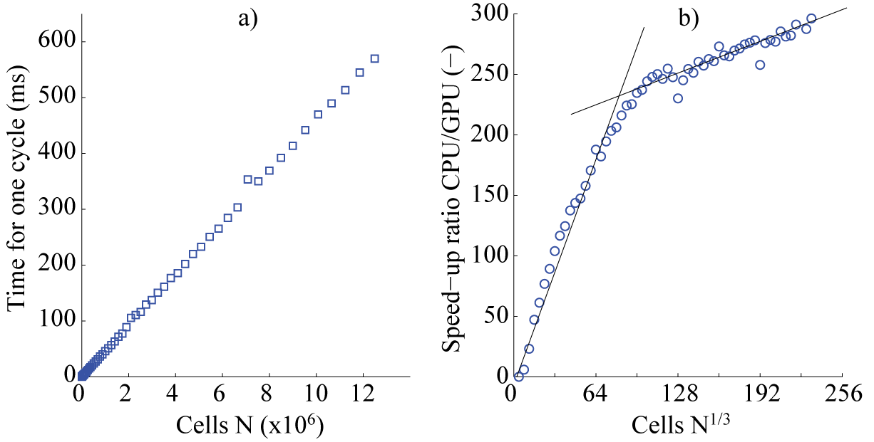

**Figure 2.4** – a) The amount of time one cycle takes on the GPU versus the number of cells (N). b) The ratio between the time it takes to execute one cycle on the CPU versus the time on the GPU versus the number of cells in one direction of the cubed domain.

# 3 Numerical examples

## 3.1 One-dimensional fluctuations of gaseous argon in equilibrium

First, the non-linear two-time-level Central Leapfrog scheme for LL-NS Fluctuating Hydrodynamics equations is applied for solving a benchmark problem of one-dimensional argon gas fluctuations at equilibrium. For this purpose, the system described in Bell at al. [17] is studied. A 1D periodic computational domain is considered than corresponds to 40 computational grid cells. The equations of mass, momentum, and energy are solved with the parameters corresponding to gaseous argon. The physical and numerical parameters of the simulation are summarised in Table 3.1 [17], which correspond to the reference dimensional variables for solving the governing equations (1.1) in a non-dimensional form.

**Table 3.1.** System parameters (in cgs units) for simulations of argon gas

|  |  |
| --- | --- |
| The diameter of the molecule (argon) |  |
| Mass of molecule (argon) |  |
| Equilibrium density |  |
| The equilibrium temperature |  |
| Speed of sound (adiabatic) |  |
| System length |  |
| System volume |  |
| Number of cells |  |
| Time step |  |
| Number of time steps | 107 |

Figure 3.1 (a) shows an instantaneous density profile at a certain time of the simulation. The mean value is indicated with the solid line. The variance of the density is also computed by , where N is the number of cells, which result is shown in Fig. 3.1 (b).

|  |  |  |  |
| --- | --- | --- | --- |
|  | |  | |
|  |  | |
| (a) | (b) | |
| **Fig. 3.1** – Fluctuations in one-dimensional argon gas: (a)a snapshot of instantaneous density profile where the line indicates the initial value and (b) density variance as a function of time. | | |

Table 3.2 compares the results of simulation for time-averaged density, momentum, and energy fluctuations of the non-linear two-time-level Central Leapfrog scheme with the solutions from the literature based on: McCormack scheme, Piecewise Parabolic Method (PPM), and central finite-differences in space with a modification of the third-order Runge-Kutta (RK3) in time method that was specifically designed for fluctuating hydrodynamics problems in [17, 42]. The reference solution obtained corresponds to a Direct Simulation Monte-Carlo (DSMC) simulation.

|  |  |  |
| --- | --- | --- |
| **Table 3.2.** Variance of the density, momentum, and energy fluctuations | | |
| DSMC reference value: | | |
|  | Calculated value | Percentage error |
| Current simulation |  |  |
| McCormack scheme |  |  |
| RK3 |  |  |
| PPM |  |  |
| DSMC reference value: | | |
| Current simulation |  |  |
| McCormack scheme |  |  |
| RK3 |  |  |
| PPM |  |  |
| DSMC reference value: | | |
| Current simulation |  |  |
| McCormack scheme |  |  |
| RK3 |  |  |
| PPM |  |  |

As can be seen from the table, the non-linear two-time-level Central Leapfrog scheme is able to accurately predict the correct value for the equilibrium fluctuations and performs very well compared to the other methods and on par with the most accurate three-stage Runge-Kutta method. However, in comparison with the latter the computational cost of the current single-stage Central Leapfrog scheme is about 3 times as small.

Besides the value of the variance of the fluctuations, other important properties to capture in the simulation are the space and time correlations, which in case of the Landau-Lifshitz model should correspond to a delta-function-like behaviour.

Figure 3.2 depicts the two-point spatial correlations of the density, momentum and energy, which are consistent with the model of spatially uncorrelated sources with the following amplitudes: , , , , and as they should be for the equilibrium system. Notably, the third relation between the fluctuation of the total energy and the density can be obtained as a linear perturbation from the energy equation  using  and  which hold at equilibrium. Here the brackets correspond to time averaging and no additional averaging over a homogeneous space direction is performed. Because of the equilibrium, the correlation functions are homogeneous in space. The slight oscillations appearing in the covariance plots are due to the limited number of time samples used for ensemble averaging. The oscillations are mostly seen in the plots which involve density, which is one of the most sensitive variables in compressible flow equations.

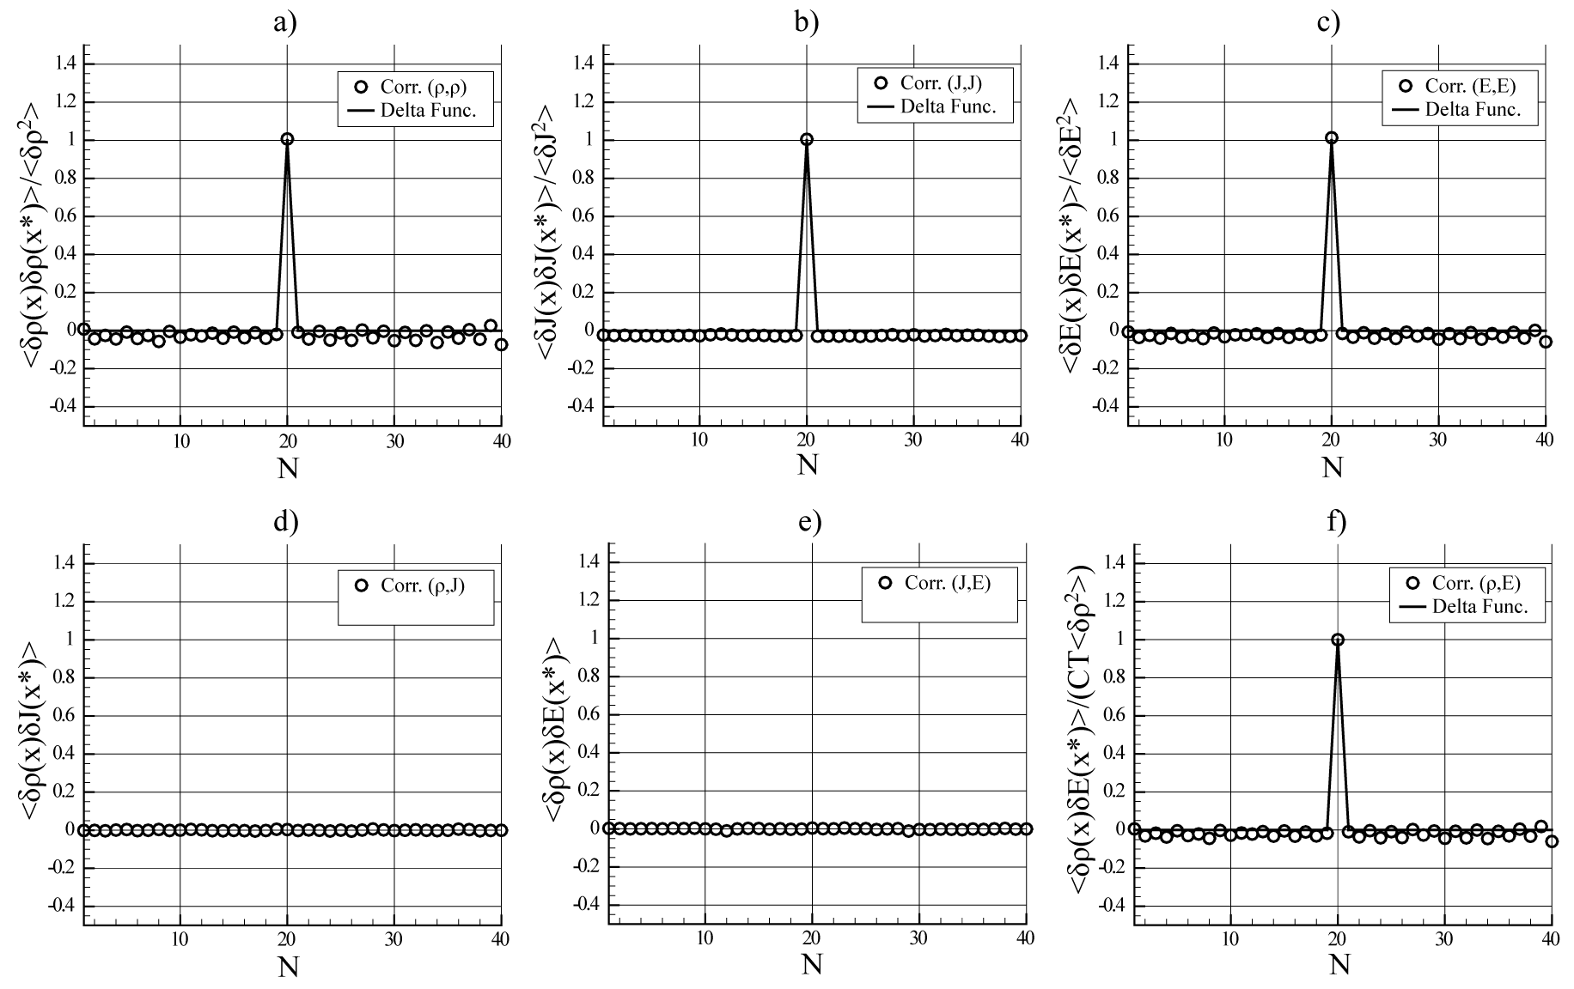

**Fig. 3.2** – *Two-point spatial correlation functions at control point x\*=0.6 : (a) , (b) , (с) , (d) ,*

*(e) , (f) .*

## The time correlations can be obtained from the equations of fluctuating hydrodynamics using several statistical physics techniques. Following [17, 24, 43], the theoretical result is:



where  is the wave number,  is the ratio of specific heats,  is the thermal diffusion coefficient,  is the coefficient of kinematic viscosity, and  is the sound attenuation coefficient. Time averaging is performed as follows:



where  are the number of steps in time, and



is the amplitude of the n-th harmonics. The normalization parameter is expressed as:



Emphasis is only given to the lowest wave number (i.e.), since the theoretical result is not accurate for short waves.

Figure 3.3 shows compares the time-correlation curve computed with the present two-time-level Central Leapfrog scheme with the computation based on the RK3 scheme and the theory [17]. It can be seen that the two numerical solutions are in a good agreement with each other and with the theoretical result.

|  |
| --- |
|  |
| **Fig. 3.3** – Two-time correlation function of density fluctuations for gaseous argon: computation with the nonlinear Central Leapfrog scheme (NCL), RK3 scheme and the theoretical prediction. 3.2 One-dimensional temperature gradient and random walk of the shock front in gaseous argon The next test for the two-time-level Central Leapfrog scheme is to investigate how accurate it is in case there are steep meanflow gradient present.  The case of a large temperature gradient is considered first. For this, the same system as before is considered (table 3.1), but now with a temperature gradient present. The temperature gradient is implemented by specifying insulated wall boundary conditions corresponding to the wall temperatures set to  and  on the left and the right boundaries. Given the microscopic size of the computational domain, this corresponds to the temperature gradient of millions of degrees per centimetre. Despite such extreme conditions, which were initially proposed for creating shock waves, the system can be quite accurately modelled using molecular dynamics methods such as DSMC [17].  Figure 3.4 (a) shows a snapshot of instantaneous temperature fluctuations in the computational domain. From statistical physics it is known that such a system will exhibit a negative spatial correlations of density and momentum fluctuations  near the point . The same property can also be demonstrated using a direct simulation method such as DSMC [17]. Figure 3.4 (b) shows the numerical prediction of the spatial correlation of density and momentum fluctuations when the LL-NS equations are solved with the nonlinear two-time-level Central Leapfrog scheme, where a negative correlation peak near the point , which corresponds to the domain centre, *x\*=0.6*, is also captured. For comparison, the reference DSCM solution from Bell et al [17] is displayed on the same plot. Both numerical solutions are in a good agreement with each other and are in a reasonable agreement with the reference solution despite some discrepancy in the peak value, which is notoriously difficult to capture with a continuum model [17].   |  |  | | --- | --- | |  |  | | (a) | (b) | | **Fig. 3.4** – Temperature gradient in gaseous argon: (a) snapshot of instantaneous temperature distribution from the current prediction, (b) two-point spatial correlation function of density and momentum distribution at control point x\*=0.6, current prediction (NCL) vs the reference molecular dynamics solution (digitized DSMC data from fig.6 of [17]). | |   To investigate how the scheme can handle large pressure gradients, the problem of a random walk of a stationary shock wave under the influence of thermal fluctuations [17] is considered next. The flow parameters before the shock front, which correspond to the right boundary of the computational domain, are set to the same values as for the equilibrium problem (table 3.1). The flow parameters behind the shock front, which correspond to the left boundary of the computational domain, are determined from the Rankine-Hugoniot relations. Three different values of the Mach number, , are investigated. The numerical parameters such as system size, number of cells, time step, etc are kept the same for all 3 computations. Table 3.2 lists the parameters of the system (CGS) for case .  **Table 3.2**. Simulation parameters (in CGS units) for the random walk of the shock wave problem   |  |  |  |  | | --- | --- | --- | --- | | System length |  | Time step |  | | System volume |  | Number of cells |  | | Mach number |  |  |  | | Density (right) |  | Density (left) |  | | Velocity (right) |  | Velocity (left) |  | | Temperature (right) |  | Temperature (left) |  | | Speed of sound (right) |  | Speed of sound (left) |  |   The position of the shock front  can be defined using the following integrals:  (3.5)  Then solving (3.5) for , gives:  (3.6)  where  is the average value of the instantaneous density, and  and  are the density values on the left and right of the gap, respectively. Besides using the density value, the front can also be determined by, for example, pressure:  (3.7)  The drift of the shock wave is similar to how the movement of particles exhibit Brownian diffusion [44]. Therefore, the average square of the shock wave front offset from the original position grows linearly in time:  (3.8)  where the diffusion coefficients  and  depend on the shock wave strength. Notably, due to the transient relaxation from the initial state, the above integral expressions may not be very accurate at very short times, or, due to finite system size, at very long times [17].  Fig. 3.5 (a) and (b) show a snapshot of instantaneous density and pressure solution profiles. The meanflow profiles corresponding to the initial time moment are shown on the same plots for comparison. Figs 3.6 (a) and (b) show the variance of the shock location for the density and pressure solution as a function of time, where the ensemble averaging is performed over 4000 realisations of the simulation. The slopes in the figure are close to the theoretical curves which are also shown and which correspond to diffusion coefficients . The same curves can also be determined with DSMC method [17], which besides the different initial transient, exhibits the same slope.   |  |  | | --- | --- | |  |  | | (a) | (b) | | **Fig. 3.5** – Random walk of the shock wave: snapshots of instantaneous density (a) and pressure (b) distributions and the corresponding initial profiles. | |   Fig36.png  **Fig 3.6** – Variance of the shock location for (a) the mass density profile and (b) the pressure profile. The solid lines correspond to the estimated variances from the 4000 realisations versus time t for a deterministically steady shock of Mach number 1.2, 1.4, or 2.0. The dotted lines correspond to the theoretical slopes.  **3.3 Three-dimensional fluctuations of liquid argon in equilibrium**  For isothermal case, three-dimensional LL-NS fluctuating hydrodynamics equations are solved where the equation of state corresponds to liquid argon and is specified in accordance with the procedure outlined in Section 1.3.  Similar to the test problem 3.1, periodic boundary conditions are specified, and each cell inside the three-dimensional domain is an open system with constant volume  and temperature  thus belonging to the grand canonical ensemble for which the variance of density and velocity fluctuations can be determined [24]:  and , (3.9)  where  is the isothermal sound speed and  is the velocity magnitude.  From the above, the sound speed is related to the standard deviations of density and velocity fluctuations as:  (3.10)  On the other hand, the same quantity is related to the macroscopic equation of state since:  (3.11) |
|  |

In order to estimate the accuracy of the three-dimensional non-linear Central Leapfrog scheme, the standard deviation of the density and velocity are computed and compared to the theoretical results. Furthermore, because these deviations are averaged quantities they do not necessarily reflect the overall accuracy of the method, therefore the density and velocity distributions at several values of (mean) density are also shown and compared.

Figure 3.7 shows the standard deviation of density (3.7a) and velocity (3.7b) when the volume of the cell is constant and the mean density inside the cell is changed. The volume is set to 37.5nm3, in order to compare with results presented in [24]. In order to get fully converged statistical results, the simulations are performed using 64x64x64 cells for 10,000,000 time steps. The theoretical curves which are obtained from the equation of state are shown with solid line. Also in Figure 3.7, the (normalised) density (3.7c) and velocity (3.7d) distributions at several (mean) densities, ρ0=100, 500, 1000, and 1500 kg/m3 is shown. Each distribution is obtained by sampling a similar interval of density and velocity values and then normalised using the highest peak value. This procedure will also give the relative relations between the displayed curves, i.e. curve width versus peak height, which of course are related to the standard deviation displayed in 3.7a and 3.7b.

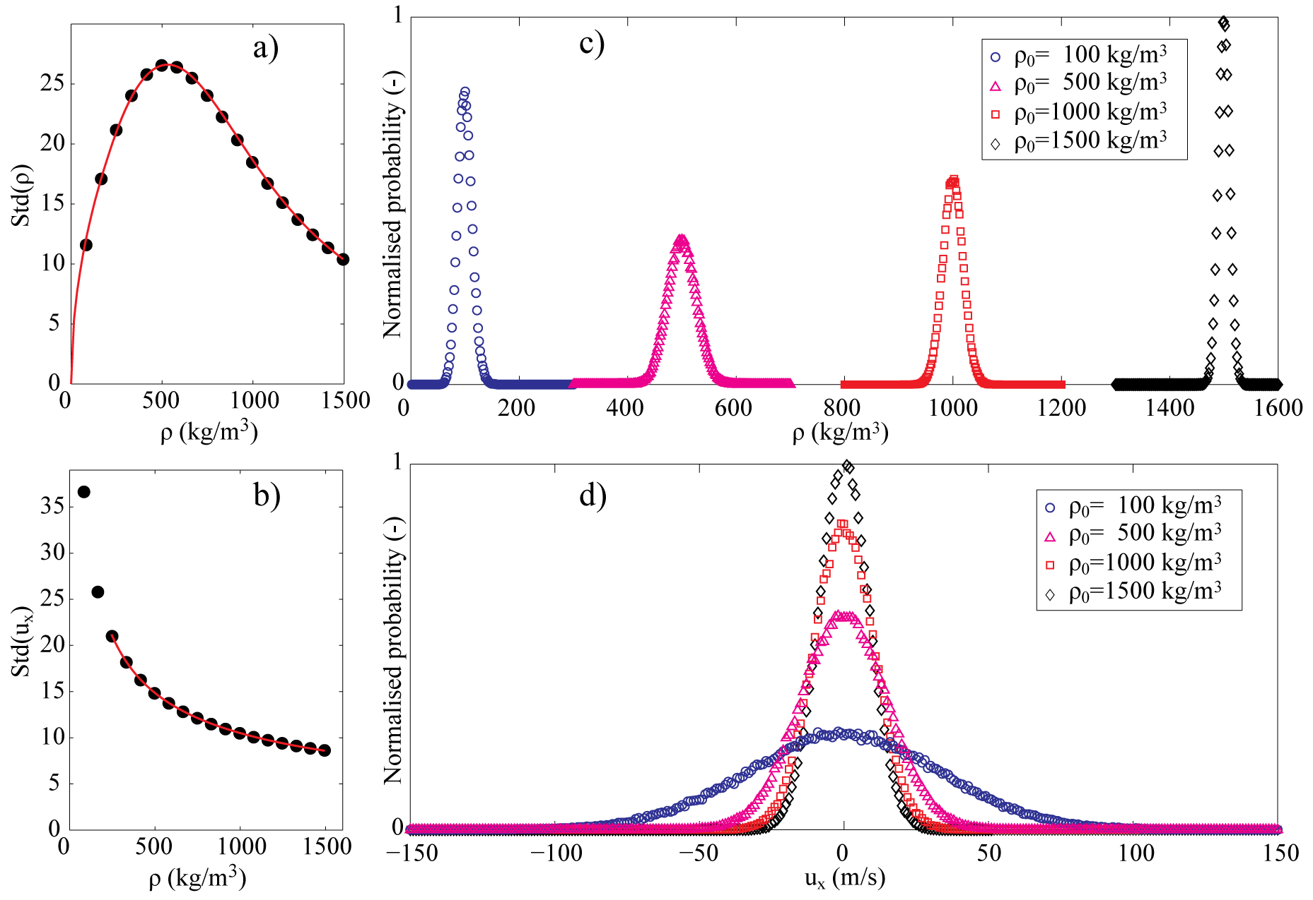

**Fig. 3.7** – a) Standard deviation of the density, and b) Standard deviation of the velocity in x-direction, in a fluid cell with volume 37.5 nm3 of argon at T=300 K. The continuous lines correspond to the grand canonical results obtained using the fitted equation of state, and the circles are the results from the fluctuating hydrodynamics simulation (64x64x64 cells). c) Normalised distribution of density, and d) Normalised distribution of velocity in x-direction, sampled in a constant interval around a mean density value, ρ0.

The numerical prediction results with the present method are shown with symbols. As can be seen, there is excellent agreement between the theory and the calculation for the whole range of density values. Despite the above indications of the good accuracy of the three-dimensional non-linear Central Leapfrog scheme, there is a slight difference between the present calculation and the solution obtained in [24]. One possibility for this discrepancy is the difference in the equation of state in our works. In order to investigate this further, we looked at how sensitive the result is on the actual fit of the equation of state obtained from the MD simulation. Indeed, it has been found that slight changes in the equation of state fit can have a notable effect on the value of the fluctuations, especially for density. The sensitivity is particularly notable for the value of the mean density near the peak of the curve as shown in figure 3.7a. This suggests that one needs to take care when informing the continuum model by a precursor molecular dynamics simulation if accurate results are to be obtained. Furthermore, Figure 3.7c and 3.7d show the expected distributions, where the distribution at ρ0=1500 kg/m3 show a sharp peak in both the density and velocity distribution as also indicated by the standard deviations, whereas the density distribution at ρ0=500 kg/m3 shows a wide distribution, that coincides with the peak in standard deviation of the density.

The previous simulation investigated how the values of the fluctuations change when the density of the domain is changed, i.e. less mass in the same volume. The next simulation aims for the opposite, i.e. to investigate how the values of fluctuations change when a larger volume is observed (i.e. a larger ensemble of atoms). According to the results from the grand canonical ensemble, the dependency should be linear and with aid of the slope of the curve, the speed of sound can be obtained [14].

Figure 3.8 shows how the density fluctuations change if the volume of the cell changes, while the mean value of density is kept constant at 996.3 kg/m3. The plot shows the inverse square root of the volume versus the density fluctuations. In agreement with the theory, the curve shows a linear dependency. The slope of this function corresponds to the effective speed of sound which should also coincide with the sound speed obtained from the equation of state in accordance with (3.10) and (3.11). The sound speed obtained from the microscopic fluctuations that correspond to the curve slope is about 568 m/s, while the input value in accordance with the equation of state at this density is 561.4 m/s. This means that actual speed of sound, as captured by the numerical method, is within 1.1 % of the input value.

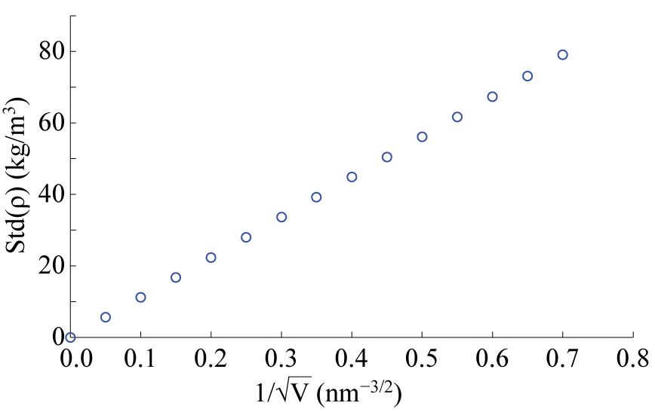

**Fig. 3.8** – Standard deviation of density versus inverse square root of the cell volume (V), while the density is kept constant at ρ0=996.3 kg/m3. The slope of the curve can be used to obtain the value of the speed of sound.

Following [21], accuracy of the current computational solution of the 3D Fluctuating Hydrodynamics equations is examined for each individual Fourier component. Firstly, the physical space-time domain solution of the fluctuating hydrodynamics equations is Fourier transformed in space and then the corresponding structure functions are computed, similar to the turbulent flows analysis.

In accordance with the theory, different Fourier modes of the fluctuating hydrodynamics solution at equilibrium conditions are uncorrelated. In particular, the Fourier-domain structure functions of density and velocity components satisfy the following relations:

 (3.12)

where,  and  are the Fourier transforms and their complex conjugates of density and velocity component fluctuations, and  are the Kronekker deltas,  (1 is in the x-direction, 2 is in the y-direction, 3 is in the z-direction),  is the cell volume,  are ensemble (time) averaged values, and  corresponds to ensemble averaging.

Fig.3.9 shows the corresponding results of the numerical solution where one of the wavevectors,  is fixed to an intermediate value and the other wavevector,  is varying, and the amplitudes of the structure functions are normalised as in (3.12). For clarity, the 3D vector field ,where  and  is compressed to a 1D vector  which is normalised by the maximum value. It can be seen that the numerical predictions are in a good agreement with the theory. A slight deviation of the amplitude from 1 is due to insufficient statistical averaging to which the density solution appears to be more sensitive in comparison with the velocity (cf. Figs.3.2a,b).

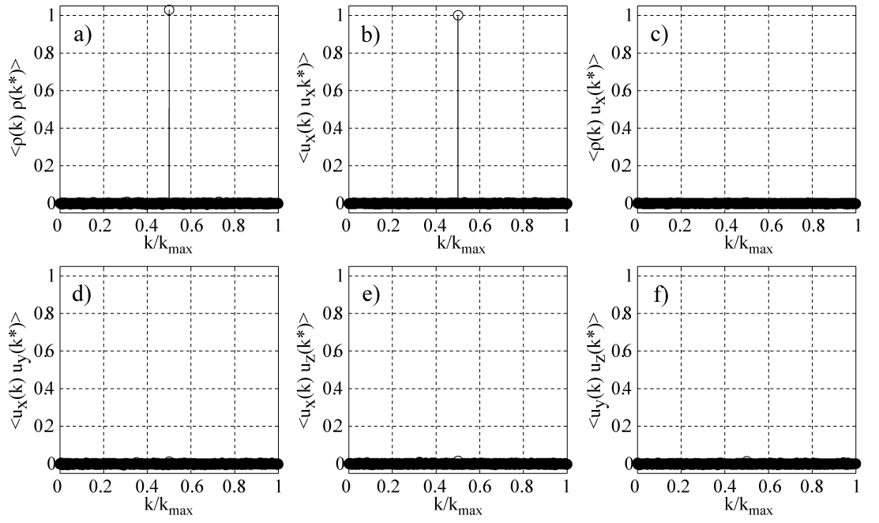

**Fig. 3.9** – Fourier-domain structure functions for density and velocity components.

**3.4 Dependency on the time step**

For the final equilibrium test, the dependency of the fluctuations on the time step is investigated. There are several ways how to test this and the test performed here is based on the measured temperature obtained from the fluctuations. According to statistical physics, the equipartion theorem provides a description how the density and velocity fluctuations, i.e. the kinetic energy, are related to the temperature as follows:

 (3.13)

The computational time step is varied in the interval [0.0005,0.05] which includes the value dt=0.005 that was applied for the simulations of Section 3.3. Here the computational values again corresponds to reduced units using the properties of argon, hence the physical time step can be computed by multiplying the computational values with 2.1502 picoseconds. In terms of the CFL number based on the sound speed, the corresponding parameter range of the time step used is [0,00018,0.018].

In each case, the temperature that corresponds to the energy of the fluctuations in accordance with (3.13),  is compared with the input value (T=300K). The volume is set to 37.5nm3 as before and the mean density is set to 996.3 kg/m3. For all cases, the total physical simulation time is kept constant so that the number of time steps varied from 100,000 to 10,000,000, while the number of cells will remain constant and equal to 64x64x64. Figure 3.10 shows the relative error in temperature . The figure shows that the error depends on the time step size almost linearly and that the relative error is less than 2% for the largest time step simulated.

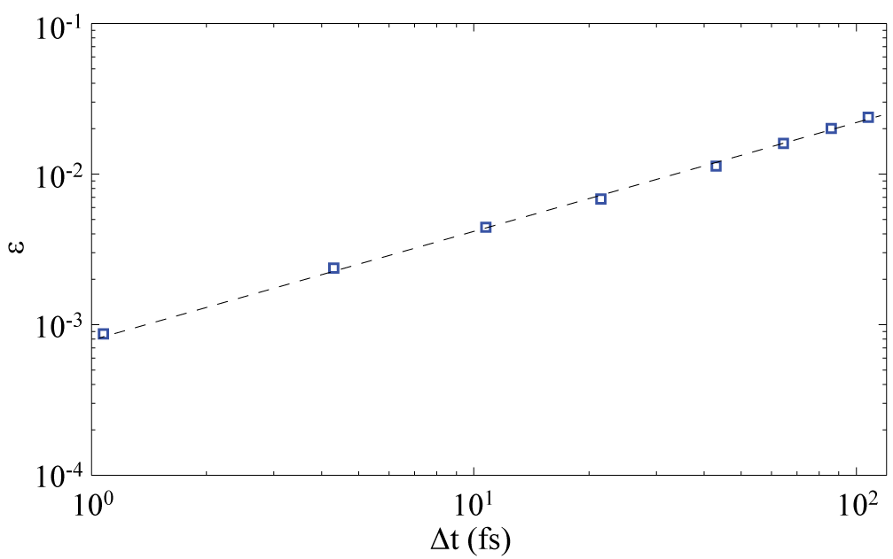

**Fig. 3.10** – The relative error  between the input temperature T=300K and the temperature computed from the density and velocity fluctuations (Tnum) versus the physical time step.

**4 Conclusion**

A new non-linear two-time-level Central Leapfrog scheme has been developed for solving the Landau-Lifshitz Fluctuating Hydrodynamics equations. The scheme is an extension of the classical three-level Central Leapfrog scheme to low-dissipative flux corrected methods with enabling compact computational stencil by using staggered flux and conservation variables. Spectral properties of the scheme for linear advection are analysed which show that the non-linear scheme is stable and low-dissipative in the entire range of wave numbers. Implementation of the new algorithm for Graphical Process Units, which allows a speedup of factor of 300 in comparison with the single-computer-core method, is discussed.

The method has been applied for solving several test problems of fluctuating hydrodynamics in one dimensional and three dimensional settings. Numerical examples provided show that the new non-linear Central Leapfrog scheme is accurate and robust for solving a range of fluctuating hydrodynamics problems at equilibrium and non-equilibrium. The accuracy of the new scheme is comparable with the best algorithms available in the literature, such as those based on multi-stage Runge-Kutta schemes specifically tailored for fluctuating hydrodynamics, which do not share the simplicity and robustness of the nonlinear Central Leapfrog scheme.

Further work will be devoted to testing the performance of the new numerical Landau-Lifshitz Fluctuating Hydrodynamics scheme for other applications including its implementation in hybrid molecular dynamics/ continuum fluid dynamics methods [X5].

**Acknowledgement**

The work of AM and SK has been supported by Engineering and Physical Sciences Research Council (EP/J004308/1) and the work of YG and VM has been supported by Russian Foundation for Basic Research (11-07-93938-G8\_a) in the framework of the G8 Research Councils Initiative on Multilateral Research Funding. SK is grateful to the Royal Society of London for their continuing support.

**References**

1. E.M. Lifshitz and L.P. Pitaevskii, *Statistical Physics Part 2*, Pergamon Press plc, 1980
2. L.D. Landau and E.M. Lifshitz, *Statistical Physics Part 1*, Elsevier Ltd., 1980
3. J.M. Ortiz de Zárate, J.V. Sengers, *Hydrodynamic Fluctuations in Fluids and Fluid Mixtures*, 2006, Elsevier, The Netherlands
4. A. L. Garcia, M. M. Mansour, G. C. Lie, and E. Cementi. *Numerical integration of the fluctuating hydrodynamic equations*. Journal of Statistical Physics, 47(1-2):209-228, 1987
5. M. Serrano and P. Español. *Thermodynamically consistent mesocopic fluid particle model*, Phy. Rev. E, 64:046115, 2001
6. A.J.C. Ladd, Short-time motion of colloidal particles: Numerical simulation via a fluctuating lattice-Boltzmann equation, Physical Review Letters, 70 (1993) 1339–1342
7. A.J.C. Ladd, Numerical simulations of particulate suspensions via a discretized Boltzmann equation. Part 2. Numerical results, Journal of Fluid Mechanics 271 (1994) 311-339
8. P. J. Hoogerbrugge, J. M. V. A. Koelman, Simulating Microscopic Hydrodynamic Phenomena with Dissipative Particle Dynamics, Europhysics Letters 19(3) (1992) 155
9. P. Español, Dissipative particle dynamics with energy conservation, Europhysics Letter 40 (1997) 631
10. P. Español, M. Serrano, H.C. Öttinger, Physical Review Letters 83 (1999) 4542-4545
11. P. Ahlrichs, B. Dünweg, Simulation of a single polymer chain in solution by combining lattice Boltzmann and molecular dynamics, Journal of Chemical Physics 111 (1999) 8225-8239
12. O.B. Usta, A.J. Ladd, J.E. Butler, Lattice-Boltzmann simulations of the dynamics of polymer solutions in periodic and confined geometries, Journal of Chemical Physics 122(9) (2005) 094902
13. A.P. Markesteijn, O.B. Usta, I. Ali, A.C. Balazs, J.M. Yeomans, Flow injection of polymers into nanopores. Soft Matter 5 (2009) 4575-4579
14. N.K. Voulgarakis and J-W. Chu, *Bridging fluctuating hydrodynamics and molecular dynamics simulations of fluids.* The Journal of Chemical Physics, 2009. 130
15. A.P. Markesteijn and S.A. Karabasov, *Time Asynchronous Relative Dimension in Space method for multi-scale problems in fluid dynamics*, J.Comp.Phys., 258, 2014, pp. 137-164
16. Omelchenko, Y.A. and Karimabadi, H. *Self-adaptive time integration of flux-conservative equations with sources*, Journal of Computational Physics, 216 (2006) 179-194
17. J.B. Bell, A.L. Garcia, and S.A. Williams, *Numerical methods for the stochastic Landau-Lifshitz Navier-Stokes equations.* Phys. Rev., 2007. **E76**.
18. J.B. Bell, A.L. Garcia, and S.A.Williams, *Computational Fluctuating Fluid Dynamics.* ESAIM: Mathematical Modeling and Numerical Analysis, 2010. **44**: p. 1085-1105.
19. A. Donev, E. Vanden-Eijnden, A.L. Garcia, J.B. Bell, *On the accuracy of finite-volume schemes for fluctuating hydrodynamics.* Comm. App. Math. and Comp. Sci., 2010. **5**(2).
20. M. Serrano, G. D. Fabritiis, P. Español, E. G. Flekkoy, and P. Coveney. *Mesoscopic dynamics of Voronoi fluid particles*, J. Phys. A: Math. Gen., 35:1605-1625, (2002)
21. F. Balboa Usabiaga, J. Bell, R. Delgado-Buscalioni, A. Donev, T. Fai, B. Griffith, C. Peskin, *Staggered shemes for Fluctuating Hydrodynamics*, Multiscale Modeling and Simulation, 10, 4, 1360-1408, 2012
22. S. Gottlieb and C. Shu, *Total variation diminishing Runge-Kutta schemes*, Math. Comp., 67 (1998), pp. 73–85
23. S.A. Karabasov and T.P. Hynes, *A Method for Solving Compressible Flow Equations in an Unsteady Free Stream*, Proc. IMechE 2006, Vol. 220 Part C:J. Mechanical Engineering Science, N.2, pp.185-202
24. G. De Fabritiis, M. Serrano, R. Delgado-Buscalioni, and P.V. Coveney, *Fluctuating hydrodynamic modeling of fluids at the nanoscale*, Physical Review E 75, 026307 (2007).
25. L.D. Landau, E.M. Lifshitz, *Fluid Mechanics*. Vol. 6 (2nd ed.), (1987), Butterworth–Heinemann
26. P. Borgelt, C. Hoheisel, and G. Stell, *Exact molecular dynamics and kinetic theory results for thermal transport coefficients of the Lennard-Jones argon fluid in a wide region of states*, Physical Review A, Volume 42, issue 2 (1990), p. 789-794
27. J.H. Irving and J.G. Kirkwood, *The Statistical Mechanical Theory of Transport Processes. IV. The Equations of Hydrodynamics*, J. Chem. Phys. 18, 817 (1950)
28. S. Nosé, J, *A unified formulation of the constant temperature molecular dynamics methods*, . Chem. Phys. 81, 511 (1984).
29. W. Hoover, *Canonical dynamics: Equilibrium phase=space distributions*, Phys. Rev. A 31, 1695 (1985).
30. B. Shang, N.K. Voulgarakis, and J-W. Chu, *Fluctuating hydrodynamics for multiscale modeling and simulation: Energy and heat transfer in molecular fluids*, J. Chem. Phys., 137, 044117 (2012)
31. A.P. Markesteijn, R. Hartkamp, S. Luding, and J. Westerweel, *A comparison of the value of viscosity for several water models using Poiseuille flow in a nano-channel*, J. Chem. Phys. 136, 134104 (2012)
32. V.M. Goloviznin, S.A. Karabasov, and I.M. Kobrinksi, *Balance-characteristic schemes with staggered conservative and transport variables*. Mathematical Modelling Journal, 15. pp. 29-48 (2003).
33. S.A. Karabasov and V.M. Goloviznin. ,*Compact Accurately Boundary Adjusting high-REsolution Technique for Fluid Dynamics*, J. Comput.Phys., 228, 7426–7451 (2009)
34. S.K. Godunov, *A difference scheme for numerical computation of discontinuous solutions of equations of fluid dynamics*, Math. Sbornik 47 (1959) 271–306.
35. J.P. Boris, D.L. Book, and K. Hain, *Flux-corrected transport: generalization of the method*, J. Comput. Phys. 31 (1975) 335–350.
36. V.P. Kolgan, *The application of a minimal solution slope principle for the development of finite-difference schemes for solving gas dynamics problems with discontinuities*, Uch. Zapiski TsAGI 3 (1972) 68–77.
37. B. Van Leer, *Towards the ultimate conservative difference scheme. V. A second-order sequel to Godunov’s method*, J. Comput. Phys. 32 (1979) 101–136.
38. A. Harten, B. Engqist, S. Osher, S. Chakravarthy, *Uniformly high order accurate essentially non-oscillatory schemes III*, J. Comput. Phys. 71 (1987) 231–303.
39. S. Pirozzoli, *On spectral properties of shock-capturing schemes.* Journal of Computational Physics, (2006). **219**: p. 489-497.
40. D. Fauconnier and E. Dick, *On the spectral and conservation properties of nonlinear discretezation operators.* Journal of computational physics, 2011. **230**.
41. G.A. Faranosov, V.M. Goloviznin, S.A. Karabasov, V.G. Kondakov, V.F. Kopiev, M.A. Zaitsev, *CABARET method on unstructured hexahedral grids for jet noise computation*, Computers and Fluids, 2013, Vol. 88, pp. 165-179
42. Pandey, A., Klar, A. and Tiwari, S, *Meshfree method for fluctuating hydrodynamics.* Math. and Comp. in Simulation, 2012.
43. J. Keizer, *Statistical Thermodynamics of Nonequilibrium Processes*, Springer-Verlag, New York, 1987
44. P.A. Ferrar and L.R.G. Fontes, *Shock fluctuations in the asymmetric simple exclusion process*. Probab. Theory Related Fields 99 305–319 *(*1994*)*
45. C. Hirsch, *Numerical computation of internal and external flows* *Vol. 1: Fundaments of numerical discretization,* (2001), Eastbourne: Antony Rowe Ltd.

X1 G. De Fabritiis, R. Delgado-Buscalioni,and P.V. Coveney, Multiscale Modeling of Liquids with Molecular Specificity, PRL 97, 134501 (2006)

X2 G. Giupponi,G. De Fabritiis, P.V. Coveney,Hybrid method coupling fluctuating hydrodynamics and molecular dynamics for the simulation of macromolecules, THE JOURNAL OF CHEMICAL PHYSICS 126, 154903, 2007

X3 C. Hirsh, “Numerical Computation of Internal and External Flows, Vol. 2, Wiley, New York, 1998.

X4 V.M. Goloviznin, V.N. Semenov, I.A Korortkin, and S.A. Karabasov, “A novel computational method for modelling stochastic advection in heterogeneous media”. Transport in Porous Media, Springer Netherlands, 2007, 66(3), pp. 439-456.

X5 A. Markesteijn, S. Karabasov, A. Scukins, D. Nerukh, V. Glotov, and V. Goloviznin, “Concurrent multiscale modelling of atomistic and hydrodynamic processes in liquids”, Philosophical Transactions of Royal Society A, in press.

**Appendix A**

**Linear spectral analysis of the two-time-level Central Leapfrog Scheme in staggered variables**

To investigate the dissipative and dispersive properties of the two-time-level Central Leapfrog scheme (2.2), the solution is considered in the form of running waves as the following:

 (A.1)

where A, B, D are arbitrary amplitudes. After substitution of (A.1) into equation (2.2) the result is the following system of equations:

 (A.2)

where .

For the system to have an allowable solution for all ranges of the A, B, D, its determinant must be zero:

 (A.3)

Solving the equation results in:

 (A.4)

From the above, under stability condition , it follows that the Central Leapfrog scheme is non-dissipative:

 (A.5)

and for long wavelengths corresponding to the fine numerical grid resolution, the first solution root has the correct phase, .

**Appendix B**

**Characteristic decomposition of the one-dimensional Landau-Lifshitz Navier-Stokes Fluctuating Hydrodynamics equations**

Let us consider LL-NS FH equations (1.1) in one-dimensional form:

 (B.1)

where

 , (B.2)

****  is the unit area on *yz-* plane, , ,

 (B.3)

and , , ,  are independent Gaussian matrices with zero mean.

To re-arrange the above equations to a characteristic form, conservative equations (B1) is first written in the following quasi-linear form:

 (B.4)

where ,  is the right-hand-side part of the equations and:

 (B.5)

where  is assumed to be positive.

The left hand-side operator of (B.4) is the standard Euler equations, which corresponds to the following characteristic form [45]:

 (B.6)

The above equations are not integrable in general, but for locally isentropic conditions, i.e., assuming that the variation of entropy in computational cell is slow in comparison with the variation of other variables, following [33], they can be re-arranged to the full-Riemann-invariant form for variables:

 (B.7)

where , , and *S* and  refer to the entropy variable and the cell-wise constant entropy field, respectively.