Causal associations of adiposity and body fat distribution with coronary heart disease, stroke subtypes and type 2 diabetes: a Mendelian randomization analysis

Authors:
Caroline E Dale^{1*}, Ghazaleh Fatemifar^{1*}, Tom M Palmer², Jon White³, David Prieto-Merino¹, Delilah Zabaneh⁴, Jorgen E L Engmann⁵, Tina Shah⁵, Andrew Wong⁶, Helen R Warren^{7,8}, Stela McLachlan⁹, Stella Trompet^{10,11}, Max Moldovan^{12,13}, Richard W Morris¹⁴, Reecha Sofat¹⁵, Meena Kumari¹⁶, Elina Hyppönen^{12,17,18}, Barbara J Jefferis¹⁹, Tom R Gaunt²⁰, Yoav Ben-Shlomo¹⁴, Ang Zhou¹⁷, Aleksandra Gentry-Maharaj²¹, Andy Ryan²¹, UCLEB consortium, METASTROKE consortium, Renée de Mutsert²², Raymond Noordam²³, Mark J Caulfield^{7,8}, J. Wouter Jukema^{10,24}, Bradford B. Worrall²⁵, Patricia B Munroe^{7,8}, Usha Menon²¹, Chris Power¹⁸, Diana Kuh⁶, Debbie A Lawlor¹⁴, Steve E Humphries²⁶, Dennis O Mook-Kanamori^{22,27}, George Davey Smith²⁰, Naveed Sattar²⁸, Mika Kivimaki²⁹, Jacqueline F Price⁹, Frank Dudbridge³⁰, Aroon D Hingorani^{1,5}, Michael V Holmes^{31,32,33†}, Juan P Casas^{1†}
* Joint first authors
† Joint last authors

Affiliations:

1. Farr Institute of Health Informatics Research, UCL Institute of Health Informatics, University College London, London, UK.
2. Department of Mathematics and Statistics, Lancaster University, Lancaster, UK.
3. UCL Genetics Institute, University College London, UK.
4. Social Genetic & Developmental Psychiatry, King's College London.
5. Institute of Cardiovascular Science, University College London, London, UK
6. MRC Unit for Lifelong Health & Ageing at UCL, London.
7. Clinical Pharmacology, William Harvey Research Institute, Barts and The London School of Medicine and Dentistry, Queen Mary University of London, London, EC1M 6BQ,UK.
8. NIHR Barts Cardiovascular Biomedical Research Unit, Barts and The London School of Medicine and Dentistry, Queen Mary University of London, London, EC1M 6BQ, UK.
9. Centre for Population Health Sciences, Usher Institute of Population Health Sciences and Informatics, University of Edinburgh, Edinburgh, United Kingdom.
10. Department of Cardiology, Leiden University Medical Center, Leiden, The Netherlands.
11. Department of Gerontology and Geriatrics, Leiden University Medical Center, Leiden, The Netherlands.
12. South Australian Health and Medical Research Institute, Adelaide, SA5000, Australia.
13. South Australian Health and Medical Research Institute, EMBL Australia.
14. School of Social and Community Medicine, University of Bristol, Bristol, UK.
15. Centre for Clinical Pharmacology, University College London.
16. Institute for Social and Economic Research, University of Essex, Colchester, UK.
17. Centre for Population Health Research, School of Health Sciences and Sansom Institute, University of South Australia, SA5000, Adelaide, Australia.
18. Population, Policy & Practice, UCL Great Ormond Street Institute of Child Health.
19. Department of Primary Care & Population Health, University College London, Royal Free Campus, London, UK.
20. MRC Integrative Epidemiology Unit, University of Bristol, Bristol, UK.
21. Department of Women’s Cancer, Institute for Women’s Health, UCL, London W1T 7DN, UK.
22. Department of Clinical Epidemiology, Leiden University Medical Center, Leiden, the Netherlands.
23. Department of Internal Medicine, Section Gerontology and Geriatrics, Leiden University Medical Center, Leiden, the Netherlands.
24. Interuniversity Cardiology Institute Netherlands, Utrecht, the Netherlands.
25. Departments of Neurology and Public Health Sciences, University of Virginia.
26. Centre for Cardiovascular Genetics, Institiute Cardiovascular Science, University College London.
27. Department of Public Health and Primary Care, Leiden University Medical Center, Leiden, the Netherlands.
28. BHF Glasgow Cardiovascular Research Centre, Faculty of Medicine, Glasgow, United Kingdom.
29. Department of Epidemiology and Public Health, University College London.
30. Dept Non-communicable Disease Epidemiology, London School of Hygiene and Tropical Medicine.
31. Clinical Trial Service Unit & Epidemiological Studies Unit, Nuffield Department of Population Health, Richard Doll Building, University of Oxford.
32. MRC Population Health Research Unit, Nuffield Department of Population Health, Richard Doll Building, University of Oxford.
33. National Institute for Health Research Oxford Biomedical Research Centre, Oxford University Hospitals, Oxford OX3 7LE, UK

Abstract: (247 words)
Background: Implications of different adiposity measures on cardiovascular disease aetiology remain unclear. In this paper we quantify and contrast causal associations of central adiposity (waist:hip ratio adjusted for BMI (WHRadjBMI)) and general adiposity (body mass index (BMI)) with cardiometabolic disease.
Methods: 97 independent single nucleotide polymorphisms (SNPs) for BMI and 49 SNPs for WHRadjBMI were used to conduct Mendelian randomization analyses in 14 prospective studies supplemented with CHD data from CARDIoGRAMplusC4D (combined total 66,842 cases), stroke from METASTROKE (12,389 ischaemic stroke cases), type 2 diabetes (T2D) from DIAGRAM (34,840 cases), and lipids from GLGC (213,500 participants) consortia. Primary outcomes were CHD, T2D, and major stroke subtypes; secondary analyses included 18 cardiometabolic traits.
Results: Each one standard deviation (SD) higher WHRadjBMI (1SD~0.08 units) associated with a 48% excess risk of CHD (odds ratio [OR] for CHD: 1.48; 95%CI: 1.28-1.71), similar to findings for BMI (1SD~4.6kg/m²; OR for CHD: 1.36; 95%CI: 1.22-1.52). Only WHRadjBMI increased risk of ischaemic stroke (OR 1.32; 95%CI 1.03-1.70). For T2D we find OR 1.82 (95%CI 1.38-2.42) per 1SD WHRadjBMI and OR 1.98 (95%CI 1.41-2.78) per 1SD BMI. Both WHRadjBMI and BMI were associated with increased left ventricular hypertrophy, glycaemic traits, interleukin-6, and circulating lipids. WHRadjBMI was associated with carotid intima-media thickness (37%; 95%CI: 7%-74% per 1SD).
Conclusions: Both general and central adiposity have causal effects on CHD and T2D. Central adiposity may have a stronger effect on stroke risk. Future estimates of adiposity burden on health should include measures of central and general adiposity.

Clinical Perspective:
What is new:
- This large-scale genetic analysis presents the most comprehensive causal assessment of adiposity with cardiometabolic diseases to date, including new data for ischaemic stroke from METASTROKE and novel cardiometabolic traits including ECG measures and CIMT.
- We find that waist:hip ratio adjusted for BMI, a measure of body fat distribution that aims to be independent of general adiposity, is causally related to higher risks of coronary heart disease, ischaemic stroke and type 2 diabetes and a multitude of cardiometabolic traits.
- Our findings also reinforce existing evidence on the causal relevance of general adiposity (BMI) to these diseases and provide more precise estimates.
What are the clinical implications:
- Both the amount of adiposity and its distribution play important roles in influencing multiple cardiometabolic traits and the development of cardiometabolic diseases.
- Furthermore, our findings indicate that body fat distribution has multiple causal roles in disease that are independent of general adiposity.
- This suggests that physicians should pay attention to measures of adiposity beyond BMI as measurement of such traits may identify patients at risk of cardiometabolic disease and provides opportunities to the scientific community to identify novel approaches to disease prevention.

Word count (4978)

Introduction
Observational studies have identified associations between adiposity and the risk of developing incident coronary heart disease (CHD), stroke and type 2 diabetes mellitus (T2D). Many observational studies report consistent results with different measures of adiposity; for example the Emerging Risk Factors Collaboration found similar associations with both general adiposity measured via body mass index (BMI) and central adiposity measured via waist to hip ratio (WHR) for CHD and ischaemic stroke¹. The association of different adiposity measures with T2D has also been found to be similar².
However, other studies have suggested that central adiposity, measured as either WHR or waist circumference (WC), may have stronger associations with cardiovascular disease. For example, INTERHEART found a stronger association for WHR with myocardial infarction (MI) than BMI, and the association of WHR with MI persisted after adjustment for BMI³. The Million Women Study found that WC increased CHD risk within BMI categories (and vice versa) again suggesting each is independently associated with CHD⁴. Furthermore, INTERSTROKE found WHR to be more strongly associated with stroke risk than BMI⁵. While these studies have attempted to separate the independent effects of general and central adiposity, this remains challenging in observational studies due to the high degree of correlation between adiposity measures. Another problem is that adiposity measures may differ in their reproducibility; for example BMI is less affected by regression dilution bias – a bias to the null resulting from measurement error - than WHR ⁶. In addition, all measures of adiposity suffer from confounding due to underlying ill-health at low or sub-clinical levels, because many chronic conditions lead to weight loss⁷⁻⁹. Consequently it is very difficult, if not impossible, to quantify the true independent effects of different measures of adiposity in observational studies alone.
Whilst Mendelian randomization (MR) studies minimise bias from traditional sources such as confounding, regression dilution bias and reverse causation, they may be susceptible to bias from pleiotropy (association of genetic variants with more than one variable). Pleiotropy can be vertical due to multiple downstream effects that follow the SNP effect on the exposure of interest, but this does not compromise MR assumptions. Alternatively, pleiotropy can be horizontal, whereby the SNP or instrument affects pathways other than those of the exposure of interest and could therefore invalidate the MR assumption that the SNP only affects the outcome through the exposure of interest, potentially leading to biased causal estimates. With multi-SNP instruments, there is a chance that pleiotropic effects might become balanced such that causal inference regarding the exposure is possible. In this study we perform MR analyses of BMI and WHR together with recently developed methods that are robust to horizontal pleiotropy under additional assumptions (Supplementary Figure 1). We therefore employ MR-Egger regression to provide a test for unbalanced pleiotropy and a causal estimate of exposure on outcome in its presence. In addition we use the weighted median estimator which can give valid estimates even in the presence of horizontal pleiotropy provided at least 50 per cent of the information in the analysis comes from variants that are valid instruments, and has the advantage of retaining greater precision in the estimates compared to MR-Egger¹².
This manuscript represents the most comprehensive assessment of the causal role of adiposity on CHD, stroke and T2D to date. It contrasts the causal effects of central adiposity (waist:hip ratio adjusted for BMI (WHRadjBMI) from general adiposity (BMI) on multiple cardiovascular outcomes: new CHD events from 14 prospective studies/ RCTs in addition to data publicly available from the CARDIOGRAMplusC4D¹³ increasing CHD cases to 66,842, multiple stroke subtypes using data from METASTROKE¹⁴ and T2D from DIAGRAM¹⁵. We present the largest number of cardiometabolic traits ever examined in a MR analysis of adiposity including lipids from the Global Lipids Genetic Consortium (GLGC; 213,500 participants)¹⁶ and many novel intermediate disease end points, including electrocardiogram (ECG) measures of left ventricular hypertrophy, carotid intima media thickness (CIMT) as a measure of sub-clinical atherosclerosis, as well as markers of renal and lung disease. We build distinct multi-SNP genetic instruments for each adiposity measure using the most comprehensive repertoire available from recent genome-wide association (GWA) studies, with 97 SNPs for BMI and 49 SNPs for WHRadjBMI, thereby more than doubling the phenotypic variance explained in some earlier MR studies¹⁹⁻²³.

Methods

Study selection and inclusion of participants
We include individual participant data from 10 studies in the University College London – London School of Hygiene and Tropical Medicine – Edinburgh - Bristol (UCLEB) consortium (see Supplementary Table 1 for study details). We include summary data from a further four studies (Anglo-Scandinavian Cardiac Outcomes Trial (ASCOT), Health and Retirement Study (HRS), Netherlands Epidemiology of Obesity (NEO) and Prospective Study of Pravastatin in the Elderly at Risk (PROSPER)), and summary data from four consortia (CARDIoGRAMplusC4D, METASTROKE, DIAGRAM, Global Lipids Genetics Consortium (GLGC)) (see Appendix). All participating studies received approval from local institutional review boards or ethics committees.
Clinical Outcomes
Supplementary Table 2 provides details of CHD ascertainment and number of events by study. In UCLEB studies the primary outcome was combined prevalent or incident CHD defined as fatal or non-fatal myocardial infarction, or a coronary revascularisation procedure, but excluding angina. In the majority of studies events were validated (e.g. hospital episode statistics, clinical/laboratory measurements, review of primary care medical records). CARDIoGRAMplusC4D used standard criteria for defining cases of CAD and myocardial infarction with some studies including angiography-confirmed stenosis and stable or unstable angina¹³. METASTROKE define stroke as a typical clinical syndrome with radiological confirmation; subtyping was done with the Trial of Org 10172 in Acute Stroke Treatment (TOAST) classification system¹⁴. We include all ischaemic stroke, three sub-types (large-vessel disease, small-vessel disease and cardioembolic stroke) and haemorrhagic stroke. T2D definitions follow DIAGRAM²⁴.
Cardiometabolic traits
For analysis of individual participant data studies, data on sex, age, measured standing height, weight, waist circumference and hip circumference were used to derive BMI and WHRadjBMI traits. WHRadjBMI was calculated by generating the predicted residuals from the linear regression of WHR on BMI. Biomarkers included in analyses were grouped into the following categories; Lipids (triglycerides, HDL-C and LDL-C), inflammation (IL-6), lung function (ratio of FEV1 to FVC), metabolic (glucose, insulin and albumin), renal (creatinine, estimated glomerular filtration rate (EGFR), MDRD) and systolic blood pressure. The following electrocardiogram (ECG) measures of left ventricular hypertrophy were recorded: QRS voltage sum, QRS voltage sum product, Cornell product and Sokolow-Lyon index as well as PR interval (see Supplementary Text 1 for definitions). Cardiometabolic traits that were not normally distributed were transformed to the natural logarithmic scale. For comparability across biomarkers, measurements were z-score standardised. Self-reports of current smoking status (ever/ never) and alcohol consumption (drinker/ non-drinker) were considered to be potential confounders of adiposity-cardiovascular disease (CVD) associations.
Genotyping
Supplementary Table 1 details genotyping by study. Genotyping in all UCLEB studies was conducted with the Metabochip array (except a subset of ELSA study that used a GWAS array)²⁵. The remaining studies used GWAS arrays (HRS, PROSPER) or Exome Chip (NEO). Individuals were excluded from the analyses on the basis of gender mismatch, excessive or minimal heterozygosity, relatedness or individual missingness (>3%). Individuals of non-European ancestry were removed to minimise confounding by population structure. SNPs with a low call rate or evidence of departure from Hardy–Weinberg equilibrium were excluded from analyses (see Supplementary Table 1 for thresholds employed in different studies).
Statistical Analyses
Observational Analyses
In individual participant data studies adiposity (BMI or WHRadjBMI) was z-score standardised and linear or logistic regression models were fitted for each cardiometabolic trait or disease outcome. Observational models were adjusted for age and sex. Fixed-effect meta-analyses were employed to derive combined observational estimates across studies. We calculated I² statistics to quantify heterogeneity between studies and derived P-values from Cochran’s Q test²⁶.
Genetic Analyses
SNP selection and construction of the genetic instruments
Selection of SNPs for the genetic instruments was based on analyses from the Genetic Investigation of ANthropometric Traits (GIANT) consortium, which included 339,224 individuals from 125 separate studies for BMI¹⁷ and 224,459 individuals from 101 studies for WHRadjBMI¹⁸. These studies identified 97 independent SNPs for BMI and 49 independent SNPs for WHRadjBMI at GWAS significance. We found no overlap between the BMI SNPs and WHRadjBMI SNPs. In studies where the SNP identified by GIANT was not available in the Metabochip array, we used proxy SNPs in linkage disequilibrium (R²>0.8) with the specified SNP. Details of proxy SNPs used by platform (Metabochip/ GWAS) are given in Supplementary Tables 3 and 4.
Genetic association analyses in individual participant data
We performed a within study genetic association analysis with adiposity (standardised BMI and WHRadjBMI) as a continuous trait using an additive model. We used linear or logistic regression models to estimate the additive effect of each SNP on cardiometabolic traits and outcomes. We used logistic regression to test the association of each SNP with smoking and alcohol consumption as potential confounders of the adiposity-CVD association.
Instrumental variable analyses in summary data
We conducted three tests for the causal estimation of each adiposity measure on cardiometabolic outcomes: 1) Inverse-variance weighted method (IVW), 2) MR-Egger and 3) Weighted median. In the absence of horizontal pleiotropy, we would expect all three tests to give consistent results. All IV estimates in summary data were calculated using the mrrobust package (available from https://github.com/remlapmot/mrrobust) in Stata version 14. The proportion of variance in adiposity explained by the genetic instruments in summary data was calculated using the grs.summary function from the gtx package in R. A threshold of statistical significance of P<0.025 (0.05/2=0.025) was used to reflect testing for two different adiposity traits (BMI and WHRadjBMI).
- IVW instrumental variable analyses
To combine data across studies with summary level data we pooled the association of each SNP on risk of each CVD outcome/ cardiometabolic trait using fixed effects meta-analysis. To provide external weights for the SNP-adiposity associations, the effect of each SNP on adiposity (BMI; WHRadjBMI) in GIANT was pooled with that in all other contributing studies, excluding studies that had already contributed to GIANT (1958BC, EAS, HRS, NSHD, PROSPER,Whitehall II). To quantify heterogeneity in the SNP effects across studies we calculated I² and derived P-values from Cochrane’s Q tests. All P-values were two-sided. Inverse-variance weighted meta-analysis (IVW) is used to provide a combined estimate of the causal estimates (SNP-outcome/ SNP-adiposity) from each SNP. IVW is equivalent to a two-stage least squares or allele score analysis using individual-level data, and is hence referred to here as “conventional MR”³¹. However, it can lead to over-rejection of the null, particularly when there is heterogeneity between the causal estimates from different genetic variants.
- MR-Egger instrumental variable analyses
To account for potential horizontal pleiotropy in the multi-SNP adiposity instruments, we re-estimated the instrumental variable associations using MR-Egger regression. MR-Egger tests for presence of, and accounts for, unbalanced pleiotropy by introducing a parameter for this bias¹⁰. Specifically, linear regression of the instrument-outcome effects is performed on the instrument-exposure effects, with the slope representing the causal effect estimate and the intercept the net bias due to horizontal pleiotropy. An additional assumption is required that the individual SNP effects on the exposure are independent of their pleiotropic effects on the outcome (termed the ‘InSIDE assumption’)¹².
- Weighted median estimate instrumental variable analyses
Finally, we applied a complementary approach termed the weighted median estimator which can give valid estimates even in the presence of horizontal pleiotropy provided at least half of the weighted variance is valid¹².
Power calculations
Power to detect causal estimates was calculated based on the proportion of variance of the exposure explained by the instruments (R²), the total number of individuals in the analysis, and the number of cases and controls using the online tool http://cnsgenomics.com/shiny/mRnd/³². Power estimates are provided in (Supplementary Table 5) .

Results

Studies and participants
Full descriptive details of the included studies are given in Supplementary Table 1. Data from 14 prospective studies and randomised trials and four consortia were included with 66,842 CHD cases (3,716 from UCLEB/ other non-consortia studies), 12,389 ischaemic stroke cases and 34,840 T2D cases. The number of individuals included in the analyses of cardiometabolic traits ranged from 6,625 to 213,556. The mean age in individual participant data studies was 63.5 years, the mean BMI 27.4 kg/m² (SD 4.6) and the mean WHR 0.89 (SD 0.13) (Supplementary Tables 1 & 6). Distribution of binary traits by study are given in Supplementary Table 7.

Instrument validation
We identified Metabochip proxies for 13 BMI SNPs and 7 WHRadjBMI SNPs; the median R2 was 0.965 & 0.913 respectively (Supplementary Tables 3 and 4). The proportion of variance (R²) of BMI explained by the BMI genetic instrument was 1.7% while the WHRadjBMI instrument explained 0.7% WHRadjBMI variance. The associations of individual SNPs with adiposity are shown in Supplementary Tables 8 and 9.

Mendelian randomization analysis of adiposity with cardiometabolic traits
Figure 1a/b presents estimates of associations between BMI and WHRadjBMI with cardiometabolic traits from IV analyses. Both genetically instrumented adiposity measures were found to be causally associated with increased insulin and triglycerides. In addition, BMI was causally associated with higher IL-6, with a directionally consistent result identified for WHRadjBMI. Both adiposity measures were also causally associated with decreased levels of HDL-C. However, only WHRadjBMI was associated with increased LDL-C, and the association with SBP was also stronger. BMI was inversely associated with albumin, while WHRadjBMI was not; but heterogeneity across studies was moderately high (I²=57%).
There was evidence for a causal association with some of the ECG measures that index left ventricular hypertrophy with both adiposity measures associated with higher log Cornell Product; in addition BMI, but not WHRadjBMI associated with lower Sokolow-Lyon index. There was no suggestion for a causal association of either measure of adiposity and PR interval.
Both WHRadjBMI and, to a weaker extent, BMI were causally associated with higher CIMT (31%, 95%CI: 7%, 56% and 16%, 95% CI: 1%, 32% higher per SD in WHRadjBMI and BMI, respectively). The association of WHRadjBMI with lung function (FEV1:FVC) was 0.12 units per SD (95%CI 0.01, 0.24), but the P-value of 0.04 does not meet the threshold which takes into account testing for multiple measures of adiposity. There was no suggestion of a causal association of either adiposity measure with any of the measures of renal function.
With MR-Egger regression there was no convincing evidence for directional pleiotropy in any of the associations of adiposity traits with continuous cardiometabolic traits (Supplementary Tables 10 and 11).
Supplementary Figures 2a/b illustrate the consistency of observational and IV estimates for associations between adiposity and cardiometabolic traits (Supplementary Tables 12 and 13).

Mendelian randomization analysis of adiposity with cardiometabolic diseases

Figures 2a-c show the association of each adiposity measure with CHD, ischaemic stroke and T2D from conventional IVW and weighted median MR analyses. MR-Egger estimates tended to be much more imprecise and are therefore presented separately in Supplementary Table 14 to facilitate interpretation.

Mendelian randomization analysis of adiposity with CHD
The summary causal estimate per 1SD increment in BMI from conventional IVW MR was an OR for CHD of 1.36 (95%CI: 1.22, 1.52) (Figure 2a). MR-Egger regression suggested little evidence for unbalanced pleiotropy in the genetic instrument (intercept P-value=0.65), and both MR-Egger and weighted median estimates were consistent with the IVW estimate (Supplementary Figure 3a). Furthermore, MR estimates were consistent with observational estimates reported by the Emerging Risk Factors Collaboration (Figure 2a)
Similarly, we found an association between WHRadjBMI and CHD using conventional MR (OR 1.48, 95% CI 1.28, 1.71 per SD WHRadjBMI, Figure 2a and Supplementary Figure 3b). The intercept for the MR-Egger test was 0.0134 (95%CI -0.0004,0.0278; P-value=0.06). The causal estimate from MR-Egger was imprecise (OR 0.89, 95% CI 0.52, 1.53), but the weighted median estimator (which retains more power than MR-Egger) provided a causal effect of 1.61 (95% CI 1.36, 1.90) which was consistent with the IVW result.

Mendelian randomization analysis of adiposity with ischaemic stroke
The causal OR for the association between BMI and ischaemic stroke was 1.09 (95%CI 0.93, 1.28 per SD) (Figure 2b). Results from the MR-Egger analysis were compatible with no unbalanced pleiotropy (intercept P-value=0.73), and the weighted median estimator suggested no causal association (Supplementary Figure 3c). Estimates for association between BMI and stroke sub-types were imprecise and all included the null (Table 1). Thus, while all IV estimates include the Emerging Risk Factors Collaboration estimate, lack of precision hinders any clear causal evidence for an association between BMI and ischaemic stroke.
Results do, however, provide some evidence for a causal association of WHRadjBMI with ischaemic stroke (OR 1.32, 95%CI 1.03, 1.70 per SD in WHRadjBMI) (Figure 2b). MR-Egger regression was consistent with no unbalanced pleiotropy (intercept P-value=0.94), and the weighted median estimator was very close to the IVW (causal OR 1.34, 95%CI 0.97, 1.86 per SD increase in WHRadjBMI) (Supplementary Figure 3d). Limited evidence was found for a causal association with stroke sub-types; all point estimates were consistently above one but precision was poor and 95% confidence intervals included the null (Table 1).

Mendelian randomization analysis of adiposity with T2D
We found a causal OR for T2D of 1.98 (95%CI: 1.41, 2.78) per SD increase in BMI (Figure 2c). Similar but stronger estimates were identified using MR-Egger (OR 3.70, 95% CI 1.63, 8.41; P-value for pleiotropy=0.10) and weighted median estimator (OR 2.70, 95% CI 2.26, 3.23). One BMI SNP (rs7903146) was an outlier (Supplementary Figure 3e) and is a marker for the TCF7L2 gene, a GWAS-identified locus for T2D³³. We therefore repeated the T2D analysis excluding rs7903146 (Supplementary Table 15 yielding an IVW OR of 2.25 (95%CI: 1.87, 2.71) per SD increase in BMI, with similar estimates from MR-Egger and weighted median estimators.
Likewise, we found a causal relationship between WHRadjBMI and T2D (OR 1.82, 95% CI 1.38, 2.42 per SD increase in WHRadjBMI, Figure 2c). MR-Egger did not provide evidence of unbalanced pleiotropy (P-value for pleiotropy=0.21), and the weighted median estimator result was consistent with the IVW (OR 1.64, 95% CI 1.25, 2.15) (Supplementary Figure 3g).
Multivariate Mendelian randomization
We found some evidence for association of both adiposity instruments with smoking, but not with other major confounders (Supplementary Table 16). To account for this, sensitivity analyses were undertaken for each cardiometabolic disease using multivariate MR including the effect of each SNP used as instrument for BMI and WHRadjBMI on smoking. MR estimates were found to be robust to this adjustment (Supplementary Table 17), with generally consistent point estimates measured with greater imprecision reflecting the reduced power in these analyses. The multivariate MR (adjusted for smoking) for the causal association of WHRadjBMI with ischaemic stroke was 1.27 (95% CI 0.84-1.93) broadly similar to 1.32 (95% CI 1.03-1.70) in the main IVW analysis, but with a wider confidence interval.We also included FEV1:FVC in these sensitivity analyses due to the likely association of this trait with smoking; again adjusted results were very similar to the main IVW results (Supplementary Table 17).

Discussion
We conducted the most comprehensive MR analysis to date comparing the causal role of central and general adiposity in the development of multiple cardiovascular disease outcomes (CHD, multiple stroke sub-types and T2D). Owing to benefits of MR to minimize residual confounding by common lifestyle factors and underlying ill-health, we are able to quantify that one standard deviation increase in genetically instrumented WHRadjBMI (~0.08 units) results in a ~50% increase in risk of CHD independent of BMI. This compares with the ~40% increase in risk of CHD we find per 1SD increase in genetically instrumented BMI (~4.6 kg/m2) which is consistent with the observational effect derived from large prospective population cohorts including the Emerging Risk Factors Collaboration ¹ (CHD HR 1.29 [1.22-1.37] per 1SD) and the Prospective Studies Collaboration³³ Thus, while observational studies such as the Emerging Risk Factors Collaboration have found risk to be consistent across different measures of adiposity, our results suggest WHRadjBMI may have a stronger effect, although the greater imprecision in the MR estimates should also be considered.
Similarly, while observational studies have found different measures of adiposity to have similar associations with risk of ischaemic stroke¹, our result again suggest that WHRadjBMI may be more strongly associated (increased risk ~30% per 1SD). Recent findings from INTERSTROKE also suggest that WHR is a much stronger deleterious risk factor for ischaemic stroke⁵. Our SBP results follow a similar pattern, with a much stronger association between central adiposity and SBP than general adiposity. This is also the first MR study to suggest potential causal association between central adiposity ischaemic stroke subtypes, and CIMT, a widely used surrogate measure of sub-clinical atherosclerosis.
Previous adiposity MR studies used limited numbers of SNPs, (with weaker genetic instruments), fewer events and generally failed to find evidence for a causal association between BMI and CHD. However, one MR study using a 3-SNP allele score (FTO, MC4R, TMEM18) reported an OR of 1.52 (95% CI 1.12-2.05 for a 4 kg/m² increase in BMI²⁰ , and most recently a MR study using a 32-SNP instrument for BMI found similar results for CHD to ours²². We do not however replicate the causal association between BMI and ischaemic stroke reported by the same study (hazard ratio per SD-increase of BMI 1.83; 95% CI 1.05-3.20)²², despite increasing the number of stroke cases tenfold. Furthermore, our results are in line with those for ischaemic stroke from the Emerging Risk Factors Collaboration and INTERSTROKE, including the apparently stronger association we find between central adiposity and stroke relative to general adiposity. Results for the causal association of WHRadjBMI with CHD and T2D are consistent with those from a recent MR analysis³⁴.
We present the largest number of cardiometabolic traits ever examined in a MR analysis of adiposity. The current findings are broadly consistent with earlier MR studies for glucose, triglycerides, HDL-C, SBP, and IL-6, providing further support for a detrimental impact of adiposity on the cardiovascular system. However, we find no evidence for a causal association between BMI and LDL-C, consistent with some but not all earlier studies. A recent MR study found a causal effect of BMI and a wide range of lipid metabolites, including all LDL metabolites³⁵, but was conducted in a younger, healthier population (average BMI ~24kg/m²) than is commonly included in MR studies (including the current one) and this could explain the discrepancy with our findings (as observational studies suggests the association of BMI and LDL-C plateaus beyond 27kg/m²) ³³. We also report novel positive causal associations of adiposity with the ECG measure log Cornell product (a measure of left ventricular hypertrophy; LVH). The negative association of BMI with Sokolow Lyon (an alternative measure of LVH) was unexpected and may represent a false positive. While both log Cornell product and Sokolow Lyon measure left ventricular hypertrophy, log Cornell product is considered to be the better test for identifying LVH when measured against a gold standard³⁶.
This study demonstrates that central obesity (as quantified by WHRadjBMI) has a causal effect on CHD that is independent of BMI. This finding demonstrates the potential of MR approaches for investigating highly correlated adiposity measures that have proved challenging to disentangle in observational studies³⁷In these analyses we find that WHRadjBMI has a more deleterious lipid profile than BMI, with detrimental associations of greater magnitude with triglycerides and HDL-C and association with LDL-C not found for BMI. The association of WHRadjBMI with CIMT is also of greater magnitude. Conversely, BMI appears to have a greater inflammatory effect than WHRadjBMI, and potentially a stronger effect on the ECG measures that index left ventricular hypertrophy as well as with glucose and T2D. The apparent lack of association of WHRadjBMI with glucose is surprising, but is potentially explained by a negative association of WHRadjBMI SNPs with BMI. Interestingly, a recent paper showed WHRadjBMI to associate with 2-hour fasting glucose suggesting that WHRadjBMI may have differential effects according to how glucose is measured; different mechanisms are likely to regulate fasting and 2-hour glucose³⁴. In keeping with our findings, the discovery GWAS that identified 49 SNPs associated with WHRadjBMI¹⁸ found associations of the SNPs with concentrations of HDL-C, TG, LDL-C, adiponectin and fasting insulin. Furthermore, the study identified enrichment of WHRadjBMI SNPs for T2D and CHD.
This study suggests that it is not only the volume of adiposity, but also its location, that is relevant for disease, lending weight to the emerging theory that the deposition of body fat plays important roles that are independent of total fat. For example, at a given BMI, there is considerable inter-individual variation in the amount of visceral fat, which shows associations with disease³⁸. Our results also suggest that efforts to quantify the effect of adiposity on burden of disease should include multiple measures of adiposity to avoid underestimating the true burden of adiposity on health³⁹.As regards specific interventions that focus WHR more than BMI, there is observational evidence that physical activity can modify WHR independent of BMI⁴⁰. Thus it may be possible to mitigate the effects of WHR through increased population-wide physical activity. In addition, our findings open potentially new avenues of investigation. For example, identifying these causal effects of WHRadjBMI can enable research to focus on the downstream consequences of this trait, and potentially identify traits (such as metabolites)³⁵ that could mediate the relationship between WHRadjBMI and disease which may themselves be amenable to pharmacological modification. Such traits downstream of WHRadjBMI could be unique (and not shared with BMI) raising the possibility of novel opportunities for drug discovery and disease prevention.
Strengths
This study has many strengths. First, independent multi-SNP instruments comparing the effect of central and general adiposity on multiple CVD outcomes; second, the use of powerful genetic instruments for BMI and WHRadjBMI which explained up to twice the phenotypic variation compared with previous MR studies; third, large number of clinical events that provided ample power to detect the associations of adiposity with cardiometabolic diseases fourth, the use of methods to minimise the impact of unbalanced pleiotropy in the genetic instruments that may invalidate findings from conventional MR.
In addition to this being the most comprehensive evaluation of adiposity-related traits with cardiovascular and metabolic risk factors and diseases, our analysis also facilitates their direct comparison, and therefore contrasts the effects of general adiposity with body fat distribution in the same datasets. This provides novel insights, demonstrating that WHRadjBMI is more relevant to the development of subclinical atherosclerosis and stroke compared to BMI, whereas both BMI and WHRadjBMI are important for CHD and diabetes.

Limitations
Limitations include the potential pleiotropic effects of the multi-SNP instruments. However, results suggest little evidence for unbalanced pleiotropy. Re-estimates of the causal associations using MR-Egger regression were broadly consistent with our conventional MR analysis, albeit with a loss of precision and consequently a loss of power, while weighted median estimates (that retains more power than MR-Egger) proved remarkably similar to IVW.
The InSIDE (Instrument Strength Independent of Direct Effect), which is untestable, assumes that the pleiotropic effects of the genetic variants are uncorrelated with the association of the genetic variants with the exposure. Violation of InSIDE would give rise to biased causal estimates from MR-Egger; however each MR approach has different strengths and assumptions, for example, violation of InSIDE does not affect the weighted median MR approach ¹². This highlights the importance of using the three MR approaches (IVW, median and MR-Egger) in our study. General concordance of MR estimates derived from these approaches helps reinforce the conclusions that can be drawn. We used a multi-SNP instrument for WHR that had already been adjusted for BMI as part of the GIANT GWAS¹⁸. Genetic instruments for phenotypes adjusted for heritable components may show association with the adjusted phenotype through collider bias⁴¹, which could violate the InSIDE assumption. Indeed, we found WHRadjBMI SNPs to be associated with BMI beyond what would be expected by chance (Supplementary Table 18). This could lead to biased results; however in the current scenario the bias will tend to be towards the null (and underestimate the true effect) as the WHRadjBMI SNPs are associated negatively with BMI.
We selected cardiometabolic traits a priori on the basis that previous studies have shown them to be observationally and genetically associated with BMI. Therefore, although we test multiple outcomes use of a conventional Bonferroni would over-penalize the interpretation.
Future studies should look to include emerging CVD outcomes such as heart failure and atrial fibrillation, and consider additional potential confounders. In addition, more stroke cases should be added to improve precision in these analyses, in particular for multivariate MR analyses.
Given that our MR analysis on CHD was largely based on summary data, we were unable undertake more detailed investigations of the linear relationship between BMI or WHRadjBMI and risk of CHD and/ or to explore the causal effects of very low levels of BMI or WHR on CHD⁴². These are important next steps to investigate, given the uncertainty regarding whether the U-shape association of BMI with disease reflects a true causal relationship, or whether it is an artefact from residual confounding and/or underlying ill-health. The recent finding of a J-shaped (rather than U-shaped) association between BMI and mortality in healthy non-smokers reinforces the likely role of artefact this association⁴³. Therefore, application of methods for non-linear MR could help to determine the true optimal level of BMI for health⁴⁴. However, such analyses would require access to individual participant data in all studies.
Finally, although we identify several downstream biological mechanisms by which general and central adiposity may mediate the effects on risk of CHD, these results should be considered as exploratory and further studies using adequate methodology for mediation analysis should be conducted, including the analysis of finer resolution for cardio-metabolic traits for example using NMR metabolomics.

Conclusions
Our study supports evidence for a causal role of both central and general adiposity in risk of CHD and T2D, and central adiposity in risk of ischaemic stroke. Furthermore, our results suggest that central adiposity may pose higher risk for stroke and CHD. Efforts to estimate the role of adiposity on cardiovascular disease should consider the potential independent effects of different measures of adiposity.

Acknowledgements:
CED is supported by a University College London Springboard Population Science Fellowship.
JP Casas is supported by the National Institute of Health Research University College London Hospitals Biomedical Research Centre.
ADH is supported by an NIHR Senior Investigator Award. Work in his laboratory is supported by a British Heart Foundation Grant (RG/10/12/28456). The UCLEB consortium, which is supported by BHF Programme Grant RG/10/12/28456, consists of 14 studies: Northwick Park Heart Study II (NPHS II), British Regional Heart Study (BRHS), Whitehall II Study (WHII), English Longitudinal Study of Ageing (ELSA), Medical Research Council National Survey of Health and Development (MRC NSHD), 1958 Birth cohort (1958BC), Caerphilly Prospective Study (CaPS), British Women’s Heart and Health Study (BWHHS), Edinburgh Artery Study (EAS), Edinburgh Heart Disease Prevention Study (EHDPS), Edinburgh Type 2 Diabetes Study (ET2DS) and Asymptomatic Atherosclerosis Aspirin Trial (AAAT). The UCLEB consortium is supported by funding from NIHR, BHF, and MRC.
Mika Kivimaki is funded by MRC (K013351), NordForsk.
SEH is a British Heart Foundation Professor, supported by the British Heart Foundation (RG008/08) and by the National Institute for Health Research, University College London Hospitals Biomedical Research Centre.
The MRC Unit for Lifelong Health and Ageing at UCL is supported by the UK Medical Research Council (MR_UU_12019/1).
MRC IEU The MRC Integrative Epidemiology Unit is supported by grants MC_UU_12013/1-9 (GDS, TRG, DAL, YBS).
BRHS: The authors acknowledge the British Regional Heart Study team for data collection. The British Regional Heart study is supported by British Heart Foundation grants (RG/08/013/25942, RG/13/16/30528). The British Heart Foundation had no role in the design and conduct of the study; collection, management, analysis, and interpretation of the data; preparation, review, or approval of the manuscript; and decision to submit the manuscript for publication.
The British Women’s Heart and Health Study has been supported by funding from the British Heart Foundation (BHF) (PG/13/66/304422).
The Caerphilly Prospective Study (CaPS) was set up by Prof. Peter Elwood, MRC Unit (South Wales).
1958BC: DNA collection was funded by MRC grant G0000934 and cell-line creation by Wellcome Trust grant 068545/Z/02. The work was supported by the National Institute for Health Research Biomedical Research Centre at Great Ormond Street Hospital for Children NHS Foundation Trust and University College London and also by the Department of Health Policy Research Programme through the Public Health Research Consortium (PHRC). The views expressed in the publication are those of the authors and not necessarily those of the Department of Health. Information about the wider programme of the PHRC is available from http://phrc.lshtm.ac.uk.
The Whitehall II study was supported by the MRC (K013351), the BHF, and the National Institutes of Health (R01HL36310).UKCTOCS was core funded by the Medical Research Council, Cancer Research UK, and the Department of Health with additional support from the Eve Appeal, Special Trustees of Bart’s and the London, and Special Trustees of UCLH. Funding for this study was obtained from the UCLH National Institute for Health Research University College London Hospitals Biomedical Research Centre.
ASCOT was funded by an investigator-initiated grant from Pfizer, USA. The study was investigator led and was conducted, analysed and reported independently of the company. The Genomewide Association Scan was funded by the National Institutes for Health Research (NIHR) as part of the portfolio of translational research of the NIHR Biomedical Research Unit at Barts and the NIHR Biomedical Research Centre at Imperial College, the International Centre for Circulatory Health Charity and the Medical Research Council through G952010. On behalf of the ASCOT investigators, we thank all ASCOT trial participants, physicians, nurses, and practices in the participating countries for their important contribution to the study.
The NEO study is supported by the participating Departments, the Division and the Board of Directors of the Leiden University Medical Center, and by the Leiden University, Research Profile Area Vascular and Regenerative Medicine. Dennis Mook-Kanamori is supported by Dutch Science Organization (ZonMW-VENI Grant 916.14.023). Raymond Noordam was supported by the European Commission funded project HUMAN (Health-2013-INNOVATION-1-602757). The authors of the NEO study thank all individuals who participated in the Netherlands Epidemiology in Obesity study, all participating general practitioners for inviting eligible participants and all research nurses for collection of the data. We thank the NEO study group, Pat van Beelen, Petra Noordijk and Ingeborg de Jonge for the coordination, lab and data management of the NEO study. We also thank Arie Maan for the analyses of the electrocardiograms. The genotyping in the NEO study was supported by the Centre National de Génotypage (Paris, France), headed by Jean-Francois Deleuze.
METASTROKE acknowledgements available as supplementary file.

Disclosures:

None
References:

Figure 1a – Association of BMI with continuous biomarkers derived from Mendelian randomization analysis

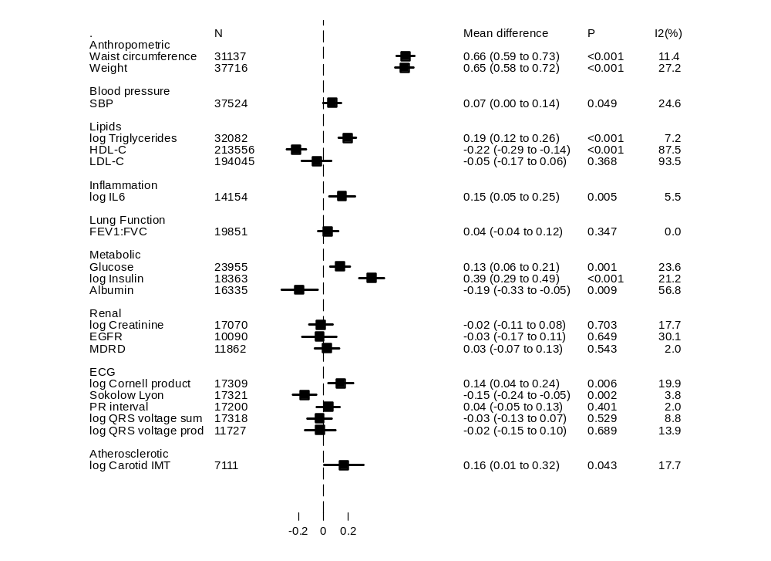

Footnotes:
Values represent mean difference per SD increase in BMI derived from conventional (IVW) Mendelian randomization analysis.
Non-normally distributed variables were natural ln transformed; therefore mean differences displayed on the log scale may be anti-logged and interpreted as percentage differences in SD of trait per SD in BMI
Log triglycerides from individual participant data studies only; GLGC triglycerides in Supplementary Table 10

Figure 1b – Association of WHRadjBMI with continuous biomarkers derived from Mendelian randomization analysis

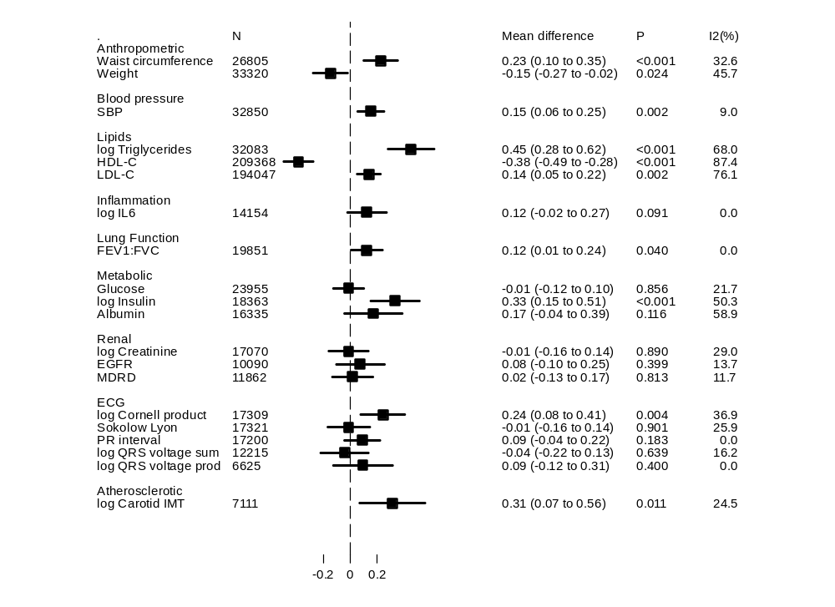

Footnotes:
Values represent mean difference per SD increase in WHRadjBMI derived from conventional (IVW) Mendelian randomization analysis.
Non-normally distributed variables were natural log transformed; therefore mean differences displayed on the log scale may be anti-logged and interpreted as percentage difference in SD of trait per SD in WHRadjBMI
Log triglycerides from individual participant data studies only; GLGC triglycerides in Supplementary Table 11

Figure 2a: Associations of adiposity with risk of CHD from observational and Mendelian randomization analyses

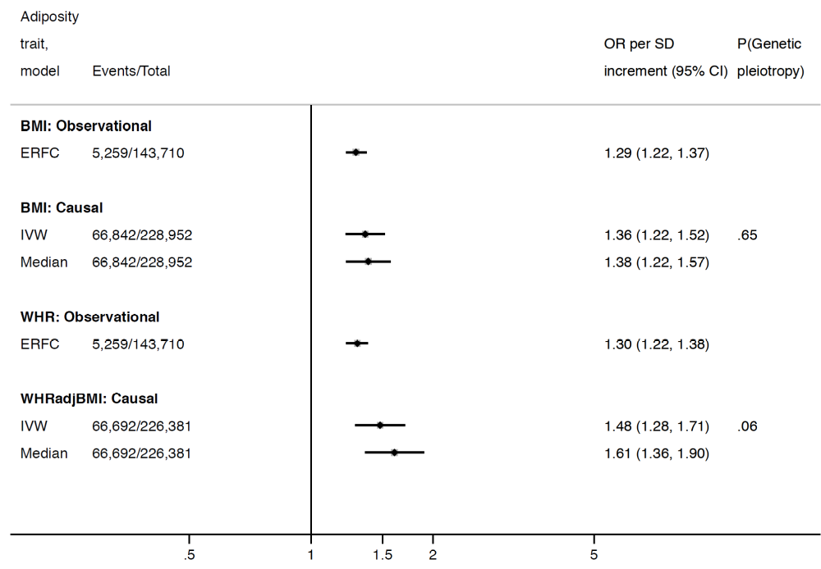

Association between coronary heart disease and adiposity (BMI and WHR adjusted for BMI) comparing causal odds ratios (OR) per SD of adiposity trait derived from instrumental variable analysis and observational analysis from the Emerging Risk Factors Consortium hazard ratio (HR per SD of BMI or waist:hip adjusted for age, sex and smoking status). Causal estimates are derived from Mendelian randomization and include conventional (ratio) approach and weighted median (see Methods for further details). P(genetic pleiotropy) relates to the P-value derived from the intercept of MR-Egger; a small P-value denotes presence of directional pleiotropy.

Figure 2b: Associations of adiposity with risk of ischaemic stroke from observational and Mendelian randomization analyses

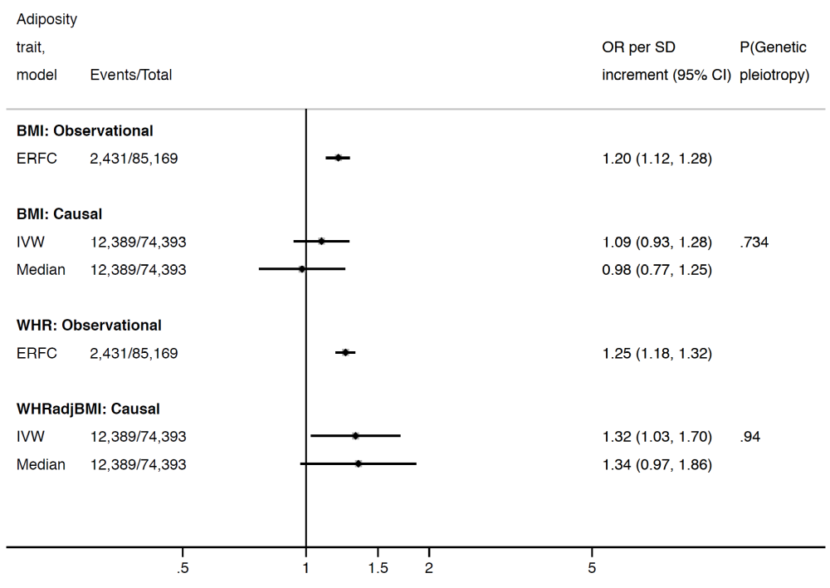

Association between ischaemic stroke and adiposity (BMI and WHR adjusted for BMI) comparing causal odds ratios (OR) per SD of adiposity trait derived from instrumental variable analysis and observational analysis from the Emerging Risk Factors Consortium (HR of ischaemic stroke per SD of BMI or waist:hip adjusted for age, sex and smoking status). Causal estimates are derived from Mendelian randomization and include conventional (ratio) approach and weighted median (see Methods for further details). P(genetic pleiotropy) relates to the P-value derived from the intercept of MR-Egger; a small P-value denotes presence of directional pleiotropy.

Figure 2c: Associations of adiposity with risk of T2D from observational and Mendelian randomization analyses

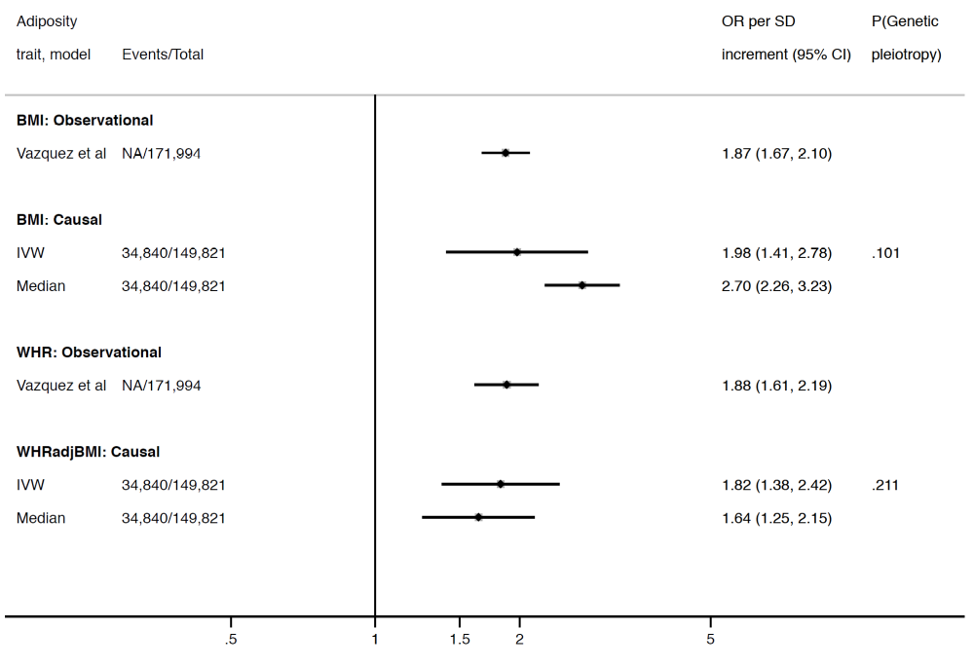

Association between T2D and adiposity (BMI and WHR adjusted for BMI) comparing causal odds ratios (OR) per SD of adiposity trait derived from instrumental variable analysis and observational analysis from Vazquez et al., 2007. Causal estimates are derived from Mendelian randomization and include conventional (ratio) approach and weighted median (see Methods for further details). P(genetic pleiotropy) relates to the P-value derived from the intercept of MR-Egger; a small P-value denotes presence of directional pleiotropy.

Table 1: Mendelian randomization estimates for the association of adiposity and stroke sub-types

 | IVW |  |  |  |  |  |  | Weighted median
 | OR | LCI | UCI | I² |  | P(Genetic pleiotropy) | OR | LCI |  | UCI
BMI
All ischaemic stroke | 1.09 | (0.93, | 1.28) | 20% | 0.734 |  | 0.98 | (0.77, |  | 1.25)
Cardioembolic | 1.18 | (0.89, | 1.55) | 0% | 0.507 |  | 1.40 | (0.87, |  | 2.24)
Large vessel disease | 1.14 | (0.82, | 1.59) | 19% | 0.625 |  | 1.12 | (0.65, |  | 1.91)
Small vessel disease | 0.93 | (0.64, | 1.35) | 30% | 0.270 |  | 1.15 | (0.67, |  | 1.97)
Haemorrhagic stroke | 1.51 | (0.73, | 3.13) | 0% | 0.435 |  | 1.28 | (0.37, |  | 4.40)
WHRadjBMI
All ischaemic stroke | 1.32 | (1.03, | 1.70) | 38% | 0.936 |  | 1.34 | (0.96, |  | 1.87)
Cardioembolic | 1.24 | (0.84, | 1.83) | 0% | 0.588 |  | 1.32 | (0.73, |  | 2.38)
Large vessel disease | 1.37 | (0.90, | 2.09) | 0% | 0.470 |  | 0.87 | (0.48, |  | 1.58)
Small vessel disease | 1.57 | (0.98, | 2.51) | 13% | 0.861 |  | 1.71 | (0.89, |  | 3.29)
Haemorrhagic stroke | 1.89 | (0.69, | 5.18) | 0% | 0.430 |  | 1.73 | (0.42, |  | 7.06)

IVW: inverse variance weighted (also termed ‘conventional’ MR) and weighted median. P(genetic pleiotropy) relates to the P-value derived from the intercept of MR-Egger; a small P-value denotes presence of directional pleiotropy.

Appendix: Sources of summary data/ beta weights from genome-wide association consortia

GIANT
BMI and WHRadjBMI data were obtained from the GIANT consortium. The Genetic Investigation of ANthropometric Traits (GIANT) consortium is an international collaboration that seeks to identify genetic loci that modulate human body size and shape, including height and measures of obesity. The GIANT consortium is a collaboration between investigators from many different groups, institutions, countries, and studies, and the results represent their combined efforts. The primary approach has been meta-analysis of genome-wide association data and other large-scale genetic data sets. Anthropometric traits that have been studied by GIANT include body mass index (BMI), height, and traits related to waist circumference (such as waist-hip ratio adjusted for BMI, or WHRadjBMI). Thus far, the GIANT consortium has identified common genetic variants at hundreds of loci that are associated with anthropometric traits.
https://www.broadinstitute.org/collaboration/giant/index.php/GIANT_consortium

CARDIoGRAMplusC4D
CARDIoGRAMplusC4D (Coronary ARtery DIsease Genome wide Replication and Meta-analysis (CARDIoGRAM) plus The Coronary Artery Disease (C4D) Genetics) consortium represents a collaborative effort to combine data from multiple large scale genetic studies to identify risk loci for coronary artery disease and myocardial infarction.CARDIoGRAMplusC4D Metabochip is a two stage meta-analysis of Metabochip and GWAS studies of European and South Asian descent involving 63,746 cases and 130,681 controls. The CARDIoGRAM GWAS data was used as Stage 1 - data as published in: CARDIoGRAMplusC4D Consortium, Deloukas P, Kanoni S, Willenborg C, Farrall M, Assimes TL, Thompson JR, Ingelsson E, Saleheen D, Erdmann J, Goldstein BA, Stirrups K, König IR,Cazier JB, Johansson A, Hall AS, Lee JY, Willer CJ, Chambers JC, Esko T, Folkersen L, Goel A, Grundberg E, Havulinna AS, Ho WK, Hopewell JC, Eriksson N, Kleber ME, Kristiansson K,Lundmark P, Lyytikäinen LP, Rafelt S, Shungin D, Strawbridge RJ, Thorleifsson G, Tikkanen E,Van Zuydam N, Voight BF, Waite LL, Zhang W, Ziegler A, Absher D, Altshuler D, Balmforth AJ,Barroso I, Braund PS, Burgdorf C, Claudi-Boehm S, Cox D, Dimitriou M, Do R, DIAGRAM Consortium, CARDIOGENICS Consortium, Doney AS, El Mokhtari N, Eriksson P, Fischer K,Fontanillas P, Franco-Cereceda A, Gigante B, Groop L, Gustafsson S, Hager J, Hallmans G,Han BG, Hunt SE, Kang HM, Illig T, Kessler T, Knowles JW, Kolovou G, Kuusisto J,Langenberg C, Langford C, Leander K, Lokki ML, Lundmark A, McCarthy MI, Meisinger C,Melander O, Mihailov E, Maouche S, Morris AD, Müller-Nurasyid M, MuTHER Consortium,Nikus K, Peden JF, Rayner NW, Rasheed A, Rosinger S, Rubin D, Rumpf MP, Schäfer A,Sivananthan M, Song C, Stewart AF, Tan ST, Thorgeirsson G, van der Schoot CE, Wagner PJ,Wellcome Trust Case Control Consortium, Wells GA, Wild PS, Yang TP, Amouyel P, Arveiler D,Basart H, Boehnke M, Boerwinkle E, Brambilla P, Cambien F, Cupples AL, de Faire U,Dehghan A, Diemert P, Epstein SE, Evans A, Ferrario MM, Ferrières J, Gauguier D, Go AS,Goodall AH, Gudnason V, Hazen SL, Holm H, Iribarren C, Jang Y, Kähönen M, Kee F, Kim HS,Klopp N, Koenig W, Kratzer W, Kuulasmaa K, Laakso M, Laaksonen R, Lee JY, Lind L,Ouwehand WH, Parish S, Park JE, Pedersen NL, Peters A, Quertermous T, Rader DJ,Salomaa V, Schadt E, Shah SH, Sinisalo J, Stark K, Stefansson K, Trégouët DA, Virtamo J,Wallentin L, Wareham N, Zimmermann ME, Nieminen MS, Hengstenberg C, Sandhu MS,Pastinen T, Syvänen AC, Hovingh GK, Dedoussis G, Franks PW, Lehtimäki T, Metspalu A,Zalloua PA, Siegbahn A, Schreiber S, Ripatti S, Blankenberg SS, Perola M, Clarke R, Boehm BO, O'Donnell C, Reilly MP, März W, Collins R, Kathiresan S, Hamsten A, Kooner JS,Thorsteinsdottir U, Danesh J, Palmer CN, Roberts R, Watkins H, Schunkert H and Samani NJ; Large-scale association analysis identifies new risk loci for coronary artery disease. Nat Genet 2013 45:25-33
http://www.cardiogramplusc4d.org/

METASTROKE
Ischaemic stroke data were obtained from the METASTROKE consortium. The METASTROKE consortium is supported by NINDS (NS017950). We thank all study participants, volunteers, and study personnel that made this consortium possible. The METASTROKE study consists of combined data from 15 GWAS of IS (12 389 cases vs 62 004 controls). We used TOAST criteria17 to classify IS as large artery stroke (LAS) (2167 cases/49 159 controls from 11 studies), cardioembolic stroke (CE) (2365 cases/ 56,140 controls from 13 studies), and small vessel disease (SVD) (1894 cases/51 976 controls from 12 studies). METASTROKE studies consisted of independently performed genome-wide single nucleotide polymorphism (SNP) genotyping using standard technologies and imputation to HapMap release 21 or 22 CEU phased genotype18 or 1000 Genome
reference panels. Investigators contributed summary statistical data from association analyses using frequentist additive models for metaanalysis after application of appropriate quality control measures.

DIAGRAM
The DIAGRAM (DIAbetes Genetics Replication And Meta-analysis) consortium is a grouping of researchers with shared interests in performing large-scale studies to characterise the genetic basis of type 2 diabetes, and a principal focus on samples of European descent. The membership and scope of DIAGRAM has developed as the scale of collaboration in the field has increased. The initial instance of DIAGRAM (retrospectively termed "DIAGRAM v1") enabled the combination of T2D genome wide association (GWA) studies from the UK (WTCCC), DGI and FUSION groups: this meta-analysis, and consequent replication, resulted in identification of six novel signals influencing T2D risk (Zeggini E, Scott LJ, Saxena R, Voight BF, Marchini JL, Hu T, de Bakker PI, Abecasis GR, Almgren P, Andersen G, Ardlie K, Boström KB, Bergman RN, Bonnycastle LL, Borch-Johnsen K, Burtt NP, Chen H, Chines PS, Daly MJ, Deodhar P, Ding CJ, Doney AS, Duren WL, Elliott KS, Erdos MR, Frayling TM, Freathy RM, Gianniny L, Grallert H, Grarup N, Groves CJ, Guiducci C, Hansen T, Herder C, Hitman GA, Hughes TE, Isomaa B, Jackson AU, Jørgensen T, Kong A, Kubalanza K, Kuruvilla FG, Kuusisto J, Langenberg C, Lango H, Lauritzen T, Li Y, Lindgren CM, Lyssenko V, Marvelle AF, Meisinger C, Midthjell K, Mohlke KL, Morken MA, Morris AD, Narisu N, Nilsson P, Owen KR, Palmer CN, Payne F, Perry JR, Pettersen E, Platou C, Prokopenko I, Qi L, Qin L, Rayner NW, Rees M, Roix JJ, Sandbaek A, Shields B, Sjögren M, Steinthorsdottir V, Stringham HM, Swift AJ, Thorleifsson G, Thorsteinsdottir U, Timpson NJ, Tuomi T, Tuomilehto J, Walker M, Watanabe RM, Weedon MN, Willer CJ; Wellcome Trust Case Control Consortium, Illig T, Hveem K, Hu FB, Laakso M, Stefansson K, Pedersen O, Wareham NJ, Barroso I, Hattersley AT, Collins FS, Groop L, McCarthy MI, Boehnke M, Altshuler D., Nature Genetics 2008;40(5):638-45). An incremental meta-analysis ("DIAGRAM v2" or "DIAGRAM+") adding GWA data from a further five studies (DGDG, KORA, Rotterdam, DeCODE, EUROSPAN for a total of 8,130 cases and 38,987 controls) together with extensive replication involving 20 other cohorts, was central to identification of a further 17 loci (Voight BF, Scott LJ, Steinthorsdottir V, Morris AP, Dina C, Welch RP, Zeggini E, Huth C, Aulchenko YS, Thorleifsson G, McCulloch LJ, Ferreira T, Grallert H, Amin N, Wu G, Willer CJ, Raychaudhuri S, McCarroll SA, Langenberg C, Hofmann OM, Dupuis J, Qi L, Segrè AV, van Hoek M, Navarro P, Ardlie K, Balkau B, Benediktsson R, Bennett AJ, Blagieva R, Boerwinkle E, Bonnycastle LL, Bengtsson Boström K, Bravenboer B, Bumpstead S, Burtt NP, Charpentier G, Chines PS, Cornelis M, Couper DJ, Crawford G, Doney AS, Elliott KS, Elliott AL, Erdos MR, Fox CS, Franklin CS, Ganser M, Gieger C, Grarup N, Green T, Griffin S, Groves CJ, Guiducci C, Hadjadj S, Hassanali N, Herder C, Isomaa B, Jackson AU, Johnson PR, Jørgensen T, Kao WH, Klopp N, Kong A, Kraft P, Kuusisto J, Lauritzen T, Li M, Lieverse A, Lindgren CM, Lyssenko V, Marre M, Meitinger T, Midthjell K, Morken MA, Narisu N, Nilsson P, Owen KR, Payne F, Perry JR, Petersen AK, Platou C, Proença C, Prokopenko I, Rathmann W, Rayner NW, Robertson NR, Rocheleau G, Roden M, Sampson MJ, Saxena R, Shields BM, Shrader P, Sigurdsson G, Sparsø T, Strassburger K, Stringham HM, Sun Q, Swift AJ, Thorand B, Tichet J, Tuomi T, van Dam RM, van Haeften TW, van Herpt T, van Vliet-Ostaptchouk JV, Walters GB, Weedon MN, Wijmenga C, Witteman J, Bergman RN, Cauchi S, Collins FS, Gloyn AL, Gyllensten U, Hansen T, Hide WA, Hitman GA, Hofman A, Hunter DJ, Hveem K, Laakso M, Mohlke KL, Morris AD, Palmer CN, Pramstaller PP, Rudan I, Sijbrands E, Stein LD, Tuomilehto J, Uitterlinden A, Walker M, Wareham NJ, Watanabe RM, Abecasis GR, Boehm BO, Campbell H, Daly MJ, Hattersley AT, Hu FB, Meigs JB, Pankow JS, Pedersen O, Wichmann HE, Barroso I, Florez JC, Frayling TM, Groop L, Sladek R, Thorsteinsdottir U, Wilson JF, Illig T, Froguel P, van Duijn CM, Stefansson K, Altshuler D, Boehnke M, McCarthy MI; MAGIC investigators; GIANT Consortium., Nature Genetics 2010;42(7):579-89). Whilst in the Voight (2010) paper, GWA data from the Framingham, ARIC and NHS studies was only used for in silico replication, the full data from these studies was subsequently combined to constitute the largest current GWA dataset in samples of European descent ("DIAGRAMv3": 12,171 cases and 56,862 controls). This data set was used as the basis for the selection of SNPs for T2D replication for the Metabochip custom array, and a manuscript describing the integration of DIAGRAM v3 and Metabochip data (a combined total of ~150k individuals) was published in 2012 (Morris AP, Voight BF, Teslovich TM, Ferreira T, Segrè AV, Steinthorsdottir V, Strawbridge RJ, Khan H, Grallert H, Mahajan A, Prokopenko I, Kang HM, Dina C, Esko T, Fraser RM, Kanoni S, Kumar A, Lagou V, Langenberg C, Luan J, Lindgren CM, Müller-Nurasyid M, Pechlivanis S, Rayner NW, Scott LJ, Wiltshire S, Yengo L, Kinnunen L, Rossin EJ, Raychaudhuri S, Johnson AD, Dimas AS, Loos RJ, Vedantam S, Chen H, Florez JC, Fox C, Liu CT, Rybin D, Couper DJ, Kao WH, Li M, Cornelis MC, Kraft P, Sun Q, van Dam RM, Stringham HM, Chines PS, Fischer K, Fontanillas P, Holmen OL, Hunt SE, Jackson AU, Kong A, Lawrence R, Meyer J, Perry JR, Platou CG, Potter S, Rehnberg E, Robertson N, Sivapalaratnam S, Stancáková A, Stirrups K, Thorleifsson G, Tikkanen E, Wood AR, Almgren P, Atalay M, Benediktsson R, Bonnycastle LL, Burtt N, Carey J, Charpentier G, Crenshaw AT, Doney AS, Dorkhan M, Edkins S, Emilsson V, Eury E, Forsen T, Gertow K, Gigante B, Grant GB, Groves CJ, Guiducci C, Herder C, Hreidarsson AB, Hui J, James A, Jonsson A, Rathmann W, Klopp N, Kravic J, Krjutskov K, Langford C, Leander K, Lindholm E, Lobbens S, Männistö S, Mirza G, Mühleisen TW, Musk B, Parkin M, Rallidis L, Saramies J, Sennblad B, Shah S, Sigurðsson G, Silveira A, Steinbach G, Thorand B, Trakalo J, Veglia F, Wennauer R, Winckler W, Zabaneh D, Campbell H, van Duijn C, Uitterlinden AG, Hofman A, Sijbrands E, Abecasis GR, Owen KR, Zeggini E, Trip MD, Forouhi NG, Syvänen AC, Eriksson JG, Peltonen L, Nöthen MM, Balkau B, Palmer CN, Lyssenko V, Tuomi T, Isomaa B, Hunter DJ, Qi L; Wellcome Trust Case Control Consortium; Meta-Analyses of Glucose and Insulin-related traits Consortium (MAGIC) Investigators; Genetic Investigation of ANthropometric Traits (GIANT) Consortium; Asian Genetic Epidemiology Network-Type 2 Diabetes (AGEN-T2D) Consortium; South Asian Type 2 Diabetes (SAT2D) Consortium, Shuldiner AR, Roden M, Barroso I, Wilsgaard T, Beilby J, Hovingh K, Price JF, Wilson JF, Rauramaa R, Lakka TA, Lind L, Dedoussis G, Njølstad I, Pedersen NL, Khaw KT, Wareham NJ, Keinanen-Kiukaanniemi SM, Saaristo TE, Korpi-Hyövälti E, Saltevo J, Laakso M, Kuusisto J, Metspalu A, Collins FS, Mohlke KL, Bergman RN, Tuomilehto J, Boehm BO, Gieger C, Hveem K, Cauchi S, Froguel P, Baldassarre D, Tremoli E, Humphries SE, Saleheen D, Danesh J, Ingelsson E, Ripatti S, Salomaa V, Erbel R, Jöckel KH, Moebus S, Peters A, Illig T, de Faire U, Hamsten A, Morris AD, Donnelly PJ, Frayling TM, Hattersley AT, Boerwinkle E, Melander O, Kathiresan S, Nilsson PM, Deloukas P, Thorsteinsdottir U, Groop LC, Stefansson K, Hu F, Pankow JS, Dupuis J, Meigs JB, Altshuler D, Boehnke M, McCarthy MI; DIAbetes Genetics Replication And Meta-analysis (DIAGRAM) Consortium, Nature Genetics 2012;44(9):981-90). Summary data from this analysis are available at http://diagram-consortium.org/downloads.html
GLOBAL LIPIDS GENETICS CONSORTIUM
Lipids data were obtained from the Global Lipids Genetics Consortium website (GLGC). GLGC started in 2006 with a genome-wide association analysis for plasma lipids within the Diabetes Genetics Initiative Study led by D. Altshuler and L. Groop. The collaborative research network involves >200 investigators from more than 80 institutions. GLGC includes 94,595 individuals from 23 studies genotyped with genome-wide association study (GWAS) arrays and 93,982 individuals from 37 studies genotyped with the Metabochip array. The Genomics Platform at the Broad Institute, led by S. Gabriel, has performed the bulk of the genotyping and sequencing.
Global Lipids Genetics Consortium., Willer CJ, Schmidt EM, Sengupta S, Peloso GM, Gustafsson S, Kanoni S, Ganna A, Chen J, Buchkovich ML, Mora S, Beckmann JS, Bragg-Gresham JL, Chang HY, Demirkan A, Den Hertog HM, Do R, Donnelly LA, Ehret GB, Esko T, Feitosa MF, Ferreira T, Fischer K, Fontanillas P, Fraser RM, Freitag DF, Gurdasani D, Heikkilä K, Hyppönen E, Isaacs A, Jackson AU, Johansson A, Johnson T, Kaakinen M, Kettunen J, Kleber ME, Li X, Luan J, Lyytikäinen LP, Magnusson PK, Mangino M, Mihailov E, Montasser ME, Müller-Nurasyid M, Nolte IM, O'Connell JR, Palmer CD, Perola M, Petersen AK, Sanna S, Saxena R, Service SK, Shah S, Shungin D, Sidore C, Song C, Strawbridge RJ, Surakka I, Tanaka T, Teslovich TM, Thorleifsson G, Van den Herik EG, Voight BF, Volcik KA, Waite LL, Wong A, Wu Y, Zhang W, Absher D, Asiki G, Barroso I, Been LF, Bolton JL, Bonnycastle LL, Brambilla P, Burnett MS, Cesana G, Dimitriou M, Doney AS, Döring A, Elliott P, Epstein SE, Eyjolfsson GI, Gigante B, Goodarzi MO, Grallert H, Gravito ML, Groves CJ, Hallmans G, Hartikainen AL, Hayward C, Hernandez D, Hicks AA, Holm H, Hung YJ, Illig T, Jones MR, Kaleebu P, Kastelein JJ, Khaw KT, Kim E, Klopp N, Komulainen P, Kumari M, Langenberg C, Lehtimäki T, Lin SY, Lindström J, Loos RJ, Mach F, McArdle WL, Meisinger C, Mitchell BD, Müller G, Nagaraja R, Narisu N, Nieminen TV, Nsubuga RN, Olafsson I, Ong KK, Palotie A, Papamarkou T, Pomilla C, Pouta A, Rader DJ, Reilly MP, Ridker PM, Rivadeneira F, Rudan I, Ruokonen A, Samani N, Scharnagl H, Seeley J, Silander K, Stancáková A, Stirrups K, Swift AJ, Tiret L, Uitterlinden AG, van Pelt LJ, Vedantam S, Wainwright N, Wijmenga C, Wild SH, Willemsen G, Wilsgaard T, Wilson JF, Young EH, Zhao JH, Adair LS, Arveiler D, Assimes TL, Bandinelli S, Bennett F, Bochud M, Boehm BO, Boomsma DI, Borecki IB, Bornstein SR, Bovet P, Burnier M, Campbell H, Chakravarti A, Chambers JC, Chen YD, Collins FS, Cooper RS, Danesh J, Dedoussis G, de Faire U, Feranil AB, Ferrières J, Ferrucci L, Freimer NB, Gieger C, Groop LC, Gudnason V, Gyllensten U, Hamsten A, Harris TB, Hingorani A, Hirschhorn JN, Hofman A, Hovingh GK, Hsiung CA, Humphries SE, Hunt SC, Hveem K, Iribarren C, Järvelin MR, Jula A, Kähönen M, Kaprio J, Kesäniemi A, Kivimaki M, Kooner JS, Koudstaal PJ, Krauss RM, Kuh D, Kuusisto J, Kyvik KO, Laakso M, Lakka TA, Lind L, Lindgren CM, Martin NG, März W, McCarthy MI, McKenzie CA, Meneton P, Metspalu A, Moilanen L, Morris AD, Munroe PB, Njølstad I, Pedersen NL, Power C, Pramstaller PP, Price JF, Psaty BM, Quertermous T, Rauramaa R, Saleheen D, Salomaa V, Sanghera DK, Saramies J, Schwarz PE, Sheu WH, Shuldiner AR, Siegbahn A, Spector TD, Stefansson K, Strachan DP, Tayo BO, Tremoli E, Tuomilehto J, Uusitupa M, van Duijn CM, Vollenweider P, Wallentin L, Wareham NJ, Whitfield JB, Wolffenbuttel BH, Ordovas JM, Boerwinkle E, Palmer CN, Thorsteinsdottir U, Chasman DI, Rotter JI, Franks PW, Ripatti S, Cupples LA, Sandhu MS, Rich SS, Boehnke M, Deloukas P, Kathiresan S, Mohlke KL, Ingelsson E, Abecasis GR., Discovery and refinement of loci associated with lipid levels. Nature genetics. Nov 2013;45(11):1274-1283.
http://csg.sph.umich.edu//abecasis/public/lipids2013/

