Sensing Mechanisms of Nanoscale Physical Properties of the Cell Microenvironment

**Stefania Di Cio1,2 and Julien E. Gautrot1,2\***

**\*Corresponding author. j.gautrot@qmul.ac.uk**

**1Institute of Bioengineering and 2School of Engineering and Materials Science, Queen Mary, University of London, Mile End Road, London, E1 4NS, UK.**

**Abstract**

The chemistry, geometry, topography and mechanical properties of biomaterials modulate other biochemical signals (in particular ligand-receptor binding events) that control cells-matrix interactions. In turn, the regulation of cell adhesion by the biochemical and physical properties of the matrix controls cell phenotypes such as proliferation, motility and differentiation. In particular, nanoscale geometrical, topographical and mechanical properties of biomaterials are key in achieving such control of the cell-biomaterials interface. The design of such nanoscale architectures and platforms requires understanding some of the molecular mechanisms underlying adhesion formation and the assembly of the actin cytoskeleton. This review presents some of the key molecular mechanisms underlying cell adhesion and discusses some of the nanoscale engineered platforms used to control these processes. Such nanoscale understanding of the cell-biomaterials interface offers exciting opportunities for the design of biomaterials and their application to the field of tissue engineering.

**Keywords**

Nanotechnology, nanopatterning, biomaterials, cell adhesion, focal adhesion, cytoskeleton

# Introduction

In recent years, the reconstruction and regeneration of human tissues that have been damaged by accident or are seriously compromised by diseases such as cancers or cardiovascular and neuro-degenerative diseases, has been the focus of significant efforts from the biomedical community. Tissue engineering and regenerative medicine aim to develop scaffolds combining biomaterials and cells that mimic some of the characteristics of the tissue they are replacing. Despite the fast progress in the range and quality of materials used, our understanding of the interface between cells and their microenvironment (in this context at cell-material interfaces) remains incomplete. This is a key point in the quest for the design of devices that closely mimic the extracellular matrix and the cell microenvironment and control and facilitate the growth and proliferation of cells and their remodelling of the matrix, leading to tissue reconstruction.

Cell adhesion to neighbours and to extracellular matrix (ECM, a complex network of proteins and polysaccharides secreted and assembled by cells) is essential to maintain tissue structure and mechanical integrity. These interactions are mediated by transmembrane cell-cell and cell-matrix adhesion molecules, providing a direct connection between neighbouring cells or ECM proteins and the cell cytoskeleton. Such molecular networks are not only fundamental to confer an architecture to cells and tissues (their shape, architecture and mechanical strength), control the orientation and localisation of subcellular organelles and cell polarity, but also for signal transduction [1-3]. The signals transduced from the exterior of the cell and the cytoplasm (as well as the nucleus) through a variety of pathways regulate cell behaviour and associated patterns of gene expression. In addition, an increasing number of reports provide evidence that physical properties of the cell micro-environment such as matrix rigidity, topography and geometry modulate biochemical cues mediated by these molecular networks. Comprehending the detailed mechanism via which molecular interactions allow cells to sense such physical properties is essential to the design of artificial ECM and biomaterials for tissue engineering and regenerative medicine applications. This review will focus on our understanding of the mechanisms underlying the sensing of the physical cellular environment at the nanoscale, with an emphasis on integrin mediated processes. Molecular mechanisms controlling the formation of integrin-mediated adhesions and their anchorage to the cell cytoskeleton are essential to such understanding.

# Nanoscale architecture and dynamics of the cytoskeleton and integrin-mediated adhesions.

The formation of cell adhesions, whether to natural extra-cellular matrix or to synthetic biomaterials, relies on the self-assembly of molecular complexes that are inherently structured at the nanoscale although often extending in size up to the microscale. These adhesions are often associated with nanoscale sensing of surface properties, although other mechanisms have also been highlighted. Hence understanding the molecular processes underlying cell adhesion, the architecture of relevant complexes and their dynamics is essential to understand the response of cells to nanoscale physico-chemical properties of biomaterials.

## 2.1 Focal adhesion structure and dynamics

In eukaryotic cells, adhesion to the ECM is primarily occurring via transmembrane heterodimers of the integrin family, resulting from the noncovalent association of two glycoprotein subunits α and β, which span the cell membrane and bind ECM molecules on the extra-cellular part and other adhesion-associated proteins in the cytoplasmic part [4] . The main types of ECM proteins are collagen, fibronectin and laminin. Once integrins adhere to such molecules, they are activated and cluster into nascent adhesions[5]. Integrins associate with a number of other cytoplasmic proteins, which provide a structural link between the membrane receptors and the actin cytoskeleton and can act as signalling molecules. These complexes evolve at the plasma membrane as the number of involved molecules increases and the mechanical strength of the adhesion becomes stronger [6, 7]. At early stages of this process, small (0.5-1 µm in diameter) transient "dot-like" contacts (the focal complexes) are formed [8]. These structures are localized at cell protrusions called lamellipodia resulting from the polymerisation of a dense actin gel, which arises at the front edge of migrating or spreading cells [9]. Some of these complexes evolve into mature, elongated structures known as focal contacts or focal adhesions (FAs, 3-10 µm) which couple with actin and sustain the assembly of filament bundles and associated molecules such as myosins [10, 11]. The early stages of these processes occur at two distinctly organized and dynamic structures, the lamella and lamellipodium. Lamellipodia are rapidly forming and retracting protrusions that probe the ECM [12]. Lamellae are connected to the actomyosin network and associated forces and adhesion site and sustain more stable adhesions.

FAs not only provide a mechanical link between the ECM and the cytoskeleton, but also act as mechanosensors, at the top of signalling pathways regulating cell phenotype [13-15].

At early stages of integrin clustering, a number of proteins are recruited at FAs, linking integrins and the cytoskeleton and falling into two distinct families: proteins that directly associate with integrins (talin, -actinin and filamin) and those that bind indirectly [16]. Amongst these proteins, those that also directly bind the cytoskeleton play an important role in the regulation of FA assembly, cell adhesion and migration. Proteins that indirectly bind to integrins, such as vinculin (which binds to talin) and other adaptor and regulatory proteins, as VASP (vasodilator-stimulated phosphoprotein), zyxin, paxillin, p130Cas, focal adhesion kinase (FAK) and integrin-linked kinase (ILK), sustain the formation and stability of actin stress fibres and regulate cross-talking and signalling with the aforementioned molecules [5].

Focal adhesion structure and dynamics (assembly, disassembly and turnover) is of fundamental importance for the reorganization of adhesive contacts and during cell migration. During these processes, new adhesions are formed at the front edge of the cell, mature and couple to the cytoskeleton and disassemble at the rear edge of the cell, associated with retraction fibres. The correct orchestration of the dynamics of these processes is essential to maintain cell spreading and control cell locomotion.

### Nanoscale structure of focal adhesions

Given the complex collection of molecular processes involved in integrin-mediated cell adhesion, the nanoscale structure of adhesion sites and the dynamics of molecular processes involved are essential to understand cell adhesion and migration. Recently, advances in microscopy techniques such as super-resolution techniques PALM [17, 18] and STORM [19], FRET [20, 21], TIRF [22], TEM [23, 24] and Electron Tomography (EM- development of TEM where data are acquired at different angles to allow the reconstruction of a high resolution 3D image) [25], provided some insight into the nanoscale, molecular, structure of cell adhesions.

TEM (transmission electron microscopy) is an imaging technique frequently used for the characterisation of biological samples and providing nanoscale resolution of sub-cellular structures. FAs were successfully visualized using this technique in a number of studies. Smith et al. [24] assessed the effect of cyclic strain on smooth muscle cells. TEM and talin immunostaining were used to visualize actin and FA organization under stress and in static conditions. Cells orienting perpendicular to strain were more elongated and both techniques confirmed that longer FAs along the cell membrane- substratum interface formed.

Combining fluorescent microscopy (and immuno-staining for FA-associated proteins such as paxillin) with cryo-electron tomography (an EM technique) enabled to image cell protrusions at higher resolution. An important disadvantage of electron microscopy techniques is the lack of specific information regarding the biochemical composition of the structures imaged. Hence correlated microscopy techniques are particularly attractive to combine the benefits of traditional fluorescence and confocal microscopy with higher resolution electron microscopy. Correlated cryo-electron tomography and fluorescent microscopy showed differences in the orientation of actin filaments in the core and periphery of FAs, with peripheral fibres being parallel to the long axis of the adhesion [25]. Below the actin bundle, at the cell membrane interface, small ring-shaped structures (20-30 nm diameter) were observed, which generally aggregate into “islands” depending on the organization of interacting fibres. They are thought to contribute to the link between the cytoskeleton and the membrane because they also tightly associate with vinculin-rich regions.

Therefore, FAs display a multi-layered structure with nano-scale organization in the z-direction: the structure starts at the plasma membrane with integrins, followed by a layer of adapter proteins including vinculin (evidenced in this study using gold nanoparticles), followed by short fibres connected with the stress fibres. By using photoactivated localization microscopy (PALM) Shroff et al. [17] provided strong evidence for the colocalization of proteins forming adhesions. α-actinin and vinculin partially overlap, with α-actinin being tightly associated to stress fibers while vinculin being apparently randomly distributed along adhesion sites. Paxillin and actin were not found to be spatially correlated, although some areas of clustering were observed. Overall, the architecture of FAs displays three layers (within 40 nm) separating the actin network from the cell membrane-associated plane at which the tails of integrin molecules are found (Figure 1) [18]: a first “integrin signalling layer” comprising FAK and paxillin; a “force transduction layer” comprising talin and vinculin and a final “actin-regulatory layer” including zyxin, VASP and α-actinin. Such well-defined architecture possibly underlies how forces are transmitted from the ECM, through the cell membrane, up to the actin cytoskeleton.

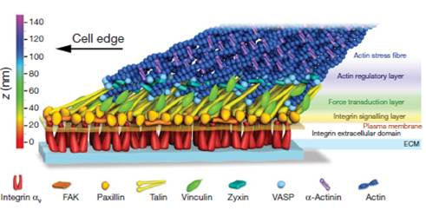

Figure 1. Schematic representation of thearchitecture of focal adhesions [18].

### Dynamics of focal adhesions

The structure of FAs must be tightly connected to the function that each molecule of the adhesome (the ensemble of molecules forming FAs) performs, in order to confer mechanical coupling. In addition, such structure and the localisation of associated proteins are inherently dynamic. Sensing of the extracellular environment, recruiting and release of molecules (turnover) and generation of the tension inside the adhesion sites are key features in understanding the adhesion process. Hence, understanding the dynamics of FA formation and temporal organization is essential to the full understanding of FA mechano-biology.

There are a number of adaptor proteins that do not function as a link with the cytoskeleton, but are signalling proteins: all the kinase (like FAK, MAPKs, Fyn, Src and ILK) and GTPase (Rap1, Rho, Rac) which contribute to FA maturation and cell motility (Stretchy Proteins on Stretchy Substrates: The Important Elements of Integrin-Mediated Rigidity Sensing). Dissecting the function and dynamics of FAs and associated proteins is perhaps better understood by reconstructing the path of signals transduction, starting from ECM binding and integrin activation and moving upward through the architecture of FAs, the recruitment of key proteins and force generation.

Several mechanisms have been proposed for integrin activation, which can be activated outside-in by sensing and binding ECM molecules and inside-out by recruiting talin and other adapter proteins [26]. Similarly, integrins can be activated via the binding of ECM proteins (normally in a fibrillar conformation), and fibrillogenesis requires mechanical tension to stretch ECM proteins and expose cryptic sites [27]. Other binding sites on ECM protein promote further integrin adhesion and increase biological activity [28, 29]. When adhering to the ECM, integrins form clusters (proposed to be composed of 3-4 molecules), or nascent adhesions [30]. Furthermore, these clusters are more stable in the central part of the cell while they are moving faster in areas of protrusion formation and retraction. FAs are also more dynamic in areas close to the leading edge where they probe the ECM and are coupled to membrane activity and actin retrograde flow [22, 31-33].

Different integrins also seem to accomplish different adhesive roles [34]. α5β1 is needed to strengthen adhesion to fibronectin, while mechanotransduction is controlled by αvβ3. Similarly, β1 integrins were found in nascent adhesions at cell protrusions, independently of myosin-II activity, whilst αv integrins promoted the formation of mature FAs mediating mechanosensing (Figure 2) [35]. Furthermore, β1 is stationary inside FAs (which could be connected to their role in strengthening the adhesion) while β3 undergoes a reward motion [36]. Hence, the association of these two heterodimers to the actin cytoskeleton appears to be different. Contrasting in another study, β3 integrin were found predominantly at the beginning of FA assembly, and β1 involved in mature adhesions [7]. Hence the synergistic effects of these two integrins allows FA maturation, but the mechanism underlying such processes is not clear as both integrin heterodimers are able to bind a wide range of adapter proteins.

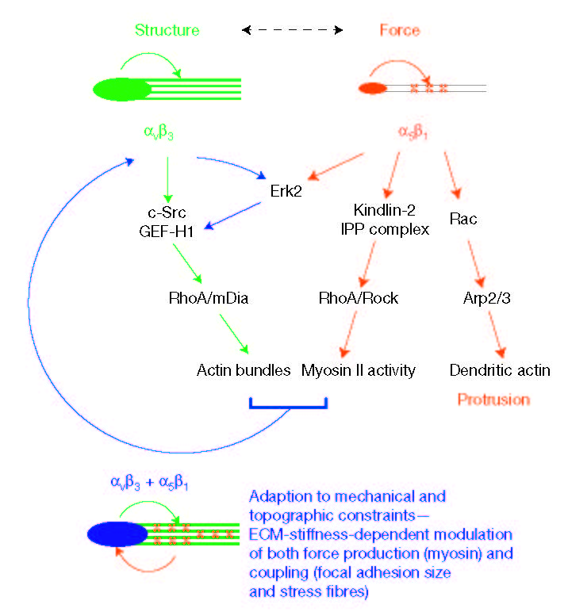

Figure 2. The role of α5β1 and αvβ3 in sensing the mechanics of the ECM [35].

Moving up along the structure connecting the ECM to the cell cytoskeleton, several adapter proteins directly or indirectly bind integrins. In this respect, -Actinin plays a dual role as adaptor protein, due to its direct binding to integrins, and as crosslinker molecule for actin [7]. Furthermore α-actinin competes with talin in binding β3 integrins (talin binds first and is then replaced by -actinin to allow force transmission), while they cooperate in binding β1. Talin plays a key role in inside-out integrin activation by connecting the integrin cytoplasmic tail to the actin cytoskeleton and presenting binding sites for other proteins, such as vinculin, paxillin, α-actinin and tensin, which are recruited in order to strengthen that binding. It exists in a closed conformation and needs to be activated to enable vinculin binding [37]. Its depletion is found not to influence initial cell spreading but to impair adhesion maturation and generation of forces [38].

One of the most studied adapter proteins is probably vinculin, due to its key role as a mechanotransducer. It is found in the cytoplasm but associates to FAs after opening of its conformation and activation [39]. Vinculin couples to talin in a force dependent manner as mechanical stretching of talin exposes cryptic binding sites [40]. Mechanical forces generated via actomyosin contractility activate vinculin molecules [41] and increase their binding to other adapter proteins such as talin or α-actinin. However, the relationship between vinculin recruitment, FA size and force generation is emerging as more complex. Not only is the recruitment of vinculin to FAs dependent on force transmission, but the stabilization of FAs is also reinforced when the vinculin recruited is under tension [21]. Of critical importance is the understanding of vinculin activation and the role of the different domains of the molecule. For the formation of FAs, vinculin has to bind talin as well as the cytoskeleton, processes that are controlled by distinct domains. Vinculin molecules lacking the tail domain colocalize with integrins (β1) [42], controlling the number and distribution of integrin complexes [41], and contribute to the formation of large FAs, colocalizing with talin and paxillin. The tail of vinculin appears instead to link with actin network (Figure 3) [43] and does not colocalize with paxillin. Therefore, the head and tail domains of vinculin regulate distinct functions, where the head interacts with integrins and talin, and the tail sustains force transmission via linking to the actin cytoskeleton. The molecular interactions that these two domains regulate directly control the nanoscale spatial segregation of vinculin within FAs. In addition, a combination of superresolution microscopy and a FRET biosensor highlighted that vinculin localisation shifts upwards, away from the cell membrane, during FA maturation, a reorganisation that contribute to the mechanical strengthening of FAs [44]. In addition, vinculin was found to orchestrate the dynamics of other FA proteins, either directly (α- actinin, talin, VASP, vinexins, ponsin, Arp2/3, paxillin and actin) and indirectly (zyxin, FAK, p130Cas, ILK, parvin, tensin), through a force-mediated mechanism [45].

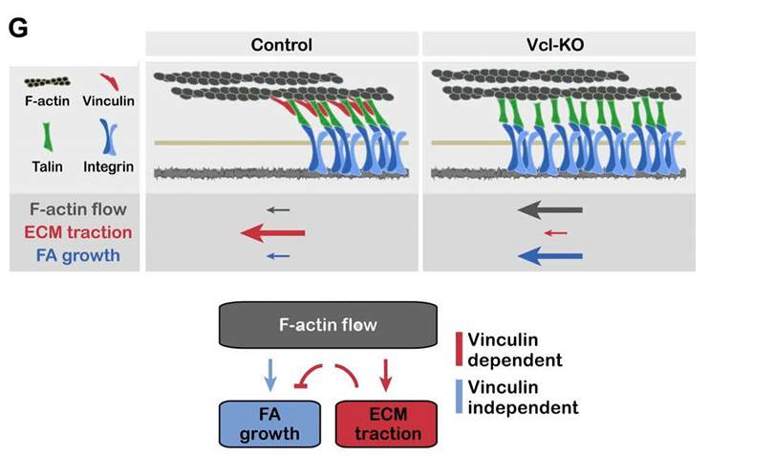

Figure 3. Vinculin regulation of FA maturation: vinculin affects F-actin flow velocity and FA growth rate [43].

High resolution techniques such as TIRF and PALM have helped resolving the dynamics of FAs.

Adhesions born at the cell edge normally present faster kinetics and play a role in probing the ECM (Figure 4). Adhesion complexes life cycle is generally constituted of different phases: formation, elongation, stabilization and merging with other adhesions, followed by disassembly at the rear of migrating cells or upon local disassembly of the actin network [32]. The study of paxillin flow in NIH 3T3 fibroblasts showed that adhesions arise in areas less than 5 µm from the cell edge and disassemble closer to the cell centre [22]. Adhesion complexes forming close to the cell edge were also spotted in Chinese hamster ovary (CHO). Paxillin turnover in these cells is around 60 s. Diffusion rate during disassembly are generally lower (0.02 ± 0.014 min-1) than assembly (0.031 ± 0.023 min-1). Similar rates were found for FAK dynamics although sizes of FAs observed were different for these two proteins [22]. α-Actinin is found in clusters with α5 integrins and the two flow together during the life cycle of the adhesion, but during disassembly α-actinin follows actin retrograde flow dynamics [30], suggesting a distinct role during this phase of the adhesion life cycle. Disassembly rate of α5 integrins was found to be 0.16 ± 0.02 min-1: much faster than values found for paxillin. Similar turnover kinetics were also found for other proteins in FAs (paxillin, vinculin, FAK and zyxin) [10].

The dynamics of proteins recruited at FAs was also reported to depend on adhesion size and stability [46]. Using simultaneous fluorescence loss in photobleaching (FLIP)-FRAP, the dynamics of recruitment of paxillin and FAK was quantified. FAK displayed a shorter residing time in FAs than paxillin, and size and strength of adhesions correlated with the recruitment dynamics of both proteins. With size increase, the rate of exchange of both proteins slows down while increasing adhesion strength gives rise to slower FAK turnover and the opposite happens for paxillin.

Hence, localization and recruitment of proteins is very dynamic and rely on several factors. This is also the case for force transmission. Using a tension sensor module based on fluorescence resonance energy transfer (FRET), forces exerted on vinculin molecules during FA assembly (when a maximum force is detected) and disassembly was studied [25]. Forces were high at small adhesions forming at the leading edge and slightly decreased during size maturation. Finally, tension decreases rapidly during the retraction and disassembly stage. This highlights the dynamic nature of vinculin recruitment, and other FA-associated proteins, and force generation.

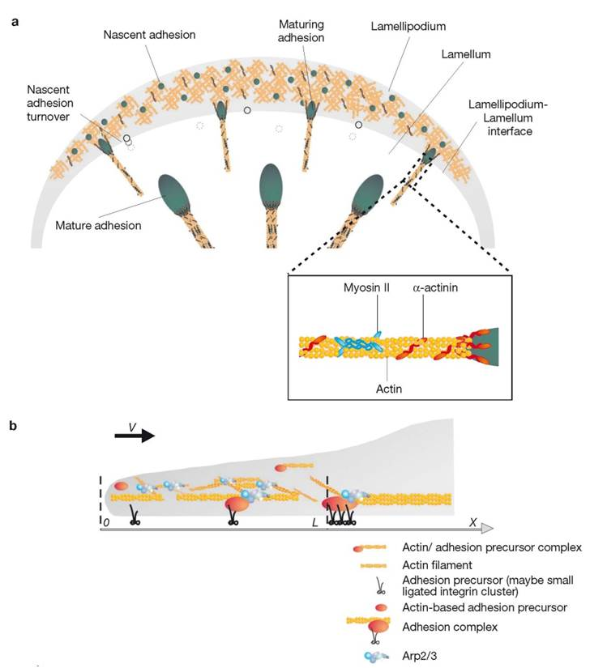

Figure 4. Schematic of adhesion assembly, turnover and maturation and their association with actin polymerization and myosin II activity [10].

## 2.2 Actin structure and dynamics

Focal adhesions structure and dynamics are tightly connected to the cytoskeleton organization and its own dynamics. Following initial integrin activation and recruitment of proteins at the adhesion site, actin filaments couple to the nascent adhesion and allow the transmission of forces necessary for sustaining further membrane protrusion and adhesion maturation. During this phenomenon actin filaments are also assembled into thicker stress fibres, which in turn impact on cell structure and polarity.

Considering the dimension of actin filaments (5-9 nm in diameter [47]), super-resolution and electron microscopy techniques have proved particularly important to resolve the structure of the F-actin network. In cell protrusions, the cytoskeleton of fixed cells was found to be organized in two different layers, each 30-40 nm thick and separated by about 100 nm (Figure 5) [19]. These two types of actin networks display distinct organisations of actin fibres, depending also on which type of adhesions they are coupled to. The dorsal layer looks more homogeneous with a mesh-like actin network organisation, whilst the ventral part also presents thick fibres originating from adhesion plaques. Disruption of myosin II activity perturbs the organization of the ventral part, resulting in a uniform mesh-like actin structure in both layers. In addition, the bundling of actin fibres enhances the mechanical properties of the network. Using optical tweezers, bundling forces in the range of 0.1 to 0.2 pN were measured, for the association of two filaments [48]. These forces correspond to the lowest force range applied to single vinculin molecules within FAs. Although such forces are one order of magnitude lower than the average force across vinculin in stationary FAs, highlighting the importance of the geometry of force distribution on the ability of the actin cytoskeleton to sustain tension, the bundling of several filaments would generate relevant forces for the deformation of the cell membrane and sustaining myosin contractility [21]. Forces around 1 pN were measured during actin polymerization of a small bundle of filaments (8), which is very close to the theoretical limit for a single actin filament growing [49]. This could be explained considering that only the longest filament is actually interacting with the bead used in the optical trap and so force transduction is permitted mainly by this filament. Cells may also use other proteins/factors to generate higher forces and prevent actin from depolymerisation. Hence the architecture of the actin network is inherently coupled to its ability to sustain mechanical forces.

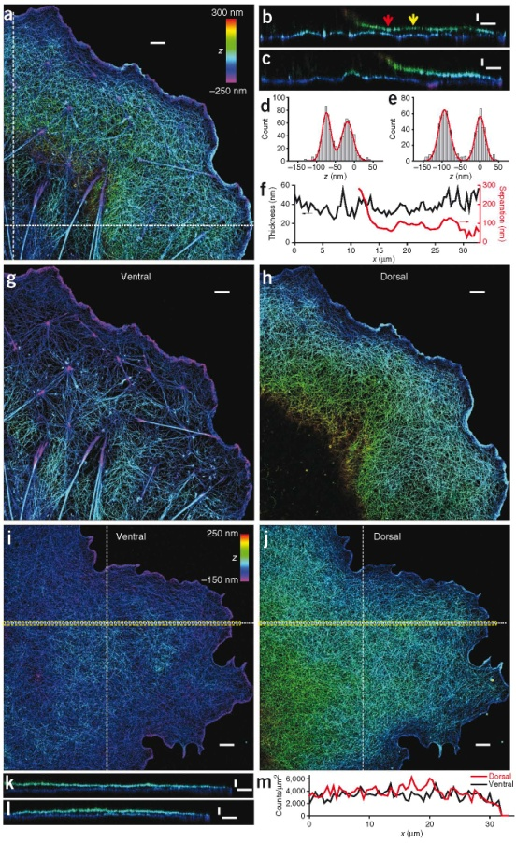

Figure 5. The F-actin cytoskeleton imaged via super-resolution microscopy [19].

Several numerical models have explored the very dynamic nature of the actin cytoskeleton and its relationship with FA formation. Loosli et al. [50, 51]proposed a model connecting the growth of actin filaments and focal adhesion stabilization: the "length threshold maturation". This model is based on the observation of tangential and centripetal forces at the boundary between lamellum and lapellipodium. The actin bundles that form when adhesions are initiated grow perpendicular to the direction of the centripetal force applied. When a threshold in the actin bundle length is reached, adhesions mature into stable FAs and the forces are redirected tangentially, parallel to the lamellum-lamellipodium interface. By using micropatterns with different length of non-adhesive area, it was possible to determine an actin length threshold for different type of cells. Increasing the spacing on non-adhesive spacing from 2 to 6 µm leads to the formation of thick actin bundles between two separate adhesions and to their stabilization and maturation [52]. A computational model based on mechanical stress applied to the actin network reproduces the behaviour of the dynamics of lamellipodia protrusion [53]. In particular, the growth velocity of actin network was not found to depend on the external force applied, up to a "stalling" value, in agreement with experimental data [54-56]. In addition, the model predicted that reorientation of the filaments depends on the force exerted, within a range of 10−2 and 10−1 pN∕nm.

A number of proteins, such as formin, profilin, α-actinin, fascin and filamin, crosslink actin filaments, with associated effects on actin dynamics, controlling the rates of polymerization and depolymerisation, but also the structure and dimension of the networks of fibres formed.

Actin dynamics is controlled by continuous actin polymerization regulated by a number of molecules such as formins, profilin or the Arp2/3 complex [57]. Other proteins such as cofilin increase the bending behaviour of actin filaments which in turns helps its disassembly [58, 59]. Furthermore the severing takes place at the boundaries of cofilin-decorated filament segments and depends on cofilin binding densities [60].

Proteins belonging to the formin family control actin dynamics (nucleation and elongation) upon association with profilin. Hence when tension is applied to anchored actin filaments, formin-controlled polymerization was slowed down in the absence of profilin, whilst an opposite trend was observed in its presence [61]. Formin was also shown to enhance elasticity of the actin network, above a certain concentration threshold, similarly to the impact of the bundling protein fascin, but in contrast to α-actinin and filamin [62].

The crosslinking protein filamin connects the cytoskeleton and integrins and has been shown to be an important adapter protein. It responds to the application of forces by increasing its binding affinity to the tail of β-integrin subunits [63]. It is normally found in an autoinhibited state, as for the other adapter protein vinculin, and switches from a closed to an open conformation when under tension, thus increasing strongly its binding affinity [64].

Fascin is another actin-bundling protein, crosslinking actin filaments into parallel bundles at the end of stress fibres [65], hindering the binding of myosin molecules. In fascin-depleted cells, focal adhesions are larger with thicker stress fibres. Moreover fascin unbinding was shown to be necessary for cofilin binding and severing for focal adhesion disassembly. Together with α-actinin which also associates with stress fibres, fascin was also found to play a synergistic role in controlling actin biophysical properties [66]. Hence the mechanical response of actin filaments, after co-injection of the two proteins, was higher than that observed after injection of these two proteins independently. -actinin and fascin synergistically increase the stiffness of the cytoskeleton thus opposing to the rearward flow of actin at cell protrusions.

Protein dynamics within adhesions in the leading-edge lamella is strongly dependent on actin dynamics itself. Adhesion associated proteins (integrins, paxillin, zyxin and FAK) move slowly with a low coherency, integrins being the slowest, whilst actin binding protein (α-actinin, talin and vinculin) move faster and coherently [67]. Differences between the dynamic behaviour of these proteins were highlighted and vinculin was found to be slower than talin but to move more coherently. In addition these proteins show a strong correlation with F-actin polymerisation, with α-actinin being the most tightly correlated protein. In contrast, zyxin, paxillin and FAK have little correlation with F-actin polymerisation. Together these results indicate that the dynamics of adhesion associated proteins is markedly different to that of actin-binding proteins in the lamella and highlight the potential role of such hierarchical organisation in force transmission.

Myosin is a molecular motor and interacts with F-actin to contract polymerized actin filaments by sliding two filaments in opposite directions. This protein itself can act as a powerful and direct force sensor [68]: it was shown, using an optical trap to manipulate single actin filaments, that even under very low load, myosin dramatically increased its binding affinity to actin, showing a great sensitivity as mechanosensor. Myosin is recruited in FAs by activated Rac1 [69]. Phosphorylation of one of the myosin IIA domains allows the maturation and turnover and turnover of FAs, enhancing cell migration.

Myosin II contractility influences adhesion assembly and dynamics, but its precise role is still debated. Adhesion formation, which occurs in the lamellipodium, is independent on myosin II activity, but is rather closely linked to actin polymerization and the speed of protrusion formation [10, 43]. Crosslinking of actin fibres mediated via myosin II and -actinin, and associated contractility, promotes FA maturation: following α-actinin binding to elongating adhesions and coupling to the polymerised actin network, paxillin, talin, vinculin, tensin and myosin IIA are sequentially recruited. In this respect, α-actinin is a key protein responsible to couple actin fibre organization and FA development. In mouse embryonic fibroblasts adhering on fibronectin, engagement of β1 integrin, talin and paxillin does not depend on myosin II contractility, whilst it does in the case of FAK, zyxin, vinculin and α-actinin [20]. Vinculin recruitment occurs via direct and indirect mechanisms as myosin II-dependent FAK activation in FAs enhanced binding of vinculin, which in turn further increased vinculin binding to immature FAs.

Myosin II also influences the dissociation rate of proteins inside FAs [6]: under myosin II inhibition, the rate of exchange of vinculin increased, whilst rates of paxillin and zyxin decreased. Considering first order kinetics for the molecular association/dissociation processes, the dissociation step is proposed to be the rate limiting step in focal adhesion turnover. A model accounting for such slow dissociation was proposed, involving the activation of new binding sites under mechanical tension, which would result in different kinetics for molecular association and dissociation, respectively, at least for a few key FA adapter proteins. Similarly, blocking myosin II contractility using the Rho-kinase inhibitor Y-27632 induced the release of proteins from FAs and a rapid disassembly [70]. A few FA proteins were ranked in terms of their dissociation rate (measured via Fluorescence Recovery After Photobleaching, FRAP): VASP being the fastest dissociating, followed by zyxin, talin, paxillin, ILK, FAK, vinculin and kindlin.

Leea et al. showed that actin binding switches from a catch type to a slip-like bond. Hence actin polymerisation shows a biphasic dependence in response applied forces, which stabilize the catch bond between actin repeat units up to a certain exerted force (20 pN) and decreases the lifetime of the slip region with further increase in tension [71].

Another important aspect of actin dynamics is the correlation between actin polymerisation, contractility of fibres formed and the generation of traction forces. F-actin polymerisation is correlated with the generation of traction forces according to a biphasic behaviour [33]. In small FAs in the lamellipodium small stresses correlate with fast F-actin polymerisation speeds. In the distal area, at the periphery of the lamella, and in the centre of large FAs, maximum traction stresses are generated and intermediate F-actin polymerisation speeds are measured and from central to proximal areas of large FAs slower polymerisation speeds and lower stresses are observed. Actin polymerisation speeds observed ranged from 0 to 30 nm/s with maximum stresses of 100 Pa. A switch between a strengthening and a weakening phase occurs at a threshold of actin polymerisation speed of 8-10 nm/s and is independent of protein density, stress quantity or stage of FA dynamics [33, 72]. Beyond the regulation of force generation, actin dynamics is also intrinsically directly regulating cell motility and linear correlations were identified between the rate of actin flow and the persistency of motile behaviour across multiple cell types [73].

Models have been developed to explain how the asymmetry between association and dissociation, under mechanical control, is indeed connected to FA dynamics. Bruinsma et al presented a theoretical model capturing the impact of mechanical tension on the asymmetry between association and dissociation rates [74]. Their two state model describes the transition from initial adhesions, linked via a weak slip link to the cytoskeleton (passive state), to focal complexes (FC), which bear high forces and represent the active state. The switch from one state to the other is dependent on ECM mechanical properties. If the force applied for activating and reinforcing the adhesion site is lower than that required for its dissociation, a focal complex is formed. On the opposite, in the case of a soft substrate, the force applied to the adhesion is generally low and the adhesion will dissociate faster.

Despite fantastic progress in the understanding of cell adhesion, the detailed temporal pattern according to which FA proteins are recruited and how this correlates with key activation steps and the establishment of actomyosin-based contractility, at the nanoscale remain elusive. The understanding of such processes clearly requires novel microscopy and molecular tools as well as engineered platforms.

# Nanostructured platforms controlling cell adhesions and cell phenotypes.

The regulation of adhesion to the ECM is controlled by molecular processes that physically connect the matrix to the cell cytoskeleton via self-assembled protein complexes. In turn, cell adhesion to the ECM plays an important role in regulating important cell phenotypes such as proliferation, apoptosis, differentiation, endocytosis, motility, matrix degradation and remodelling. In addition, given the nature of the molecular events that translate matrix adhesion into biochemical signals, it is not surprising to find that processes controlling cellular sensing of the physical microenvironment rely on sensing of its nanoscale physical properties, such as nanoscale geometry, nano-topography and nanoscale mechanics. Cues that cells feel *in vivo* from the ECM are very complex and interconnected. Importantly, it has been shown that these signals, although relying on the biochemical context, depend on its geometry [75-77], topography [78-81] and mechanics[82-84]. Engineered ECMs at the nanoscale have therefore attracted considerable attention recently, whether for the understanding of such nanoscale sensory events or for the design of scaffolds and cell culture platforms for regenerative medicine applications.

Thanks to advances in precise fabrication and engineering techniques (such as EBL [85], photolithography [75, 76] and self- assembly [28, 86]), it is now possible to create synthetic bio-interfaces with controlled physical properties at the nano- to micro-scale. These platforms aim to mimic some of the geometrical, topographical and mechanical properties of the cell micro-environment. These nano-structured substrates and matrices, functionalized with specific proteins or peptide sequences recognised by cell membrane receptors, have been utilised to control the phenotype of a wide range of cells, whether to study the underlying processes regulating such behaviours or for tissue engineering applications. In many cases, it has been established that such control of cell phenotype is mediated by the regulation of cell adhesion via processes such as integrin clustering, recruitment of associated proteins, maturation of nascent adhesions to FAs and their controlled disassembly. In turn, these processes result in the regulation of signalling pathways and cytoskeletal reorganisation directing cell phenotype.

To enable the development of such platforms, patterning methods have been widely used in the last few decades as they allow the fabrication of nano- to microstructured substrates with high accuracy, reproducibility and, in some cases, in large scale [87].

These patterning processes allow the fabrication or reproduction (i.e. through a mask or master) of desired patterns on a substrate that can have 2D or 3D features. There are two main approaches to fabricate nanofeatures: in the top down approach, the bulk material is modified using processes controlled at the macroscopic level, whilst in the bottom up approach patterns are obtained by self-assembly of small building blocks. Depending on how the pattern is reproduced on the substrates, the patterning methods can also be divided into direct write, replicate and self-assembly. Here a brief introduction to the different techniques used to structure biomaterials at the nano-scale is presented, focusing on how their features allow the understanding or control of cell adhesion and associated phenotype [86, 88-91].

## 3.1 Geometrically patterned surfaces

The chemistry of the surface and how molecules are spaced and organized on a substrate affects cell behaviour. The functionalization of surfaces with patterning techniques has allowed the precise spacing at the molecular level of adhesion proteins and peptide sequences such as RGD (mimicking the adhesion properties of fibronectin), recognized by integrin heterodimers, and regulating cell adhesion and mechano-transduction. Thanks to these techniques it has been possible to understand at the molecular level some of the parameters controlling the very initial integrin recruitment steps in FA formation.

Self- assembly techniques involve the organisation of small components (the building blocks) that interact to form larger, stable and potentially hierarchically organised objects [89]. These structures can be used directly or as a mask in order to transfer the resulting pattern. One advantage of self-assembly techniques is that they allow the patterning of large area surfaces, suitable for biological studies that typically require high sample numbers.

Block copolymers are formed from at least two chemically distinct, and often immiscible, polymers covalently linked. The lack of miscibility of the two blocks is determined by their interaction parameters, according to Flory-Huggins theory and equations. Unlike polymer blends that can fully demix into large, macro-scale phases, the covalent bond linking the two blocks frustrate their phase segregation and gives rise to a variety of nanoscale patterns or morphologies, depending on the chain length of the blocks, their chemistry and environmental conditions (temperature, solvent, pH) [92-96]. In the biomedical field, block copolymers have been used as building blocks for micellar drug-delivery systems [97], for the design of polymers for gene or drug delivery [98] and to functionalize surfaces for protein patterning and cell culture[13, 99].

The work by Spatz and coworkers explored early stages of the integrin recruitment process using arrays of 5-10 nm gold clusters generated via block-copolymer micelle nanolithography (Figure 6) [13, 75, 100]. The dimension of each gold cluster adhesive site, functionalised with short peptide sequences such as RGDfK, allows the binding of only one cell membrane receptor. These adhesive sites are separated by a protein and cell resistant coating to ensure that membrane receptor binding is specific, with a controlled geometry. The spacing between adhesive sites, which can be tuned through the molecular design of the block-copolymer that formed the micellar array, can be defined readily, in the range of 20 to 250 nm. In addition, the level of order of the resulting array can also be adjusted, via the addition of free polymers of the same type as one of the block (e.g. polystyrene), resulting in the perturbation of the ordered lattice normally formed by the block copolymer micelles [13]. This technique was further modified to obtain surfaces with simultaneous control of ligand spacing (local density) and global ligand density. This was achieved via micropatterning the nanopatterned surface to control the microscale geometry of adhesive sites independently of ligand spacing. To do so, the gold nanoclusters were removed selectively using photolithography [75]. To control simultaneously substrate mechanics and ligand spacing, PEG mircopillar functionalised with gold cluster arrays were produced via microscope projection photolithography [76]. The nanocluster decorated pillars were generated using a layering approach in which the clusters, initially assembled on a slide are covalently bound to the hydrogel pillars during the photopatterning step and then simply transferred upon detachment of the substrate. Using this approache, the control of substrate stiffness and pillar geometry, each able to accommodate a mature FA, with a diameter of about 3.5 µm, was achieved.

Another self-assembly process that has been used to control cell adhesion and phenotype is the spontaneous assembly of fibronectin proteins into fibrillar nano-structures in contact with some polymer surfaces. Hence, whereas fibronectin molecules adsorb as relatively homogenous films onto poly(methyl acrylate) (PMA), presenting globular assemblies, fibronectin organised into nanofibrils (< 100 nm across) when interacting with poly(ethyl acrylate) (PEA) [28, 29, 101, 102].

Similarly to the micellar self –assembly techniques, colloidal patterning consists of a solution of spheres that are deposited on a substrate to serve as mask or template for further processing (Figure 6). The solvent is then allowed to dewet or evaporate leaving spheres self-assembled into an array at the surface [86]. The particles can either be tightly packed or more dispersed, depending on the starting colloidal concentration and deposition parameters. The resulting pattern can then be used directly or as a mask to protect areas of a substrate during subsequent steps. Hence in colloidal lithography (CL), the pattern resulting from the colloidal array is then transferred to the substrate via etching or physical vapour deposition.

Using the CL approach, Sutherland and co-workers produced nanopatterned substrates presenting circular patches of gold surrounded by a SiO2 or TiO2 background. The patches display a short range order only and can be conveniently functionalized with fibronectin via simple incubation in a solution of this protein, after protection of the background with anti-adhesive poly(L-lysine)-graft-poly(ethylene glycol). The diameter of the patches generated using this approach ranged from 100 to 3000 nm [14]. The shape of the patterned objects that are obtained via CL is typically spherical, but other shapes, such as triangles, ellipsoids and hexagonal platelets have been successfully patterned too [87]. Hence triangular and circular nanopatterns functionalized with fibronectin, with sizes ranging from 92 to 405 nm were generated via CL of polystyrene spheres [103]. The spheres were removed after gold deposition. The patterns were also spaced from 177 nm to 1.534 μm, to allow the control of fibronectin density. The background was functionalised with a PEG silane to prevent uncontrolled cell attachment.

Replication methods include the use of a master (made through direct writing methods) which is used several times to reproduce the desired pattern [89]. The production of such masters is typically carried out via a lithography technique. The choice of the technique depends on the resolution and size of the features that is required. Photolithography is a commonly used technique, which is part of replication method, to structure biomaterials. This process requires a mask, normally made of a transparent material (e.g. quartz), on which the desired pattern was previously designed. The target substrate is coated with a photoresist which contains a photosensitive element that is modified when irradiated (visible light, X-Ray or UV in the case of photolithography). When the substrate covered by the mask is exposed to those radiations, the photoresist generate either a positive or negative replica of the pattern above it. The modified or non-modified part of the photoresist is then removed and the pattern can in some cases be transferred to the substrate by either etching or deposition [88, 104].

Nanoimprint lithography, in conjunction with surface functionalization, was used to produce biomimetic arrays in which the position of single molecules or small clusters of molecules can be precisely controlled [77, 105]. Nanoimprint lithography is based on the use of a mould (normally produced by electron beam lithography, EBL) to imprint a thin polymer film. The resolution of the obtained patterns is determined by the feature size on the mask and the type of lithography used to generate such template [106]. In this work the template, which was previously patterned via EBL, is reproduced on glass substrates by NIL on a PMMA film. The PMMA is then selectively removed from the surface via metal evaporation at an angle and etching of unprotected areas, leaving exposed areas onto which gold clusters can be deposited. The resulting gold clusters, with precise control of size and position on the substrate (determined at the EBL stage) are then functionalised with cyclic RGDfK and can only accommodate one integrin while the background is passivated to prevent cell adhesion.

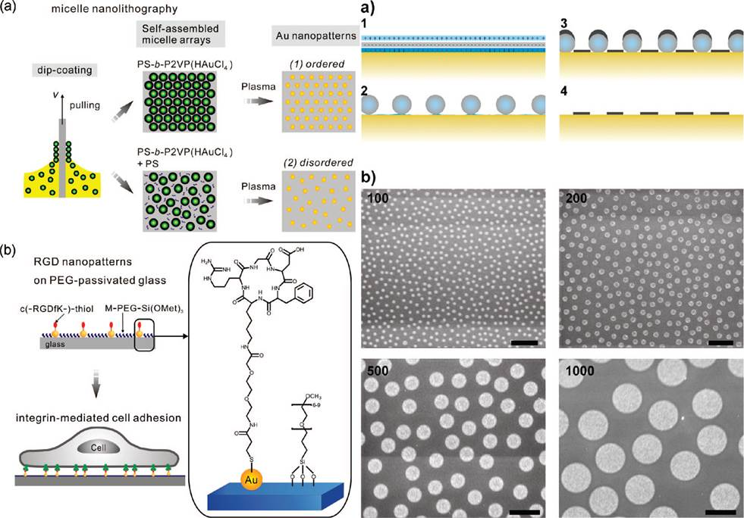

B

A

Figure 6. A: representation of the micelle nanolithography technique used to produce ordered and disordered nanopatterns and their functionalization [13]. B: colloidal lithography approach schematic and SEM images of pattern with different sizes [14].

Another technique belonging to replication methods is soft lithography. It relies on the use of a patterned elastomer (normally poly(dimethyl siloxane), PDMS), replicated from a master, to print small molecules or proteins onto a substrate (typically gold, silicon, glass or PDMS) [89]. The most widely employed of these techniques is micro contact printing (µCP), which normally uses PDMS stamps inked molecules to be transferred to the target substrate during conformal contact. Three main strategies have been developed to use µCP to control cell adhesion, with objects printed spanning four orders of magnitude, in the range of 100 nm [107, 108] to 1000 m. The first strategy relies on the direct printing of a protein/cell-resistant molecule. In the second approach an initiator molecule for surface initiated polymerisation is printed. Finally, the ECM protein itself can be printed before passivation of the background.

It is possible to directly deposit self-assembled monolayers of a protein and cell resistant molecules, which subsequently protect the printed areas from the adsorption of ECM molecules [109, 110]. Gallant et al. developed micropatterned self-assembled monolayer of thiols on gold, functionalized with adhesive and non-adhesive areas [111]. Microarrays of circular patches with diameters of 2, 5, 10, and 20 µm, spaced 75 µm, were produced to control cell adhesion and spreading depending on the adhesive area. Similarly, a technique based on µCP allowing the reproduction of a protein pattern at the nanoscale from a nanotemplate on an elastomeric surface was developed [107]. The method was used to generate adhesive nanoislands of fibronectin in a non-fouling background and study the dependence of FA assembly and force transmission. Nanoislands with controlled areas and density of ligand where prepared with this technique [108].

Alternatively, a second strategy consists in printing a monolayer of an initiator molecule from which polymer brushes can be generated via a controlled radical polymerisation process. The growth of ultra-protein resistant brushes, such as oligo(ethylene glycol) methacrylate and sulfopropyl methacrylate brushes, allows the protection of patterned areas from protein adsorption, hence enabling the control of cell adhesion to well defined patterns, even during prolonged culture and in the presence of complex protein mixtures [112, 113]. Finally, it is possible to directly print the ECM protein before backfilling the non-printed areas with a protein and cell resistant molecule to prevent subsequent non-specific protein adsorption and uncontrolled cell adhesion [114].

Another approach for chemical patterning of 2D surfaces is the direct “writing” of patterns on the substrate [88]. This type of patterning can further be distinguished in direct writing with "ink" and without "ink". The former class includes techniques such as inkjet printing (IJP) and dip-pen nanolithography (DPN). The latter method uses an AFM tip to directly deliver chemical reagents on a specific area of the target substrate [115] and has been very successful for patterning molecules and proteins for biological applications due to its high resolution. Arrays of proteins with features ranging from 100 to 350 nm and no unspecific binding on the passivated background were produced for cell adhesion assays [116]. Printing of collagen in 30-50 nm wide lines was also achieved with DPN: it was also possible to keep the structural organization of the biologically active molecule [117]. However, a drawback of these methods is their slow speed and throughput.

## 3.2 Surface topography

The control of cell behaviour simply via the design of the nano-topography of a surface is appealing as it avoids the requirement for chemical modification and has important implications for the design and processing of implants. Hence, a number of strategies to scaffolds with nano-scale features, displaying a range of sizes and morphologies, have been developed. Proteins in the extracellular matrix *in vivo* are often presented in the form of fibrils displaying defined diameters, but also some hierarchical structure, as in the case of collagen fibres. Electrospinning is an approach that has been widely exploited to reproduce a similar topography with polymeric materials, affording fibres with diameters ranging from a few tens of nanometres to a few microns (50 nm to 5 µm) [118]. It has gained increasing attention thanks to the simplicity of the process and the accessibility of the equipment, the wide range of materials that can be “spun” and the dimensions obtained.

The electrospinning process is based on the application of an electric field to a flowing solution containing the polymer/material of interest. The electric field charges the liquid interface producing charge repulsion in the solution which competes with the surface tension resulting in a deformed “droplet” called the Taylor cone. When the electrostatic repulsion overcomes the surface tension, a jet is generated from the Taylor cone which is then accelerated and "stretched" by the electrostatic forces, resulting in a decreased diameter. The jet is then divided into multiple filaments with significantly smaller diameters, which stretch, bend and solidify into fibres. This process is influenced by many factors, the effects of which are often difficult to isolate. Globally, the variables can be divided in solution properties (viscosity, conductivity and surface tension), processing conditions (flow rate, strength of the electric field and distance between the Taylor cone and the collector) and ambient parameters (temperature and humidity). These properties affect fibre shape and diameter [119, 120]. Sizes obtained can go down to a few nanometers, with the smallest reported being around 1 nm [121]. Polymer concentration, and thus the viscosity of the solution, principally affects fibre diameter and leads to thinner fibres [122, 123]. Increasing the conductivity of the solution, such as with the addition of salts, also allows the formation of smaller fibres: pyridine in formic acid produces salts by can conveniently be removed via evaporation [121]. The flow rate also controls fibre diameter and it was shown that fibre diameter decreases with slower flow rates [120]. A wide range of materials have been spun from polymers to metals to composites and hybrid materials [124, 125]. A vast number of polymers have been used including natural (e.g. collagen, gelatin, cellulose, fibrinogen, silk and chitosan) and synthetic (PEO, PVA, PAA, PS, PET, PMMA, PVC, PE, PP) but also block copolymers (PLA-b-PEO, poly(lactide-*co*-glycolide)-*b*-PEO, PS-*b*-PP), metal (copper, iron, gold, and titanium), metal oxide and hybrid polymer/ metal oxide (zinc oxide, PEO/Au, PVP/Ag and PAN/Ag).

Soft lithography has also been used to produce nanotopographic features. Nanogratings of 350 and 500 nm width and 350 nm depth were produced on poly(dimethylsiloxane) (PDMS) [126] via moulding from a nanoimprinted poly(methyl methacrylate) (PMMA)-coated Si master. Moulding is a type of soft lithography technique in which the pattern is formed in between the voids of a master substrate. Embossing is a related approach and recreates a relief on a substrate via mechanical stress (as well as softening of the materials for hot embossing) [127, 128]. Embossing was also used to generate 500 nm features in materials such as tissue-culture polystyrene (TCPS).

Polymeric nanopillars with diameter from 200 to 700 nm were fabricated using nanosphere lithography and nano-moulding [129]. Polystyrene nanospheres were used as a mask on silicon substrate to produce holes via etching. The patterned silicon is then used as a mask for a UV- curable polymer which is spin coated on top of the silicon, cured and peeled off to obtain an array of nanopillar with the desired diameter.

Fabrication of micro/sub-micro elastomeric pillar via molding allows the production of systems with controlled topography (size and density of pillars) and mechanics: the apparent modulus of the materials is controlled by varying the diameter and height of the pillars [130]. The pillars are obtained by producing a master via photolithographic methods and then using it as a mould to cast PDMS substrates[131-133]. The top of the pillar is then selectively functionalised with a cell adhesive protein (typically fibronectin) to promote cell adhesion only at the top of the pillars. Spring constants obtained vary from 1 nN/µm to 1000 nN/µm.

Scanning Beam Lithography is another powerful fabrication method based on the "direct writing" of a programmed pattern into a substrate. The writing process is controlled by a focused beam of either electrons (Electron Beam Lithography - EBL) or ions (Focused Ion Beam - FIB) directed towards a resist (PMMA, ZEP, NEB31 and hydrogen silsesquioxane (HSQ)) [134]. Normally the photoresist is exposed to the focused beam and the areas that were selectively exposed (or not exposed, depending on the type of resist) are removed by wet etching. This technique can generate patterns with resolution just below 10 nm, typically in the range of 10 nm to 1 mm for lateral dimensions [85]. Biofunctional resist themselves can be used to generate the pattern directly [135]. However, the process is relatively slow and low throughput and the sample dimensions are restricted to small areas, typically below 1 cm2. The resulting patterns can either directly be used as substrates for cell culture [136, 137]or as master for transfer of the patterns to a different material. Ion-beam and chemical etching have been used to create substrates with controlled texture at multiple scales. This technique was used to generate micropatterns on two semiconductor surfaces (Si and TiO2) bearing areas with different nanoroughnes [79]. The Si surfaces presented a pattern with 35 μm stripes and a root mean square roughness (Rrms) of 2.6 nm. The TiO2 surface presented squares or stripes with 3 μm depth and Rrms of 1-4.5 nm, depending on the area.

## 3.3 Stiffness – matrices that cells can remodel

Cell phenotype is strongly dependent on the mechanical properties of the microenvironment. Hence, matrix stiffness has been shown to impact behaviours such as spreading and motility [138, 139], proliferation, differentiation [140, 141], endocytosis and apoptosis [142-146]. In addition, matrix remodelling (the degradation of old matrix and deposition of new matrix) is influenced by changes in matrix stiffness [147]. These mechanical cues are not necessarily nanoscale effects only, with forces being able to be transmitted over large, micron scale, distances, such as in collagen gel contraction and sensing of mechanical properties by microtissues [148, 149]. However, in a number of cases, nanoscale mechanical properties, rather than bulk stiffness, have been shown to impact cell behaviour [83]. In this review, we will focus on such nanoscale effects and briefly describe some of the platforms allowing the study of the impact of substrate mechanics on cell behaviour.

Hydrogels have been used for cell culture for decades, but synthetic hydrogels have only more recently started replacing more traditional compliant matrices such as collagen gels, matrigel [150-154] and fibrin gels [155, 156]. This shift is due to the lack of control of some of the properties of these natural hydrogels, as well as their large batch to batch variation. Hence synthetic hydrogels such as poly(ethylene glycol) (PEG) and poly(acrylamide) (PAAm) gels have been replacing some these natural hydrogels [157]. Indeed, the mechanical properties of PEG and PAAm hydrogels can readily be tuned over a wide range of stiffness (typically 1 kPa to 1 MPa), via the variation of the weight fraction of polymer and the crosslinker ratio used. Although cells are typically unable to spread at the surface of these gels, they can be biofunctionalised with proteins and short peptide sequences (type RGD) to allow cell adhesion, spreading, motility and proliferation. Hence activated esters can be coupled to the surface of these gels to sustain the coupling of ECM proteins such as collagen or fibronectin [140]. Other strategies have consisted in coupling short peptide sequences using activated esters via amine residues or Michael addition of peptides presenting cysteine residues (Figure 7) [147]. Alternatively, polymerizable cell adhesive peptides can directly be incorporated in the monomer mixture before polymerisation.

A disadvantage of methacrylate and acrylate-based hydrogels is their lack of degradability as their backbone and associated crosslinkers do not degrade hydrolytically or enzymatically. Hence for 3D culture studies this lack of degradability does not allow cell growth, proliferation and matrix remodelling required for long term culture and tissue engineering applications [158]. A number of strategies have been developed to confer degradability to hydrogels and allow their remodelling by embedded cells. Therefore, 3D gels are considered to better reconstruct an environment mimicking the *in vivo* ECM.

Gels based on natural proteins resemble more closely the ECM in which cells live and migrate and inherently allow cell adhesion and matrix remodelling. Collagen based matrices have received much attention, based on their ease of preparation and the prevalence of collagen as a component of natural ECM. In some cases, the physical properties of collagen gels can be tuned using crosslinkers such as glutaraldehyde [159]. Collagen based matrices were prepared at different protein concentrations to control stiffness and porosity. Porous glycosaminoglycan (GAG) matrices have also been used for 3D cell culture, owing to their degradability and, in some cases such as hyaluronan gels [160, 161], bioactivity. As for other natural or synthetic hydrogels, their stiffness can be tuned via the weight fraction of polymers used and the level of crosslinking.

Another strategy consists of producing synthetic but degradable hydrogels. The Burdick group has developed a platform based on hyaluronan backbone and peptide crosslinkers that controls cell spreading via cross-linking density [162]. Bis-cysteine degradable peptides were used to control the crosslinking of alkene- or acrylate-bearing polymers via thiol-ene coupling or Michael addition. In addition, this approach enabled the patterning of methacrylated hyaluronic acid with areas of varying topography and stiffness [163].

Mooney and co-workers used another approach to produce interconnected 3D matrices, based on interpenetrated networks, and independently vary different properties of the gels, such as cell adhesion and mechanics. Examples of systems used were based on alginate, poly(ethylene glycol dimethacrylate) [164], or protein based Matrigel [165], allowing stiffnesses to be tuned in the range of 2.5 to 110 kPa.

Finally, another approach to form hydrogels is based on the self-assembly of peptides. A range of peptide-amphiphile molecules have been shown to self- assemble into fibrous hydrogels [166, 167]. An example of such process relies on the hydrophobic interactions of 6, 10, 16 or 22chains coupled to the peptides or Fmoc (fluorenylmethoxycarbonyl) residues [168] and is controlled by pH. Fibres present different morphologies and controlled bioactivity, depending on the procedure employed and the type of peptide sequence used. Bundle formation was observed, depending on the peptide concentration and fibres sometimes organised as “flat ribbons”. Such fibrous structures are able to closely mimic the fibrous nature of many types of ECM found in different tissues, making this strategy particularly attractive to tissue engineering. In addition, using a combination of self-assembly and micropatterning techniques, it was also possible to produce micro-patterned nanofibrous gels in which fibre alignment was controlled within the patterned holes, posts or channels [169]. A similar approach was used by other groups by mixing different types of peptides to obtain stiff nanofibrous hydrogels which promote cell proliferation [170].



Figure 7. Sequential cross-linking of degradable hydrogels for dynamic studies of matrix remodelling by cells [147].

# Nanoscale sensing of the physical environment

The various techniques described in the previous section to control the nanoscale geometry, topography and mechanics of matrices have been applied to cell culture, for the control of cell phenotype. Cell adhesion plays an important part in mediating such cell-substrate interactions and sensing nanoscale physical properties of the matrix. Important questions that have been addressed by these studies to understand the role of such cues in directing cell phenotype will be discussed in this section. How do nanoscale physical properties control integrin clustering? How is the geometrical maturation of FAs and their ability to sustain tension coupled to nanoscale physical properties of the matrix? How is nano-scale topography sensed by cells, in a relatively homogenous biochemical context? Is local (nano- to microscale) remodelling of 3D matrices an important mechanism via which cells sense substrate mechanics in 3D?

## 4.1 Geometrical control of integrin clustering.

The control of integrin activation and clustering has attracted a considerable interest from the research community, considering that this is the first step in the control of FA formation. The distance required for integrin heterodimers to cluster together and form nascent adhesions is an important parameter controlling the early stages of FA development. To control the clustering of cell membrane receptors, gold cluster arrays generated via block copolymer micelle nanolithography were used. Integrin clustering was controlled via the ligand density with a threshold of around 60 nm between two neighbouring ligands. Below this threshold, ligands density allowed the formation of adhesions [100]. On nanopatterns displaying greater inter-ligand distances, cells were unable to spread. This effect was not observed on disordered nanopatterns as the perturbed organisation of the clusters resulted in shorter inter-ligand distances locally (Figure 8) [13]. In a further development, the effect of ligand density on a local (spacing between ligands at the nanoscale) and a global (micropatterned surfaces) scale was assessed to dissociate physical parameters controlling cell adhesion at different scales [75]. Cell response to the local density of ligands, rather than global density, was more pronounced, with FA maturation and cell adhesion strength being more effective when spacing between ligands was below 60 nm. Ligand spacing on the micropatterned surfaces was kept constant at around 60 nm and allowed higher cell spreading compared to unpatterned surfaces presenting higher inter-ligand spacing (74 and 120 nm), despite the fact that these surfaces presented a lower global particle density. These experiments indicate that a small number of sufficiently large FAs is sufficient to sustain cell spreading and that local ligand density and integrin clustering controls the formation of FAs.

In another study, nanocluster-functionalised hydrogel micropillars were used to study forces generated by adhesions recruiting different integrins, αvβ3 and α5β1 heterodimers [76]. The latter were found to sustain greater maximum forces than the former during adhesion. Also, the ratio of zyxin to actin in FAs at the cell periphery is higher for α5β1, possibly indicating different mechanical roles for these two integrin heterodimers. This is consistent with observations made using a magnetic tweezers assay, which identified α5β1 as an important mediator able to sustain mechanical forces, whereas αvβ3 was found to play a role in mechanotransduction [34]. However, such integrin specific response is also likely to be dependent on the expression level of the respective integrins and the abundance (and possibly affinity) of the ligands present in the matrix. Hence, engineered cell lines expressing αvβ3 and α5β1 integrins displayed similar abilities to exert traction forces, although their response to external cyclic strain and ability to respond to matrix stiffness was slightly more sensitive in the case of αvβ3 [171].

To further probe the impact of clustering on the ability of cells to exert tension on their matrix, the approach of block copolymer micelle nanolithography was combined with molecular tension fluorescent microscopy, in which fluorophores quenched by the close proximity of gold clusters become activated when under tension [172]. Tension was found to depend on ligand spacing and a threshold of 60-70 nm was found to be necessary for FA formation and tension development. In addition, this work highlighted a two-step adhesion process, in which initial tension at bound integrins is regulated first by F-actin polymerization, followed by the ligand spacing dependent and actomyosin-driven maturation of FAs and the increase of average tension per receptor (up to 6-8 pN per integrin). However, the generation of high traction forces relies on the increase of the number of integrins under tension, rather than a further increase in the tension per molecule. Using a similar technique, the force distribution inside FAs was studied [173], and high tensions were observed at the cell periphery, colocalizing with paxillin. In addition, this FRET assay highlighted that various molecules involved in FA regulation, in particular avb3 and paxilin, directly localise at high tension areas [174].

In good agreement with these experiments and work carried out on micropillars, optical tweezers assays also provide evidence that traction forces generated at the leading cell edge are stronger than those generated closer to the cell body [31]. The size of beads coated with RGD molecules and the ligand surface density both influenced force transmission, thus confirming the influence of integrin recruitment on forces generated. A linear relationship was found between traction forces and retrograde flow. In addition, cell migration was inversely correlated to tension, indicating enhanced migration when low forces are generated.

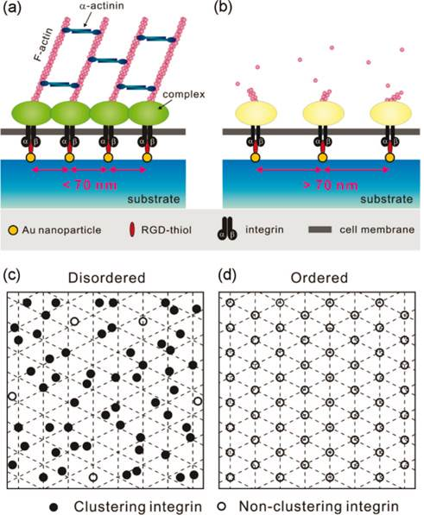

Figure 8. Effect of ordered and disordered nanopatterns on integrin clustering [13].

A similar threshold for integrin clustering and cell spreading was measured for cells plated on substrates displaying gold clusters positioned in different geometries (arrays of 2-7 clusters separated by 50-60 nm, assembled in different shapes, spaced by 200 nm distances), and functionalised with RGD molecules [77]. Cell spreading was dependent on the size of the group of gold clusters (between 2-7). On hexagonal arrays composed of groups of 6 or 7 clusters, cells showed maximum spreading, despite the large distance between groups (200 nm). On dimer and trimer arrays presenting the same distances between clusters (50-60 nm) and groups of clusters (200 nm), cells were instead struggling to adhere. In addition, it was found that 4-5 gold cluster within each group was sufficient to sustain cell spreading. This behaviour may suggest that cluster density, rather than distance between ligands, controls cell adhesion, however when the density of groups of 7 gold clusters was decreased to the level of the density of groups of 2-3 gold clusters (by increasing the spacing between larger groups up to 370 nm), cell adhesion was not perturbed. Together, these results indicate that clustering of integrins may only be required to occur at a local scale (4-5 integrins) and that cell adhesion may not require the formation of continuous domains of integrins over larger (micron) scales. The question of whether such discontinuity in integrin clustering enables fully mature FAs to form remains open, but suggests that such adhesions are not continuous and homogenous protein assemblies, but rather relies on local clustering of associated proteins.

## 4.2 Geometrical control of FA maturation.

Once integrins have been recruited, other molecules associate with growing adhesion sites, mediating coupling to the actin network, enabling the generation of tension and maturation of FAs. The size of adhesions is often used as a hallmark of fully mature FAs, but the relationship between protein recruitment, size or geometry and mechanical coupling is not clear. It is well established that, at the microscale, adhesive area allows integrin clustering, FA assembly and force transmission [111]. Adhesion strength increased exponentially with the number of recruited integrins and with increasing the adhesive area on micropatterned surfaces, up to a threshold, where no further strengthening is seen. In turn this impacts on a variety of cell phenotypes such as polarity [175], cell division [176], differentiation [177-179] and apoptosis [180]. However, the geometry of the adhesive landscape rather than the total amount of ECM molecules was found to control cell adhesion. Hence cells are able to bridge across relatively large non-adhesive areas to sustain their spreading, without compromising their phenotype [113]. The size of adhesive patches was identified as a key parameter controlling such cell behaviour. Cells were unable to adhere to adhesive nanoislands with an area below a threshold of 0.11 µm2, even though the total adhesive area remained unchanged [108]. This also correlated with adhesion strength, quantified via a spinning disk assay. Expression of the head domain of talin (binding the cytoplasmic tail of integrins) resulted in the formation of adhesions independently of the size of the adhesive patch. In contrast talin mutants unable to bind integrins did not alter cell spreading. This suggests that stabilisation of integrin clusters by the binding of talin is sufficient to compensate the lack of stability of nascent adhesions at nanopatterns. In addition, expression of the vinculin head domain stabilising integrin clustering, but not vinculin wild-type, resulted in the stabilisation of nascent adhesions even on the smallest nanopatterns. Interestingly, expression of the mutant VinT12 constitutively adopting an open conformation allowing the exposure of talin and actin binding sites (and therefore the transmission of tension) did not result in the stabilisation of adhesions. This suggests that nascent adhesions are unable to sustain mechanical shear forces resulting from actin threadmilling and myosin contractility, resulting in the disassembly of integrin clusters, unless stabilised by the binding of proteins allowing to decouple this phenomenon (as for the head domains of talin and vinculin). These results are in good agreement with studies of vinculin dynamics showing that the head domain of vinculin stabilises adhesions in the absence of tension, but that the actin binding site of the vinculin tail is essential for mechanical sensing [45]. Hence, vinculin and talin appear to equally serve as key mediators of the sensing of nanoscale geometry.

The influence of adhesive area size on cell attachment and spreading was also studied via nanopatterned substrates prepared via colloidal lithography and presenting circular adhesive gold patches with diameters ranging from 100 to 1000 nm [14]. On the smallest patterns, cells can still adhere although weakly, but spreading is limited and only nascent adhesions can be observed. On 500 nm patterns, cell spreading is more evident with the formation of focal complexes and the presence of some actin fibers. On the largest patterns, elongated FAs are formed and connect to better structured and more mature actin fibers. In a further study, the influence of different protein coatings (fibronectin or vitronectin) was assessed on patches ranging from 100-3000 nm [181]. On larger patches cell spreading is higher on fibronectin and gradually decreases for smaller patches, without any strong evidence for a specific area threshold. Although cells spreading on vitronectin displayed a similar behaviour, their spreading was not as restricted on 200nm patches as compared to cells spreading on fibronectin. Bridging of patches was observed with vinculin stainings on small patterns with vitronectin but not fibronectin and could explain this difference in nanoscale sensing. However, the involvement of different integrins in the binding of fibronectin and vitronectin patches (51 and v3 respectively), and potentially their respective expression level in the cell type used in this study, could also account for the behaviours observed.

Other phenotypes such as cell motility were also found to be controlled by the nanoscale geometry of adhesions. Adhesion formation and maturation strongly influences migration dynamics and cells seeded on triangle and circular patterns of different sizes produced by colloidal lithography [103] formed many small adhesions and displayed enhanced motility on sub-100 nm patterns. On larger patterns (from 222 to 405 nm), adhesions were larger and fewer and cell migration speed decreased. Similarly, the adhesion and spreading of keratinocytes was found to be impaired on small (100-600 nm) adhesive patches, compared to large patterns (3 m) or homogenous substrates (Figure 10) [182]. In addition, this behaviour correlated with an increase in cell differentiation (expression of the cornified envelope protein involucrin) as cell spreading was impaired. Although the restriction of cell spreading was associated with a gradual deterioration of the actin cytoskeleton, the recruitment of key focal adhesion proteins (talin, vinculin, paxilin) and protein phosphorylation were not reduced on the smallest patches, in contrast with the study discussed above by Garcia and co-workers [108]. Cells were able to deposit laminin at the adhesive patches further suggesting that, from a biochemical point of view, adhesions formed on nanopatterns were relatively mature. A similar behaviour was observed for proteins associated with hemidesmosomes, a type of matrix adhesion sustained by 64 integrins [183], connecting the ECM to the keratin network and not thought to bear tension. However, the dynamics of vinculin binding was found to be faster on small (600 nm) patches, compared to large patches or homogenous substrates, and comparable to vinculin dynamics in cells treated with the myosin inhibitor blebbistatin. Hence these experiments suggest that altered protein dynamics result in uncoupling between adhesions and the actin cytoskeleton and impaired transmission of tension required for cell spreading.

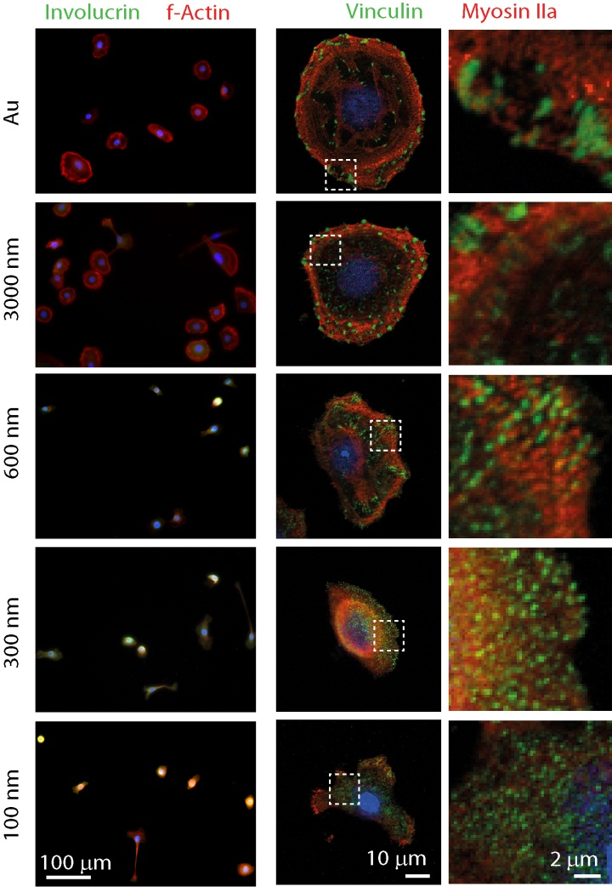

Figure 9. Focal adhesion formation and keratinocytes spreading are controlled by the nanoscale geometry of adhesions [182].

The importance of the relationship between matrix geometry and organisation of the actin networks was demonstrated in a series of experiments in which the nucleation of actin polymerisation was controlled by micropatterned substrates. Actin filament orientation and length and the formation of filopodium-like structures are influenced by the spatial organisation and shape of the nucleation area [184]. Interestingly, this not only had an impact on the actin network structure but also on the regulation of myosin activity [185]. In addition, this patterning approach allowed the control of the polarisation of actin filament. When the filaments are antiparallel myosin based contractility results in the deformation and disassembly of the network, whilst parallel bundles are not affected and continue to extend. This so called "orientation selection" mechanism may act as an important nano-to micro-scale sensor of substrate geometry via the regulation of cross-talks between the actin network structure and its ability to sustain contractile forces.

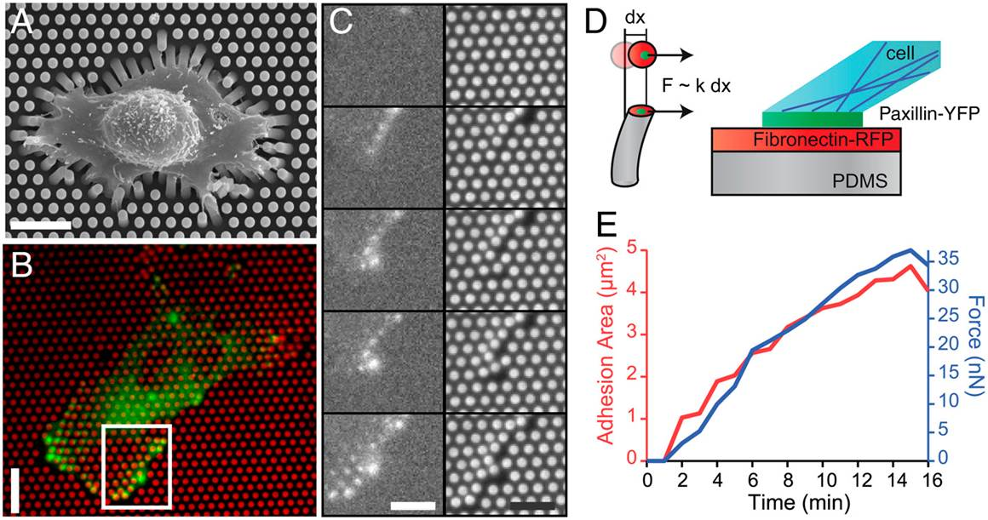

Figure 10. Cells adhering and deforming elastic micropillar: SEM (A, C) and epifluorescent (B) images. D: relationship between force and adhesion area [131].

The relationship between adhesion area and force generation was further explored using micropillar arrays allowing the tuning of the rigidity of the substrate via the length of the pillars (Figure 10) [131]. These experiments highlighted a strong correlation between focal adhesion size and forces generated, consistently with results obtained via an optical laser trap assay [186] and previous reports by Geiger and co-workers [187]. In addition, force generation was increased on stiffer substrates. However, super-resolution imaging of FAs formed on such arrays showed that large adhesions were in fact composed of multiple small (but elongated and sometimes reaching beyond the boundary of the pillar) adhesions, 100-300 nm across [188]. The stresses experienced by such adhesions were calculated to be in the range of 10-300 nN/m2, one order of magnitude higher than previously measured. Hence the relationship between apparent focal adhesion area and stress may be more complex than the simple linear relationship evidenced by conventional confocal microscopy.

In addition, a detailed analysis of the structure of adhesions and stress field generated by cells spreading on micropillar arrays highlighted significant differences depending on the pillar area [132]. For micron-size pillars, paxilin staining was localised at the periphery of the pillars and forces applied to neighbouring pillars were correlated. On sub-micron pillars (500 nm), paxilin staining was restricted to the top of the pillars and forces applied to neighbouring pillars appeared to be weakly correlated. This was proposed to result from local contractions generated on sub-micron pillars and uncorrelated to longer range forces. However, it should be noted that the paxilin stainings presented in this work, for large pillars, are significantly different to what others reported [188], possibly highlighting cell-dependent phenomena. In addition, although maximum pillar displacement was relatively independent to bending stiffness, it strongly decreased for sub-micron pillars (near 60 nm). Correlated to this behaviour, shear stress was increased 12-fold on the stiffest sub-micron pillars. This behaviour was suppressed in cells lacking the receptor-like protein tyrosine phosphatase α, playing an important role in rigidity sensing. Hence it was proposed that high shear stress local contractions over 60 nm distances was an important mechano-sensing step via which cells responded to the sub-micron geometry of the matrix on which they spread.

## 4.3 Topography sensing.

The ECM often displays a fibrillar morphology and electrospinning has been widely studied to mimic such environment. In many cases, the size of fibres and the dimensions of the gaps that they form were found to control cell fate decision. Rat hippocampus-derived adult neural stem cells (rNSCs) were cultured on electrospun Polyethersulfone (PES) fibres with diameters of 300, 750 and 1500 nm, after coating with laminin [80]. Differentiation was found to increase with decreasing fibre diameter, in differentiation medium. Cell morphology was also strongly affected by fibre size, with cells spreading relatively homogenously in all directions on the smallest fibres but stretching and following the main axis of larger fibres. When comparing fibres sizes (around 300, 500, 700 and 1000 nm) with different fibre orientation (parallel and random fibres), neural stem cells (NSCs) presented aligned morphologies along the parallel fibre and more polygonal shape on randomly oriented fibres [189]. Differentiation was more prominent on parallel patterns with highest level on the 500 nm fibres. No significant difference based on fibre diameter was found on random fibres. It was proposed that fibre diameter affects cell proliferation and differentiation through signalling cascades resulting from changes in FA formation: the MAPK pathway, which affects osteoblastic differentiation, was affected by the size of nanofibres, making such scaffolds attractive for tissue engineering applications [190]

In contrast to platforms displaying controlled geometry, the size of nanofibres not only controls the potential dimension of focal adhesion that cells may form at their surface, but also the curvature of the membrane at the adhesion sites. In turn, such changes in membrane curvatures can affect the binding of membrane associated proteins such as the curvature sensor POR1. The size of fibres (from 100 to 1000 nm) was found to control osteoinduction and the mechanism underlying the activation of a signalling cascade involved in the expression of the osteoinductive marker alkaline phosphatase (ALP) was explored [78]. Cells spreading on the smallest fibres showed higher POR1 binding (as a result of the local increase in membrane curvature), which in turn activated the Rac1 pathway. The largest fibres induced higher ALP activity, as a result of reduced Rac1 signalling, and osteoinductive phenotype. Myosin IIa was also found to sense surface curvature due to increase tension generated on curved surfaces (Figure 11) [191]. Osteogenic differentiation was enhanced on fibrous substrate due to higher tension generated by myosin contractility, in parallel to increased RhoA/ROCKII signalling. Finally, beyond the curvature and size of nanofibres, the shape of these objects also seems to impact the maturation of FAs. Hence, MSCs adhering to mats of silica nanoribbons generated from self-assembled amphiphiles formed larger FAs on helical nanoribbons, compared to twisted ribbons or controlled substrates [192]. This behaviour correlated with increased osteodifferentiation.

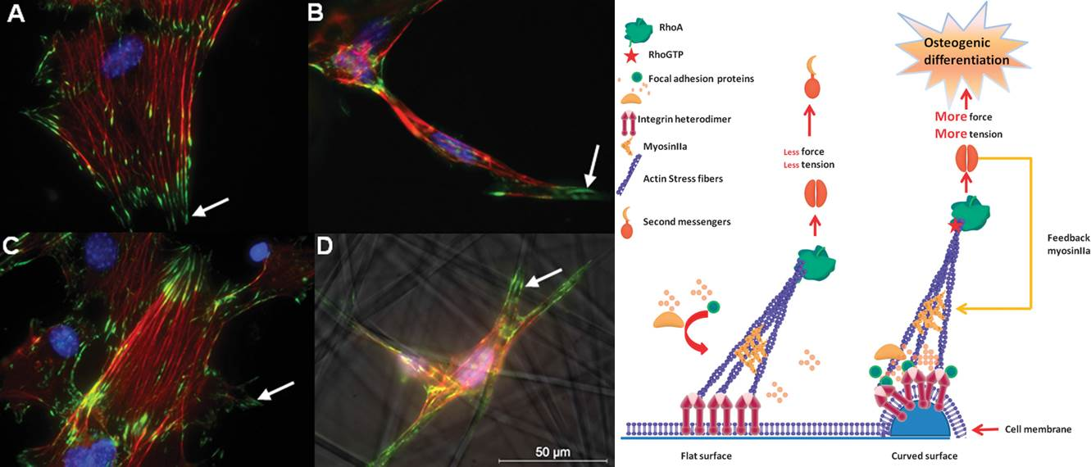

Figure 9. Schematic of topography sensing through RhoA/ROCK signaling [191].

Hence, fibrous networks are significantly more complex physical and geometrical environments than other 2D or quasi 2D substrates. In addition to their intrinsic porosity, the stiffness of the fibres that they are based on (hence the nanoscale mechanics rather than bulk mechanics of the mats) can impact on cell adhesion and phenotype.

When comparing fibrous scaffolds with similar sizes but different porosity, cells were found to proliferate more in mats of poly(3-caprolactone) (PCL) with pore diameter bigger than 6 μm, while proliferation is impaired when pores smaller than 3 μm are presented to cells [193]. When going to pore sizes > 20 μm, cell deposition of ECM decreases and cells tend to align and spread on single fibres rather than branching across.

Grooves, as fibres, allow the control of cell alignment and morphology. In neonatal rat ventricular myocytes (NRVMs) cultured on substrates with controlled nanotopography (nanoridges/grooves), actin fibres were aligned and more organised along the ridge and FA formation was observed at the side of the ridges. Such topographically triggered reorganization of the cell cytoskeleton was found to depend on the size of the patterns [23]. This behaviour is general to a range of materials and cells spreading at the surface of grooved materials are subjected to contact guidance and tend to align in the direction of the grooves, depending on the size (width, depth and spacing) of the features. On 240 and 540 nm deep groove (12.5 μm wide) cell nuclei were more distorted and greater numbers of focal complexes were formed than on planar surfaces. Such changes in FA formation correlated with a decrease in FAK activation and downregulation of osteogenesis in osteoblast-like MG63 cultured on grooved surfaces [194]. On chip with grooves ranging from 2 to 15 μm wide (2 μm deep), MSCs were found to differentiate in different lineages depending on the width on the groove: adipogenesis was favoured on bigger grooves, whilst osteogenic differentiation on the smallest [195]. Migration was also found to be directed parallel to the direction of the grooves.

In order to decouple the respective contributions of nanotopography and stiffness on cell behaviour, cells were cultured on soft nanopatterned (nanogratings of 350 and 500 nm width and 350 nm depth) PDMS substrates [126]. The sensing of stiffness, rather than topography, was found to control the expression of proteins associated with FA formation (integrins and vinculin) and the organization of actin fibres. On the other hand, surface features and stiffness were found to impact on the ability of cells to exert a higher cytoskeletal tension on a stiffer surface.

The tuning of the nanoroughness of surfaces to control the behaviour of cells and stem cells has recently received considerable attention from the bioengineering community, owing to the implication of such surface texturing for for the design of implants. On surfaces presenting different microtopographies and roughness, hMSCs adhered preferentially on homogenous surfaces whilst adhesion was impaired on nanostructured porous silicon [79]. This correlated with the reduced formation of actin fibers and a decrease in cell migration on rough silicon surfaces. Human embryonic stem cell (hESC) proliferation was also decreased and adhesions were disrupted on nanorough surfaces, compared with homogenous controls [196]. Furthermore, while stemness was retained on smooth surfaces, cells on rough surfaces differentiated more frequently. This behaviour correlated with disrupted FA formation and a change in the expression of non-muscle myosin IIA, known to control stem cell self-renewal. Importantly, the response to surface roughness is often cell dependent: in the same study, the response of fibroblasts to surface roughness was the opposite of that of hESCs and these former cells adhered and spread better on rougher surfaces.

The level of order and disorder of the surface topography was also found to affect the formation of FAs by affecting integrin recruitment [13] and FA maturation and cell spreading. Dalby et al. produced surfaces textured with nanopits arranged in square, hexagonal and disordered square arrays (with 120 nm diameter, 100 nm deep and an average spacing ranging from 50 to 20 nm). The disordered arrays stimulated osteogenic differentiation of human mesenchymal stem cell (MSCs) while ordered arrays showed poorer cellular adhesion and decreased osteoblastic differentiation [81]. Ordered arrays disrupted FA formation and cell spreading possibly affecting the ERK/MAPK signalling pathways which in turn downregulated differentiation [15]. MSCs were more spread on the ordered square arrays, but FA size and level of actomyosin recruitment at stress fibres were higher on disordered arrays. These cytoskeletal changes were also correlated with changes in nuclear lamina remodelling [197]. However, although ordered nanopit surfaces were not as efficient at inducing osteo-differentiation, they can be used to retain the stemness of MSCs when cultured over long periods of time, hence allowing their expansion from few cells or to higher cell numbers, an important development for the field of cell based therapies [198].

Similarly, hMSC differentiation was found to depend on the density of nanoposts on textured surfaces [199]. Cells on surfaces presenting denser topographies were more rounded and softer, favouring adipogenesis, while on sparser nanopost surfaces, cells were stiffer and underwent osteogenic differentiation.

Cells spreading on nanopillars with diameters ranging from 200 to 700 nm [129] present FA assembly similar to the one of cells spreading on 2D circular patches of similar size range. FAs were decreasing in size with pillar diameter, but on 200 nm bridging of adjacent pillars as a result of forces exerted by cells, allowed larger focal adhesions to be generated. The smallest nanopillars display lower flexural moduli and allow higher cell-substrate interactions. Similarly, the height of Titania nanopillars ranging from 15 to 100 nm was also found to control cell spreading and differentiation [200]. Shorter pillars maximised cell spreading, cytoskeleton organisation and osteoblastic differentiation.

It is thus evident that designing the size and shape of surface features at the nano- to micro-scale is important to control some of the physical properties of the ECM and the stimuli that cells sense and to which they adjust during fate decision. Such changes in behaviour seem to be directly controlled by changes in focal adhesion formation and cytoskeleton organisation. However, this response is cell type dependent, which highlights the importance of understanding both the biological and physical context in order to design surfaces and implants appropriate for specific applications.

## 4.4 Nanoscale remodelling of the matrix.

The ability of cells to remodel their microenvironment is clearly illustrated by their ability to degrade and migrate through hydrogels {Friedl, 2012 #220{Yilmaz`, 2009 `#221;Friedl, 2012 #220}[201, 202] as well as trigger processes such as angiogenesis [203]. The deformation of engineered extra-cellular matrix also clearly highlights the relationship between stress applied at adhesions, resulting deformation of the matrix and control of cell phenotype [130, 133, 187]. Not surprisingly, such remodelling plays an important role in the sensing of the cell microenvironment at the nanoscale. This section will focus on such processes and will present in particular how local nanoscale remodelling and deformation of the matrix plays an important role in controlling cell behaviour.

Cell behaviour is typically altered by changes in the mechanical properties of the ECM. Hence stem cell fate decision is modulated by matrix stiffness and this behaviour is often associated with marked changes in focal adhesion formation and cell morphology [82-84, 204]. This, in turn, can strongly impact on the behaviour of stem cells such as MSCs [82]. Indeed MSCs committed to differientate into different lineages depending stiffness of the matrix on which they spread: neurogenic for soft, myogenic for stiffer and osteogenic for rigid matrices. A material commonly used for such studies is polyacrylamide (PA), as its rigidity can conveniently be varied via the level of crossilinking and the concentration of monomers used during the formation of the gels [140]. Spreading and cytoskeleton organization were enhanced when smooth muscle cells were cultured on stiff PA gels, in a ligand density dependent manner. Similarly, cells responded to substrate stiffness independently of apparent matrix porosity and protein tethering , suggesting that differentiation was not affected by changes in porosity, but only by bulk mechanical properties [84]. In addition, it was demonstrated that the binding of integrins to ligand was weaker on soft substrate, therefore favoring integrin internalization and stem cell differentiation [205]. Thus cells apparently respond to the bulk mechanical properties of the extracellular matrix

However, recent reports highlight that bulk mechanical properties may in fact be dominated by nanoscale interfacial properties. Hence stem cell spreading was unaffected by the mechanical properties of poly(dimethyl siloxane) (PDMS) substrates, in contrast to their behaviour on polyacrylamide hydrogels of similar range of stiffness [83]. Similarly focal adhesion formation and cell differentiation were not significantly altered on ultra-soft PDMS whereas it strongly depended on the stiffness of hydrogels. A similar lack of response of cell spreading and motility to the stiffness of crosslinked collagen gels was observed in the case of fibroblasts [159]. Instead, matrix porosity was found to have a stronger impact on cell behaviour. Others found that the number and size of focal adhesions and in turn cell polarization were affected by the stiffness of PDMS matrices, but without significant changes in total cell spreading [206].

These somewhat conflicting results highlight the need for a deeper understanding of molecular mechanisms underlying cell spreading and in particular how nanoscale mechanical properties of the matrix impact on cell behaviour. Indeed, one direct implication of matrix compliance is its deformation when sustaining shear forces during cell spreading and motility. This in turn may have a direct impact on ligand accessibility and clustering. The ability of cells to deform the matrix to cluster ligands is well illustrated by traction force microscopy, which highlights the strong stresses that matrices experience during the spreading of cells in 2D. Interestingly these stresses are not confined to the plane of the matrix onto which cells spread, but also extend normal to this plane [207]. Preosteoblasts seeded on RGD-functionalised alginate gels locally deformed their matrix to cluster adhesive ligands, as evidenced by FRET microscopy. This behaviour was found to be stiffness dependent, with ligand clustering being maximised on alginate gels with intermediate compliance (60 kPa) [208]. Such nanoscale remodelling may also explain the lack of cell response to PDMS mechanical properties. Cell response to the compliance of alginate gels with identical Youngs’ moduli but different frequency dependent shear properties (comparing alginate gels crosslinked covalently and with calcium ions) was strikingly different [209]. Whereas cells remained rounded on 1.4 kPa covalently crosslinked alginate gels with elastic properties and low stress relaxation, they were able to spread on gels of similar stiffness with ionic crosslinking. This behaviour was strongly dependent on ligand density and mediated via the formation of focal adhesions and the establishment of a structured actin cytoskeleton. It also correlated with the ability of cells to cluster adhesive ligands on the alginate gels displaying more viscous properties. Similarly, cell spreading was modulated by the flexibility and motility of ligands bound to hard substrates [210, 211], suggesting that ligand mobility and clustering is a relatively general behaviour controlling cell adhesion, perhaps via the regulation of integrin clustering. Lautscham et al. used multiple phospholipid bilayer assemblies to control substrate compliance and the mobility of adhesive ligands independently of their surface density [212]. Cell spreading, focal adhesion formation and motility were gradually impaired as substrate compliance and ligand mobility increased.

When going to 3D matrices, although cell morphology changes strikingly as a result of the change in apico-basal asymmetry, similar concepts have been explored. However, marked differences are observed in the type and morphology of adhesions that are formed in 3D and focal adhesions structure, composition (content of integrin, paxillin etc.), dynamics and stress generation significantly differs [213]. Typically, in 3D matrices, focal adhesions are not observed by conventional confocal microscopy, either implying that they do not form or that their size and geometry are significantly different compared to 2D adhesions [150]. Proteins normally recruited at 2D adhesions (talin, paxillin, vinculin, α‑actinin, zyxin, vasodilator-stimulated phosphoprotein (VASP), and enzymes and adaptor proteins FAK and p130Cas) did not form adhesive clusters but were homogenously distributed in the cytoskeleton and at the cell membrane. Cell migration was also found to be significantly altered, not surprisingly given the physical barrier of the 3D microenvironment, but was still found to be dependent on β1 integrins (although 3D migration is not always integrin dependent, depending on cell type [214]). Despite the lack of formation of large protein complexes, cell protrusions formed, although with different sizes compared to 2D, and their activity was influenced by focal adhesion proteins. Furthermore changes in their dynamics correlated with changes in cell speed, showing that motility is regulated by FA proteins through changes in protrusion number and growth speed [215]. In addition, using beads embedded in the matrix to track stresses generated, it was observed that cells only pull at the matrix without pushing. Adhesion proteins such as VASP, talin, vinculin, p130Cas and FAK were also involved in the generation of such traction forces. Cell motility in 3D is thus regulated by the formation of protrusions that test the environment and pull the matrix via mechanisms relying on focal adhesion proteins, despite the lack of large cluster formation. Interestingly, cell speed was not found to be affected by matrix rigidity, but rather by changes in the microenvironment geometry. In contrast, Kubow and Horwitz [151] observed the formation of focal adhesion like structures at the leading edge of cells embedded in 3D matrices. Once formed, these FA-like structures deform the matrix during their retraction. Hence, the formation of FAs in 3D matrices is still disputed but there is clear evidence that the same molecules involved in adhesive behaviour in 2D are recruited to cell protrusions in 3D and are controlling matrix deformation [215].

Hence, cells exert strong forces on their 3D microenvironment too, although the processes and geometry via which these forces are generated are potentially different, most likely as a result of the altered adhesive geometry and associated altered cell morphology and distribution of adhesive proteins at the cell membrane. Hence, it was found that traction forces are maximal at the tip of long protrusions generated by cells cultured in 3D matrices [216]. In addition, it was found that during the growth of cellular extensions, the tip itself is not applying strong stresses to the matrix and stresses are applied several microns behind these tips. Therefore matrix remodelling involves a complex pattern of matrix degradation, protrusion formation and associated traction forces in order to sustain cell motility and tissue development. In addition, cells exerted stronger forces on stiffer 3D matrices, in contrast to the contractile behaviour of cells spreading on 2D matrices. Indeed, cells spreading on collagen- glycosaminoglycan (GAG) (chondroitin 6-sulfate) matrices exerted similar forces, independently of the matrix stiffness, rather than applying fixed deformations to their surrounding matrix [217]. The spacing of collagen fibrils (porosity) thus plays a major role in cell spreading and migration, rather than matrix stiffness. This is due to the fact that displacement of the protein is prevented at lower porosity (higher collagen concentration) and cell migration is facilitated [159]. Cell morphology is also very different depending on whether cells are embedded inside or laying on the surface of the matrix: hence, mechano-sensing processes in 3D are likely to be distinct than in 2D. Moreover, studying the modulation of 3D cell motility by protrusions and branching events in 3D collagen matrices, a strong correlation between cell branching and the local cell-surface curvature was observed [152]. This process is controlled by myosin II motor activity. Myosin regulates cell branching, minimising the surface curvature and vice versa cell-surface curvature controls myosin II cortical localization. Hence myosin II controls cell branching direction and orientation in 3D, through the regulation of its assembly/disassembly cycles at the cortex.

Stem cell differentiation is also strongly affected by the structure and mechanics of 3D matrices. However the relationship between stiffness and matrix remodelling is complex and may explain somewhat contradicting results. In covalently crosslinked hyaluronic acid (HA) hydrogels hMSCs were found to differentiate via a degradation-mediated mechanism, independently of matrix mechanics [147]. When cells were able to degrade and remodel the matrix they were more spread, generated higher traction forces and committed to osteogenic differentiation. Adipogenesis occurred instead in the opposite scenario. In contrast, MSCs cultured in 3D alginate gels with varying degrees of stiffness committed to osteogenic differentiation on relatively rigid matrices 11-30 kPa and adipogenic lineage in softer gels (2.5-5 kPa) [164]. This behaviour correlated with increased ligand clustering for matrices with moduli close to 20 kPa. Similarly, the behaviour of normal mammary epithelial cells could be biased towards a malignant phenotype via matrix stiffness alone (Figure 12) [165]. Using interpenetrating networks of alginate and reconstituted basement membrane (rBM) matrix (Matrigel), it was shown that in this case too ligand clustering is key to the phenotypes observed.



Figure 10. Nanoscale remodelling of extra-cellular matrix controls malignant cell phenotype [165].

Hence the different nanoscale remodelling events that can occur in 3D matrices, depending on matrix stiffness, morphology and degradability are likely to result in complex and often contradicting cell behaviours. Therefore, a greater understanding of hydrogels physico-chemical behaviour during degradation and under cell tension will be essential to allow the design of artificial extra-cellular matrices with applications in tissue engineering and regenerative medicine.

# Conclusions

Cell sensing of the nanoscale physical properties of biomaterials underlies cell spreading and the control of motility and is essential to direct cell phenotypes such as proliferation, differentiation and apoptosis. The molecular processes regulating adhesion formation (molecular clustering, protein complexing, actin polymerisation, bundling and contractility) and their dynamics play a key role in such nanoscale sensing. In addition, increasing evidence indicates that such response to nanoscale properties may in fact dominate cell response to bulk properties of materials, as in the case of the response of cells to matrix mechanics. However, the precise molecular mechanism via which cells sense the nanoscale properties of their microenvironment remains often poorly understood. This is particularly important to fully understand mechanotransduction processes that in turn control cell phenotype. The direct implication of such understanding is the ability to design novel biomaterials allowing an improved control of cell adhesion and behaviour. Engineering the nanoscale properties of biomaterials is particularly appealing for applications in tissue engineering and regenerative medicine as it allows the design of bulk and interfacial properties of implants, scaffolds and cell culture systems independently. Indeed, the structural and mechanical properties of such platforms and their ability to control cell adhesion and phenotype are sometimes hard to reconcile. This is the case for example in the design of implantable brain electrodes or for soft tissue engineering where mechanical integrity is essential, as in cardiac repair. Hence the design of biomaterials for such applications is inherently multidisciplinary and requires technological challenges to be tackled for the synthesis, processing and patterning of relevant materials, with control of the nanoscale, as well as a deeper understanding of the molecular processes underlying their interaction with cells and tissues.

**References**

[1] Lutolf MP, Hubbell JA. Synthetic biomaterials as instructive extracellular microenvironments for morphogenesis in tissue engineering. Nat Biotechnol 2005;23:47-55.

[2] Geiger B, Spatz JP, Bershadsky AD. Environmental sensing through focal adhesions. Nat Rev Mol Cell Bio 2009;10:21-33.

[3] Vogel V, Sheetz M. Local force and geometry sensing regulate cell functions. Nat Rev Mol Cell Bio 2006;7:265-75.

[4] Harburger, Calderwood. Integrin signalling at a glance. J Cell Sci 2009;122:159-63.

[5] Petit V, Thiery JP. Focal adhesions: structure and dynamics. Biol Cell 2000;92:477-94.

[6] Wolfenson H., Alexander Bershadsky, Henis YI, Geiger aB. Actomyosin-generated tension controls the molecular kinetics of focal adhesions. J Cell Sci 2010;124:1425-32.

[7] Roca-Cusachs P, del Rio A, Puklin-Faucher E, Gauthier NC, Biais N, Sheetz MP. Integrin-dependent force transmission to the extracellular matrix by alpha-actinin triggers adhesion maturation. PNAS 2013;110:E1361-70.

[8] Bershadsky AD, Ballestrem C, Carramusa L, Zilberman Y, Gilquin B, Khochbin S, et al. Assembly and mechanosensory function of focal adhesions: experiments and models. Eur J Cell Biol 2006;85:165-73.

[9] Worth DC, Parsons M. Adhesion dynamics: mechanisms and measurements. Int J Biochem Cell B 2008;40:2397-409.

[10] Choi CK, Vicente-Manzanares M, Zareno J, Whitmore LA, Mogilner A, Horwitz AR. Actin and alpha-actinin orchestrate the assembly and maturation of nascent adhesions in a myosin II motor-independent manner. Nat Cell Biol 2008;10:1039-50.

[11] Zaidel-Bar R, Ballestrem C, Kam Z, Geiger B. Early molecular events in the assembly of matrix adhesions at the leading edge of migrating cells. J Cell Sci 2003;116:4605-13.

[12] Ponti A, Machacek M, Gupton S, Waterman-Storer C, Danuser G. Two distinct actin networks drive the protrusion of migrating cells. Science 2004;305:1782-6.

[13] Huang JH, Grater SV, Corbellinl F, Rinck S, Bock E, Kemkemer R, et al. Impact of Order and Disorder in RGD Nanopatterns on Cell Adhesion. Nano Lett 2009;9:1111-6.

[14] Malmstrom J, Christensen B, Jakobsen HP, Lovmand J, Foldbjerg R, Sorensen ES, et al. Large area protein patterning reveals nanoscale control of focal adhesion development. Nano Lett 2010;10:686-94.

[15] Biggs MJP, Richards RG, Gadegaard N, Wilkinson CDW, Oreffo ROC, Dalby MJ. The use of nanoscale topography to modulate the dynamics of adhesion formation in primary osteoblasts and ERK/MAPK signalling in STRO-1+ enriched skeletal stem cells. Biomaterials 2009;30:5094–103.

[16] Zent MBSaR. Integrin Structure and Function. Cell-Extracellular Matrix Interactions in Cancer 2010.

[17] Shroff H, Galbraith CG, Galbraith JA, White H, Gillette J, Olenych S, et al. Dual-color superresolution imaging of genetically expressed probes within individual adhesion complexes. PNAS 2007;104:20308-13.

[18] Kanchanawong P, Shtengel G, Pasapera AM, Ramko EB, Davidson MW, Hess HF, et al. Nanoscale architecture of integrin-based cell adhesions. Nature 2010;468:580-4.

[19] Xu K, Babcock HP, Zhuang X. Dual-objective STORM reveals three-dimensional filament organization in the actin cytoskeleton. Nat Methods 2012;9:185-8.

[20] Pasapera AM, Schneider IC, Rericha E, Schlaepfer DD, Waterman CM. Myosin II activity regulates vinculin recruitment to focal adhesions through FAK-mediated paxillin phosphorylation. J Cell Biol 2010;188:877-90.

[21] Grashoff C, Hoffman BD, Brenner MD, Zhou RB, Parsons M, Yang MT, et al. Measuring mechanical tension across vinculin reveals regulation of focal adhesion dynamics. Nature 2010;466:263-U143.

[22] Berginski ME, Vitriol EA, Hahn KM, Gomez SM. High-resolution quantification of focal adhesion spatiotemporal dynamics in living cells. PloS one 2011;6:e22025.

[23] Kim DH, Lipke EA, Kim P, Cheong R, Thompson S, Delannoy M, et al. Nanoscale cues regulate the structure and function of macroscopic cardiac tissue constructs. PNAS 2010;107:565-70.

[24] Smith PG, Garcia R, Kogerman L. Strain reorganizes focal adhesions and cytoskeleton in cultured airway smooth muscle cells. Exp Cell Res 1997;232:127-36.

[25] Patla I, Volberg T, Elad N, Hirschfeld-Warneken V, Grashoff C, Fassler R, et al. Dissecting the molecular architecture of integrin adhesion sites by cryo-electron tomography. Nat Cell Biol 2010;12:909-15.

[26] Shattil SJ, Kim C, Ginsberg MH. The final steps of integrin activation: the end game. Nat Rev Mol Cell Bio 2010;11:288-300.

[27] Klotzsch E, Smith ML, Kubow KE, Muntwyler S, Little WC, Beyeler F, et al. Fibronectin forms the most extensible biological fibers displaying switchable force-exposed cryptic binding sites. PNAS 2009;106:18267-72.

[28] Salmeron-Sanchez M, Rico P, Moratal D, Lee TT, Schwarzbauer JE, Garcia AJ. Role of material-driven fibronectin fibrillogenesis in cell differentiation. Biomaterials 2011;32:2099-105.

[29] Vanterpool FA, Cantini M, Seib FP, Salmeron-Sanchez M. A material-based platform to modulate fibronectin activity and focal adhesion assembly. BioRes Open Access 2014;3:286-96.

[30] Wiseman PW, Brown CM, Webb DJ, Hebert B, Johnson NL, Squier JA, et al. Spatial mapping of integrin interactions and dynamics during cell migration by image correlation microscopy. J Cell Sci 2004;117:5521-34.

[31] Schwingel M, Bastmeyer M. Force mapping during the formation and maturation of cell adhesion sites with multiple optical tweezers. PloS one 2013;8:e54850.

[32] Shroff H, Galbraith CG, Galbraith JA, Betzig E. Live-cell photoactivated localization microscopy of nanoscale adhesion dynamics. Nat Methods 2008;5:417-23.

[33] Gardel ML, Sabass B, Ji L, Danuser G, Schwarz US, Waterman CM. Traction stress in focal adhesions correlates biphasically with actin retrograde flow speed. J Cell Biol 2008;183:999-1005.

[34] Roca-Cusachs P, Gauthier NC, del Rio A, Sheetz MP. Clustering of α5β1 integrins determines adhesion strength whereas αvβ3 and talin enable mechanotransduction. PNAS 2009;106:16245–50. [35] Schiller HB, Hermann M-R, Polleux J, Vignaud T, Zanivan S, Friedel CC, et al. β1- and αv-class integrins cooperate to regulate myosin II during rigidity sensing of fibronectin-based microenvironments. Nat Cell Biol 2013;15:625-36.

[36] Rossier O, Octeau V, Sibarita JB, Leduc C, Tessier B, Nair D, et al. Integrins beta1 and beta3 exhibit distinct dynamic nanoscale organizations inside focal adhesions. Nat Cell Biol 2012;14:1057-67.

[37] Lee HS, Anekal P, Lim CJ, Liu CC, Ginsberg MH. Two modes of integrin activation form a binary molecular switch in adhesion maturation. Mol Biol Cell 2013;24:1354-62.

[38] Zhang X, Jiang G, Cai Y, Monkley SJ, Critchley DR, Sheetz MP. Talin depletion reveals independence of initial cell spreading from integrin activation and traction. Nat Cell Biol 2008;10:1062-8.

[39] Bakolitsa C, Cohen DM, Bankston LA, Bobkov AA, Cadwell GW, Jennings L, et al. Structural basis for vinculin activation at sites of cell adhesion. Nature 2004;430:583-6.

[40] del Rio A, Perez-Jimenez R, Liu R, Roca-Cusachs P, Fernandez JM, Sheetz MP. Stretching single talin rod molecules activates vinculin binding. Science 2009;323:638-41.

[41] Dumbaulda D.W., Ted T. Leea, Ankur Singha, Jan Scrimgeourb, Charles A. Gersbacha, Evan A. Zamir, et al. How vinculin regulates force transmission. PNAS 2013;110:9788–93.

[42] Humphries JD, Wang P, Streuli C, Geiger B, Humphries MJ, Ballestrem C. Vinculin controls focal adhesion formation by direct interactions with talin and actin. J Cell Biol 2007;179:1043-57.

[43] Thievessen I, Thompson PM, Berlemont S, Plevock KM, Plotnikov SV, Zemljic-Harpf A, et al. Vinculin–actin interaction couples actin retrograde flow to focal adhesions, but is dispensable for focal adhesion growth. J Cell Biol 2013;202:163-77.

[44] Case LB, Baird MA, Shtengel G, Campbell SL, Hess HF, Davidson MW, et al. Molecular mechanism of vinculin activation and nanoscale spatial organization in focal adhesions. Nat Cell Biol 2015.

[45] Carisey A, Tsang R, Greiner AM, Nijenhuis N, Heath N, Nazgiewicz A, et al. Vinculin regulates the recruitment and release of core focal adhesion proteins in a force-dependent manner. Curr Biol 2013;23:271-81.

[46] Le Devedec SE, Geverts B, de Bont H, Yan K, Verbeek FJ, Houtsmuller AB, et al. The residence time of focal adhesion kinase (FAK) and paxillin at focal adhesions in renal epithelial cells is determined by adhesion size, strength and life cycle status. J Cell Sci 2012;125:4498-506.

[47] Egelman E. The structure of F-actin. J Muscle Res Cell Motil 1985;6:129-51.

[48] Streichfuss M, Erbs F, Uhrig K, Kurre R, Clemen AEM, Bohm CHJ, et al. Measuring Forces between Two Single Actin Filaments during Bundle Formation. Nano Lett 2011;11:3676-80.

[49] Footer MJ, Kerssemakers JW, Theriot JA, Dogterom M. Direct measurement of force generation by actin filament polymerization using an optical trap. PNAS 2007;104:2181-6.

[50] Loosli Y, Luginbuehl R, Snedeker JG. Cytoskeleton reorganization of spreading cells on micro-patterned islands: a functional model. Philos T R Soc A 2010;368:2629-52.

[51] Loosli Y, Vianay B, Luginbuehl R, Snedeker JG. Numerically bridging lamellipodial and filopodial activity during cell spreading reveals a potentially novel trigger of focal adhesion maturation. Integr Biol-Uk 2012;4:508-21.

[52] Loosli Y, Labouesse C, Luginbuehl R, Meister JJ, Snedekerz JG, Vianayz B. An actin length threshold regulates adhesion maturation at the lamellipodium/lamellum interface. Integr Biol-Uk 2013;5:865-76.

[53] Cardamone L, Laio A, Torre V, Shahapure R, DeSimone A. Cytoskeletal actin networks in motile cells are critically self-organized systems synchronized by mechanical interactions. PNAS 2011;108:13978-83.

[54] Shahapure R, Difato F, Laio A, Bisson G, Ercolini E, Amin L, et al. Force Generation in Lamellipodia Is a Probabilistic Process with Fast Growth and Retraction Events. Biophys J 2010;98:979-88.

[55] Prass M, Jacobson K, Mogilner A, Radmacher M. Direct measurement of the lamellipodial protrusive force in a migrating cell. J Cell Biol 2006;174:767-72.

[56] Parekh SH, Chaudhuri O, Theriot JA, Fletcher DA. Loading history determines the velocity of actin-network growth. Nat Cell Biol 2005;7:1219-23.

[57] Pollard TD, Blanchoin L, Mullins RD. Molecular mechanisms controlling actin filament dynamics in nonmuscle cells. Annu Rev Bioph Biom 2000;29:545-76.

[58] McCullough BR, Blanchoin L, Martiel JL, De la Cruz EM. Cofilin increases the bending flexibility of actin filaments: implications for severing and cell mechanics. J Mol Biol 2008;381:550-8.

[59] Michelot A, Berro J, Guerin C, Boujemaa-Paterski R, Staiger CJ, Martiel JL, et al. Actin-filament stochastic dynamics mediated by ADF/cofilin. Curr Biol: CB 2007;17:825-33.

[60] Suarez C., Roland, Rajaa Boujemaa-Paterski, Hyeran Kang, Brannon R. McCullough, Anne-Cécile Reymann, et al. Cofilin Tunes the Nucleotide State of Actin Filaments and Severs at Bare and Decorated Segment Boundaries. Curr Biol 2011;21:862–8.

[61] Courtemanche N, Lee JY, Pollard TD, Greene EC. Tension modulates actin filament polymerization mediated by formin and profilin. PNAS 2013;110:9752-7.

[62] Esue O, Harris ES, Higgs HN, Wirtz D. The filamentous actin cross-linking/bundling activity of mammalian formins. J Mol Biol 2008;384:324-34.

[63] Ehrlicher AJ, Nakamura F, Hartwig JH, Weitz DA, Stossel TP. Mechanical strain in actin networks regulates FilGAP and integrin binding to filamin A. Nature 2011;478:260-3.

[64] Rognoni L, Stigler J, Pelz B, Ylanne J, Rief M. Dynamic force sensing of filamin revealed in single-molecule experiments. PNAS 2012;109:19679-84.

[65] Elkhatib N, Neu MB, Zensen C, Schmoller KM, Louvard D, Bausch AR, et al. Fascin Plays a Role in Stress Fiber Organization and Focal Adhesion Disassembly. Curr Biol 2014;24:1492-9.

[66] Tseng Y, Kole TP, Lee JSH, Fedorov E, Alino SC, Schafer BW, et al. How actin crosslinking and bundling proteins cooperate to generate an enhanced cell mechanical response. Biochem Bioph Res Co 2005;334:183-92.

[67] Hu K, Ji L, Applegate KT, Danuser G, Waterman-Storer CM. Differential transmission of actin motion within focal adhesions. Science 2007;315:111-5.

[68] Laakso JM, Lewis JH, Shuman H, Ostap EM. Myosin I can act as a molecular force sensor. Science 2008;321:133-6.

[69] Pasapera AM, Plotnikov SV, Fischer RS, Case LB, Egelhoff TT, Waterman CM. Rac1-dependent phosphorylation and focal adhesion recruitment of myosin IIA regulates migration and mechanosensing. Curr Biol 2015;25:175-86.

[70] Lavelin I, Wolfenson H, Patla I, Henis YI, Medalia O, Volberg T, et al. Differential effect of actomyosin relaxation on the dynamic properties of focal adhesion proteins. PloS one 2013;8:e73549.

[71] Lee CY, Lou JZ, Wen KK, McKane M, Eskin SG, Ono S, et al. Actin depolymerization under force is governed by lysine 113:glutamic acid 195-mediated catch-slip bonds. PNAS 2013;110:5022-7.

[72] Han SJ, Oak Y, Groisman A, Danuser G. Traction microscopy to identify force modulation in subresolution adhesions. Nat Methods 2015.

[73] Maiuri P, Rupprecht J-F, Wieser S, Ruprecht V, Bénichou O, Carpi N, et al. Actin Flows Mediate a Universal Coupling between Cell Speed and Cell Persistence. Cell 2015;161:374-86.

[74] Bruinsma R. Theory of force regulation by nascent adhesion sites. Biophys J 2005;89:87-94.

[75] Deeg JA, Louban I, Aydin D, Selhuber-Unkel C, Kessler H, Spatz JP. Impact of Local versus Global Ligand Density on Cellular Adhesion. Nano Lett 2011;11:1469-76.

[76] Rahmouni S, Lindner A, Rechenmacher F, Neubauer S, Sobahi TRA, Kessler H, et al. Hydrogel Micropillars with Integrin Selective Peptidomimetic Functionalized Nanopatterned Tops: A New Tool for the Measurement of Cell Traction Forces Transmitted through αvβ3 - or α5β1 -Integrins. Adv Mater 2013;25:5869–74.

[77] Schvartzman M, Palma M, Sable J, Abramson J, Hu XA, Sheetz MP, et al. Nanolithographic Control of the Spatial Organization of Cellular Adhesion Receptors at the Single-Molecule Level. Nano Lett 2011;11:1306-12.

[78] Higgins AM, Banik BL, Brown JL. Geometry sensing through POR1 regulates Rac1 activity controlling early osteoblast differentiation in response to nanofiber diameter. Integ Biol 2015;7:229-36.

[79] Pereza D.G., Esther Punzón Quijornaa, Ruy Sanzd, Vicente Torres-Costa, Josefa P. García Ruize, Silván MM. Nanotopography enhanced mobility determines mesenchymal stem cell distribution on micropatterned semiconductors bearing nanorough areas. Colloid Surfaces B 2015;126:146–53.

[80] Christopherson GT, Song H, Mao HQ. The influence of fiber diameter of electrospun substrates on neural stem cell differentiation and proliferation. Biomaterials 2009;30:556-64.

[81] Dalby MJ, Gadegaard N, Tare R, Andar A, Riehle MO, Herzyk P, et al. The control of human mesenchymal cell differentiation using nanoscale symmetry and disorder. Nat Mater 2007;6:997-1003.

[82] Engler AJ, Sen S, Sweeney HL, Discher DE. Matrix elasticity directs stem cell lineage specification. Cell 2006;126:677-89.

[83] Trappmann B, Gautrot JE, Connelly JT, Strange DG, Li Y, Oyen ML, et al. Extracellular-matrix tethering regulates stem-cell fate. Nat Mater 2012;11:642-9.

[84] Wen JH, Vincent LG, Fuhrmann A, Choi YS, Hribar KC, Taylor-Weiner H, et al. Interplay of matrix stiffness and protein tethering in stem cell differentiation. Nat Mater 2014;13:979-87.

[85] Kolodziej CM, Maynard HD. Electron-Beam Lithography for Patterning Biomolecules at the Micron and Nanometer Scale. Chem Mater 2012;24:774-80.

[86] Yang SM, Jang SG, Choi DG, Kim S, Yu HK. Nanomachining by colloidal lithography. Small 2006;2:458-75.

[87] Wood MA. Colloidal lithography and current fabrication techniques producing in-plane nanotopography for biological applications. J R Soc Interface 2007;4:1-17.

[88] Nie ZH, Kumacheva E. Patterning surfaces with functional polymers. Nat Mater 2008;7:277-90.

[89] Geissler M, Xia YN. Patterning: Principles and some new developments. Adv Mater 2004;16:1249-69.

[90] Gates BD, Xu Q, Stewart M, Ryan D, Willson CG, Whitesides GM. New approaches to nanofabrication: molding, printing, and other techniques. Chemical reviews 2005;105:1171-96.

[91] Zhang SG. Fabrication of novel biomaterials through molecular self-assembly. Nat Biotechnol 2003;21:1171-8.

[92] Mai YY, Eisenberg A. Self-assembly of block copolymers. Chem Soc Rev 2012;41:5969-85.

[93] Klok HA, Lecommandoux S. Supramolecular materials via block copolymer self-assembly. Adv Mater 2001;13:1217-29.

[94] Bates FS. Polymer-polymer phase behavior. Science 1991;251:898-905.

[95] Steiner U, Klein J, Fetters LJ. Surface Phase Inversion in Finite-Sized Binary-Mixtures. Phys Rev Lett 1994;72:1498-501.

[96] Darling SB. Directing the self-assembly of block copolymers. Prog Polym Sci 2007;32:1152-204.

[97] Rosler A, Vandermeulen GWM, Klok HA. Advanced drug delivery devices via self-assembly of amphiphilic block copolymers. Adv Drug Deliver Rev 2012;64:270-9.

[98] Smart T, Lomas H, Massignani M, Flores-Merino MV, Perez LR, Battaglia G. Block copolymer nanostructures. Nano Today 2008;3:38-46.

[99] Kumar N, Hahm JI. Nanoscale protein patterning using self-assembled diblock copolymers. Langmuir 2005;21:6652-5.

[100] Cavalcanti-Adam EA, Micoulet A, Blummel J, Auernheimer J, Kessler H, Spatz JP. Lateral spacing of integrin ligands influences cell spreading and focal adhesion assembly. Eur J Cell Biol 2006;85:219-24.

[101] Gugutkov D, Gonzalez-Garcia C, Hernandez JCR, Altankov G, Salmeron-Sanchez M. Biological Activity of the Substrate-Induced Fibronectin Network: Insight into the Third Dimension through Electrospun Fibers. Langmuir 2009;25:10893-900.

[102] Rico P, Hernandez JCR, Moratal D, Altankov G, Pradas MM, Salmeron-Sanchez M. Substrate-Induced Assembly of Fibronectin into Networks: Influence of Surface Chemistry and Effect on Osteoblast Adhesion. Tissue Eng Pt A 2009;15:3271-81.

[103] Slater JH, Boyce PJ, Jancaitis MP, Gaubert HE, Chang AL, Markey MK, et al. Modulation of Endothelial Cell Migration via Manipulation of Adhesion Site Growth Using Nanopatterned Surfaces. Acs Appl Mater Inter 2015;7:4390-400.

[104] del Campo A, Arzt E. Fabrication approaches for generating complex micro- and nanopatterns on polymeric surfaces. Chem Rev 2008;108:911-45.

[105] Cheng ZA, Zouani OF, Glinel K, Jonas AM, Durrieu M-C. Bioactive chemical nanopatterns impact human mesenchymal stem cell fate. Nano Lett 2013;13:3923-9.

[106] Hua F, Sun YG, Gaur A, Meitl MA, Bilhaut L, Rotkina L, et al. Polymer imprint lithography with molecular-scale resolution. Nano Lett 2004;4:2467-71.

[107] Coyer SR, Garcia AJ, Delamarche E. Facile preparation of complex protein architectures with sub-100-nm resolution on surfaces. Angew Chem Int Edit 2007;46:6837-40.

[108] Coyer SR, Singh A, Dumbauld DW, Calderwood DA, Craig SW, Delamarche E, et al. Nanopatterning reveals an ECM area threshold for focal adhesion assembly and force transmission that is regulated by integrin activation and cytoskeleton tension. J Cell Sci 2012;125:5110-23.

[109] Chen CS, Mrksich M, Huang S, Whitesides GM, Ingber DE. Micropatterned surfaces for control of cell shape, position, and function. Biotechnol Progr 1998;14:356-63.

[110] Dike LE, Chen CS, Mrksich M, Tien J, Whitesides GM, Ingber DE. Geometric control of switching between growth, apoptosis, and differentiation during angiogenesis using micropatterned substrates. In Vitro Cell Dev-An 1999;35:441-8.

[111] Gallant ND, Michael KE, Garcia AJ. Cell adhesion strengthening: Contributions of adhesive area, integrin binding, and focal adhesion assembly. Mol Biol Cell 2005;16:4329-40.

[112] Gautrot JE, Trappmann B, Oceguera-Yanez F, Connelly J, He XM, Watt FM, et al. Exploiting the superior protein resistance of polymer brushes to control single cell adhesion and polarisation at the micron scale. Biomaterials 2010;31:5030-41.

[113] Tan KY, Lin H, Ramstedt M, Watt FM, Huck WTS, Gautrot JE. Decoupling geometrical and chemical cues directing epidermal stem cell fate on polymer brush-based cell micro-patterns. Integr Biol-Uk 2013;5:899-910.

[114] Théry M, Pépin A, Dressaire E, Chen Y, Bornens M. Cell Distribution of Stress Fibres in Responseto the Geometry of the Adhesive Environment. Cell Motil Cytoskel 2006;63:341-55.

[115] Ginger DS, Zhang H, Mirkin CA. The evolution of dip-pen nanolithography. Angew Chem Int Edit 2004;43:30-45.

[116] Lee KB, Park SJ, Mirkin CA, Smith JC, Mrksich M. Protein nanoarrays generated by dip-pen nanolithography. Science 2002;295:1702-5.

[117] Wilson DL, Martin R, Hong S, Cronin-Golomb M, Mirkin CA, Kaplan DL. Surface organization and nanopatterning of collagen by dip-pen nanolithography. PNAS 2001;98:13660-4.

[118] Shin YM, Hohman MM, Brenner MP, Rutledge GC. Electrospinning: A whipping fluid jet generates submicron polymer fibers. Appl Phys Lett 2001;78:1149-51.

[119] Deitzel JM, Kleinmeyer J, Harris D, Tan NCB. The effect of processing variables on the morphology of electrospun nanofibers and textiles. Polymer 2001;42:261-72.

[120] Fridrikh SV, Yu JH, Brenner MP, Rutledge GC. Controlling the fiber diameter during electrospinning. Phys Rev Lett 2003;90:144502.

[121] Huang CB, Chen SL, Lai CL, Reneker DH, Qiu H, Ye Y, et al. Electrospun polymer nanofibres with small diameters. Nanotechnology 2006;17:1558-63.

[122] Wnek GE, Carr ME, Simpson DG, Bowlin GL. Electrospinning of nanofiber fibrinogen structures. Nano Lett 2003;3:213-6.

[123] Sencadas V, Correia DM, Areias A, Botelho G, Fonseca AM, Neves IC, et al. Determination of the parameters affecting electrospun chitosan fiber size distribution and morphology. Carbohyd Polym 2012;87:1295-301.

[124] Greiner A, Wendorff JH. Electrospinning: A fascinating method for the preparation of ultrathin fibres. Angew Chem Int Edit 2007;46:5670-703.

[125] Agarwal S, Greiner A, Wendorff JH. Electrospinning of Manmade and Biopolymer Nanofibers-Progress in Techniques, Materials, and Applications. Adv Funct Mater 2009;19:2863-79.

[126] Yim EKF, Darling EM, Kulangara K, Guilak F, Leong KW. Nanotopography-induced changes in focal adhesions, cytoskeletal organization, and mechanical properties of human mesenchymal stem cells. Biomaterials 2010;31:1299-306.

[127] Gadegaard N, Thoms S, Macintyre DS, Mcghee K, Gallagher J, Casey B, et al. Arrays of nano-dots for cellular engineering. Microelectron Eng 2003;67-8:162-8.

[128] Dalby MJ, Gadegaard N, Riehle MO, Wilkinson CDW, Curtis ASG. Investigating filopodia sensing using arrays of defined nano-pits down to 35 nm diameter in size. Int J Biochem Cell B 2004;36:2005-15.

[129] Kuo CW, Chueh DY, Chen P. Investigation of size-dependent cell adhesion on nanostructured interfaces. J Nanobiotechnology 2014;12:54.

[130] Yang MT, Fu JP, Wang YK, Desai RA, Chen CS. Assaying stem cell mechanobiology on microfabricated elastomeric substrates with geometrically modulated rigidity. Nat Protoc 2011;6:187-213.

[131] Trichet L, Le Digabel J, Hawkins RJ, Vedula SR, Gupta M, Ribrault C, et al. Evidence of a large-scale mechanosensing mechanism for cellular adaptation to substrate stiffness. PNAS 2012;109:6933-8.

[132] Ghassemi S, Meacci G, Liu SM, Gondarenko AA, Mathur A, Roca-Cusachs P, et al. Cells test substrate rigidity by local contractions on submicrometer pillars. PNAS 2012;109:5328-33.

[133] Fu JP, Wang YK, Yang MT, Desai RA, Yu XA, Liu ZJ, et al. Mechanical regulation of cell function with geometrically modulated elastomeric substrates. Nat Methods 2010;7:733-U95.

[134] Gates BD, Xu QB, Stewart M, Ryan D, Willson CG, Whitesides GM. New approaches to nanofabrication: Molding, printing, and other techniques. Chem Rev 2005;105:1171-96.

[135] Kolodziej CM, Kim SH, Broyer RM, Saxer SS, Decker CG, Maynard HD. Combination of integrin-binding peptide and growth factor promotes cell adhesion on electron-beam-fabricated patterns. J Am Chem Soc 2011;134:247-55.

[136] Curtis AS, Casey B, Gallagher JO, Pasqui D, Wood MA, Wilkinson CD. Substratum nanotopography and the adhesion of biological cells. Are symmetry or regularity of nanotopography important? Biophys Chem 2001;94:275-83.

[137] Christman KL, Enriquez-Rios VD, Maynard HD. Nanopatterning proteins and peptides. Soft Matter 2006;2:928-39.

[138] Beningo KA, Lo CM, Wang YL. Flexible polyacrylamide substrata for the analysis of mechanical interactions at cell-substratum adhesions. Method Cell Biol 2002;69:325-39.

[139] Pelham RJ, Jr., Wang Y. Cell locomotion and focal adhesions are regulated by substrate flexibility. PNAS 1997;94:13661-5.

[140] Engler A, Bacakova L, Newman C, Hategan A, Griffin M, Discher D. Substrate Compliance versus Ligand Density in Cell on Gel Responses. Biophys J 2004;86:617–28.

[141] Engler AJ, Griffin MA, Sen S, Bonnemann CG, Sweeney HL, Discher DE. Myotubes differentiate optimally on substrates with tissue-like stiffness: pathological implications for soft or stiff microenvironments. J Cell Biol 2004;166:877-87.

[142] Huang CJ, Butler PJ, Tong S, Muddana HS, Bao G, Zhang SL. Substrate Stiffness Regulates Cellular Uptake of Nanoparticles. Nano Lett 2013;13:1611-5.

[143] Chu C, Kong H. Interplay of cell adhesion matrix stiffness and cell type for non-viral gene delivery. Acta Biomater 2012;8:2612-9.

[144] Leight JL, Wozniak MA, Chen S, Lynch ML, Chen CS. Matrix rigidity regulates a switch between TGF-β1–induced apoptosis and epithelial–mesenchymal transition. Mol Biol Cell 2012;23:781-91.

[145] Schrader J, Gordon-Walker TT, Aucott RL, van Deemter M, Quaas A, Walsh S, et al. Matrix stiffness modulates proliferation, chemotherapeutic response, and dormancy in hepatocellular carcinoma cells. Hepatology 2011;53:1192-205.

[146] Wei SC, Fattet L, Tsai JH, Guo Y, Pai VH, Majeski HE, et al. Matrix stiffness drives epithelial–mesenchymal transition and tumour metastasis through a TWIST1–G3BP2 mechanotransduction pathway. Nat Cell Biol 2015;17:678-88.

[147] Khetan S, Guvendiren M, Legant WR, Cohen DM, Chen CS, Burdick JA. Degradation-mediated cellular traction directs stem cell fate in covalently crosslinked three-dimensional hydrogels. Nat Mater 2013;12:458-65.

[148] Legant WR, Pathak A, Yang MT, Deshpande VS, McMeeking RM, Chen CS. Microfabricated tissue gauges to measure and manipulate forces from 3D microtissues. PNAS 2009;106:10097-102.

[149] Harris AR, Peter L, Bellis J, Baum B, Kabla AJ, Charras GT. Characterizing the mechanics of cultured cell monolayers. PNAS 2012;109:16449-54.

[150] Fraley SI, Feng Y, Krishnamurthy R, Kim DH, Celedon A, Longmore GD, et al. A distinctive role for focal adhesion proteins in three-dimensional cell motility. Nat Cell Biol 2010;12:598-604.

[151] Kubow KE, Horwitz AR. Reducing background fluorescence reveals adhesions in 3D matrices. Nat Cell Biol 2011;13:3-5; author reply -7.

[152] Elliott H, Fischer RS, Myers KA, Desai RA, Gao L, Chen CS, et al. Myosin II controls cellular branching morphogenesis and migration in three dimensions by minimizing cell-surface curvature. Nat Cell Biol 2015;17:137-47.

[153] Liu X, Ory V, Chapman S, Yuan H, Albanese C, Kallakury B, et al. ROCK inhibitor and feeder cells induce the conditional reprogramming of epithelial cells. Am J Pathol 2012;180:599-607.

[154] Koutsopoulos S, Zhang S. Long-term three-dimensional neural tissue cultures in functionalized self-assembling peptide hydrogels, matrigel and collagen I. Acta Biomater 2013;9:5162-9.

[155] Catelas I, Sese N, Wu BM, Dunn JCY, Helgerson S, Tawil B. Human mesenchymal stem cell proliferation and osteogenic differentiation in fibrin gels in vitro. Tissue Eng 2006;12:2385-96.

[156] Bensaid W, Triffitt JT, Blanchat C, Oudina K, Sedel L, Petite H. A biodegradable fibrin scaffold for mesenchymal stem cell transplantation. Biomaterials 2003;24:2497-502.

[157] Lee K.Y., D.J. M. Hydrogels for Tissue Engineering. Chem Rev 2001;101:1869-79.

[158] Tibbitt MW, Anseth KS. Hydrogels as Extracellular Matrix Mimics for 3D Cell Culture. Biotechnol Bioeng 2009;103:655-63.

[159] Miron-Mendoza M, Seemann J, Grinnell F. The differential regulation of cell motile activity through matrix stiffness and porosity in three dimensional collagen matrices. Biomaterials 2010;31:6425-35.

[160] Gerecht S, Burdick JA, Ferreira LS, Townsend SA, Langer R, Vunjak-Novakovic G. Hyaluronic acid hydrogel for controlled self-renewal and differentiation of human embryonic stem cells. PNAS 2007;104:11298-303.

[161] Burdick JA, Chung C, Jia XQ, Randolph MA, Langer R. Controlled degradation and mechanical behavior of photopolymerized hyaluronic acid networks. Biomacromolecules 2005;6:386-91.

[162] Khetan S, Katz JS, Burdick JA. Sequential crosslinking to control cellular spreading in 3-dimensional hydrogels. Soft Matter 2009;5:1601-6.

[163] Marklein RA, Burdick JA. Spatially controlled hydrogel mechanics to modulate stem cell interactions. Soft Matter 2010;6:136-43.

[164] Huebsch N, Arany PR, Mao AS, Shvartsman D, Ali OA, Bencherif SA, et al. Harnessing traction-mediated manipulation of the cell/matrix interface to control stem-cell fate. Nat Mater 2010;9:518-26.

[165] Chaudhuri O, Koshy ST, da Cunha CB, Shin JW, Verbeke CS, Allison KH, et al. Extracellular matrix stiffness and composition jointly regulate the induction of malignant phenotypes in mammary epithelium. Nat Mater 2014;13:970-8.

[166] Hartgerink JD, Beniash E, Stupp SI. Self-assembly and mineralization of peptide-amphiphile nanofibers. Science 2001;294:1684-8.

[167] Hartgerink JD, Beniash E, Stupp SI. Peptide-amphiphile nanofibers: a versatile scaffold for the preparation of self-assembling materials. PNAS 2002;99:5133-8.

[168] Jayawarna V, Ali M, Jowitt TA, Miller AF, Saiani A, Gough JE, et al. Nanostructured Hydrogels for Three-Dimensional Cell Culture Through Self-Assembly of Fluorenylmethoxycarbonyl– Dipeptides. Adv Mater 2006;18:611-4.

[169] Mata A, Hsu L, Capito R, Aparicio C, Henrikson K, Stupp SI. Micropatterning of bioactive self-assembling gels. Soft Matter 2009;5:1228-36.

[170] Zhou M, Smith AM, Das AK, Hodson NW, Collins RF, Ulijn RV, et al. Self-assembled peptide-based hydrogels as scaffolds for anchorage-dependent cells. Biomaterials 2009;30:2523-30.

[171] Balcioglu H. E., Hedde van Hoorn, Dominique M. Donato, Thomas Schmidt, Danen aEHJ. The integrin expression profile modulates orientation and dynamics of force transmission at cell–matrix adhesions. J Cell Sci 2015;128:1316-26.

[172] Liu Y, Medda R, Liu Z, Galior K, Yehl K, Spatz JP, et al. Nanoparticle Tension Probes Patterned at the Nanoscale: Impact of Integrin Clustering on Force Transmission. Nano Lett 2014;14:5539-46.

[173] Morimatsu M, Mekhdjian AH, Adhikari AS, Dunn AR. Molecular Tension Sensors Report Forces Generated by Single Integrin Molecules in Living Cells. Nano Lett 2013;13:3985-9.

[174] Morimatsu M, Mekhdjian AH, Chang AC, Tan SJ, Dunn AR. Visualizing the interior architecture of focal adhesions with high-resolution traction maps. Nano Lett 2015;15:2220-8.

[175] Thery M, Racine V, Piel M, Pepin A, Dimitrov A, Chen Y, et al. Anisotropy of cell adhesive microenvironment governs cell internal organization and orientation of polarity. PNAS 2006;103:19771-6.

[176] Thery M, Racine V, Pepin A, Piel M, Chen Y, Sibarita JB, et al. The extracellular matrix guides the orientation of the cell division axis. Nat Cell Biol 2005;7:947-53.

[177] Connelly JT, Gautrot JE, Trappmann B, Tan DWM, Donati G, Huck WTS, et al. Actin and serum response factor transduce physical cues from the microenvironment to regulate epidermal stem cell fate decisions. Nat Cell Biol 2010;12:711-U177.

[178] McBeath R, Pirone DM, Nelson CM, Bhadriraju K, Chen CS. Cell shape, cytoskeletal tension, and RhoA regulate stem cell lineage commitment. Dev Cell 2004;6:483-95.

[179] Kilian KA, Bugarija B, Lahn BT, Mrksich M. Geometric cues for directing the differentiation of mesenchymal stem cells. PNAS 2010;107:4872-7.

[180] Chen CS, Mrksich M, Huang S, Whitesides GM, Ingber DE. Geometric control of cell life and death. Science 1997;276:1425-8.

[181] Malmström J, Lovmand J, Kristensen S, Sundh M, Duch M, Sutherland DS. Focal Complex Maturation and Bridging on 200 nm Vitronectin but Not Fibronectin Patches Reveal Different Mechanisms of Focal Adhesion Formation. Nano Lett 2011;11:2264–71.

[182] Gautrot JE, Malmstrom J, Sundh M, Margadant C, Sonnenberg A, Sutherland DS. The Nanoscale Geometrical Maturation of Focal Adhesions Controls Stem Cell Differentiation and Mechanotransduction. Nano Lett 2014;14:3945-52.

[183] Sonnenberg A, Calafat J, Janssen H, Daams H, Vanderraaijhelmer LMH, Falcioni R, et al. Integrin-Alpha-6-Beta-4 Complex Is Located in Hemidesmosomes, Suggesting a Major Role in Epidermal-Cell Basement-Membrane Adhesion. J Cell Biol 1991;113:907-17.

[184] Reymann AC, Martiel JL, Cambier T, Blanchoin L, Boujemaa-Paterski R, Thery M. Nucleation geometry governs ordered actin networks structures. Nat Mater 2010;9:827-32.

[185] Reymann A. C., Rajaa Boujemaa-Paterski, Jean-Louis Martiel, Christophe Guérin, Wenxiang Cao, Harvey F. Chin, et al. Actin Network Architecture Can Determine Myosin Motor Activity. Science 2012;336.

[186] Galbraith CG, Yamada KM, Sheetz MP. The relationship between force and focal complex development. J Cell Biol 2002;159:695-705.

[187] Balaban NQ, Schwarz US, Riveline D, Goichberg P, Tzur G, Sabanay I, et al. Force and focal adhesion assembly: a close relationship studied using elastic micropatterned substrates. Nat Cell Biol 2001;3:466-72.

[188] van Hoorn H, Harkes R, Spiesz EM, Storm C, van Noort D, Ladoux B, et al. The nanoscale architecture of force-bearing focal adhesions. Nano Lett 2014;14:4257-62.

[189] He LM, Liao SS, Quan DP, Ma K, Chan C, Ramakrishna S, et al. Synergistic effects of electrospun PLLA fiber dimension and pattern on neonatal mouse cerebellum C17.2 stem cells. Acta Biomater 2010;6:2960-9.

[190] Jaiswal D, Brown JL. Nanofiber diameter-dependent MAPK activity in osteoblasts. J Biomed Mater Res A 2012;100A:2921-8.

[191] Ozdemir T, Xu LC, Siedlecki C, Brown JL. Substrate curvature sensing through Myosin IIa upregulates early osteogenesis. Integr Biol-Uk 2013;5:1407-16.

[192] Das RK, Zouani OF, Labrugere C, Oda R, Durrieu M-C. Influence of nanohelical shape and periodicity on stem cell fate. Acs Nano 2013;7:3351-61.

[193] Lowery JL, Datta N, Rutledge GC. Effect of fiber diameter, pore size and seeding method on growth of human dermal fibroblasts in electrospun poly(ɛ-caprolactone) fibrous mats. Biomaterials 2010;31:491-504.

[194] Cassidy JW, Roberts JN, Smith CA, Robertson M, White K, Biggs MJ, et al. Osteogenic lineage restriction by osteoprogenitors cultured on nanometric grooved surfaces: the role of focal adhesion maturation. Acta Biomater 2014;10:651-60.

[195] Abagnale G, Steger M, Nguyen VH, Hersch N, Sechi A, Joussen S, et al. Surface topography enhances differentiation of mesenchymal stem cells towards osteogenic and adipogenic lineages. Biomaterials 2015;61:316-26.

[196] Chen WQ, Villa-Diaz LG, Sun YB, Weng SN, Kim JK, Lam RHW, et al. Nanotopography Influences Adhesion, Spreading, and Self-Renewal of Human Embryonic Stem Cells. Acs Nano 2012;6:4094-103.

[197] Tsimbouri P, Gadegaard N, Burgess K, White K, Reynolds P, Herzyk P, et al. Nanotopographical Effects on Mesenchymal Stem Cell Morphology and Phenotype. J Cell Biochem 2014;115:380-90.

[198] McMurray RJ, Gadegaard N, Tsimbouri PM, Burgess KV, McNamara LE, Tare R, et al. Nanoscale surfaces for the long-term maintenance of mesenchymal stem cell phenotype and multipotency. Nat Mater 2011;10:637-44.

[199] Ahn EH, Kim Y, Kshitiz, An SS, Afzal J, Lee S, et al. Spatial control of adult stem cell fate using nanotopographic cues. Biomaterials 2014;35:2401-10.

[200] Sjostrom T, Dalby MJ, Hart A, Tare R, Oreffo ROC, Su B. Fabrication of pillar-like titania nanostructures on titanium and their interactions with human skeletal stem cells. Acta Biomater 2009;5:1433-41.

[201] Friedl P, Locker J, Sahai E, Segall JE. Classifying collective cancer cell invasion. Nat Cell Biol 2012;14:777-83.

[202] Yilmaz M, Christofori G. EMT, the cytoskeleton, and cancer cell invasion. Cancer Metast Rev 2009;28:15-33.

[203] Arnaoutova I, George J, Kleinman HK, Benton G. The endothelial cell tube formation assay on basement membrane turns 20: state of the science and the art. Angiogenesis 2009;12:267-74.

[204] Yeung T, Georges PC, Flanagan LA, Marg B, Ortiz M, Funaki M, et al. Effects of substrate stiffness on cell morphology, cytoskeletal structure, and adhesion. Cell Motil Cytoskel 2005;60:24-34.

[205] Du J, Chen XF, Liang XD, Zhang GY, Xu J, He LR, et al. Integrin activation and internalization on soft ECM as a mechanism of induction of stem cell differentiation by ECM elasticity. PNAS 2011;108:9466-71.

[206] Prager-Khoutorsky M, Lichtenstein A, Krishnan R, Rajendran K, Mayo A, Kam Z, et al. Fibroblast polarization is a matrix-rigidity-dependent process controlled by focal adhesion mechanosensing. Nat Cell Biol 2011;13:1457-U178.

[207] Legant WR, Choi CK, Miller JS, Shao L, Gao L, Betzig E, et al. Multidimensional traction force microscopy reveals out-of-plane rotational moments about focal adhesions. PNAS 2012;110:881–6.

[208] Kong HJ, Polte TR, Alsberg E, Mooney DJ. FRET measurements of cell-traction forces and nano-scale clustering of adhesion ligands varied by substrate stiffness. PNAS 2005;102:4300-5.

[209] Chaudhuri O, Gu L, Darnell M, Klumpers D, Bencherif SA, Weaver JC, et al. Substrate stress relaxation regulates cell spreading. Nat Commun 2015;6.

[210] Thid D, Bally M, Holm K, Chessari S, Tosatti S, Textor M, et al. Issues of ligand accessibility and mobility in initial cell attachment. Langmuir 2007;23:11693-704.

[211] Kakinoki S, Seo JH, Inoue Y, Ishihara K, Yui N, Yamaoka T. Mobility of the Arg-Gly-Asp ligand on the outermost surface of biomaterials suppresses integrin-mediated mechanotransduction and subsequent cell functions. Acta Biomater 2015;13:42-51.

[212] Lautscham LA, Lin CY, Auernheimer V, Naumann CA, Goldmann WH, Fabry B. Biomembrane-mimicking lipid bilayer system as a mechanically tunable cell substrate. Biomaterials 2014;35:3198-207.

[213] Cukierman E, Pankov R, Stevens DR, Yamada KM. Taking cell-matrix adhesions to the third dimension. Science 2001;294:1708-12.

[214] Lämmermann T, Bader BL, Monkley SJ, Worbs T, Wedlich-Söldner R, Hirsch K, et al. Rapid leukocyte migration by integrin-independent flowing and squeezing. Nature 2008;453:51-5.

[215] Fraley SI, Feng YF, Wirtz D, Longmore GD. Reply: reducing background fluorescence reveals adhesions in 3D matrices. Nat Cell Biol 2011;13:5-U254.

[216] Legant WR, Miller JS, Blakely BL, Cohen DM, Genin GM, Chen CS. Measurement of mechanical tractions exerted by cells in three-dimensional matrices. Nat Methods 2010;7:969-U113.

[217] Freyman TM, Yannas IV, Yokoo R, Gibson LJ. Fibroblast contractile force is independent of the stiffness which resists the contraction. Exp Cell Res 2002;272:153-62.