xx

Table of Contents
Chapter 24 The eye
Introduction
Common eye disorders encountered in rheumatological disease
Dry eyes
Episcleritis
Scleritis
Acute anterior uveitis
Retinal vasculitis and posterior uveitis
Optic neuropathy
Specific ocular manifestations of systemic inflammatory diseases
Giant cell arteritis
Systemic lupus erythematosus
Polyarteritis nodosa
Wegener's granulomatosis
Systemic sclerosis
Rheumatoid arthritis
Ankylosing spondylitis and the seronegative arthropathies
Behçet's disease
Ocular involvement in rheumatic conditions of childhood
Juvenile idiopathic arthritis
Treatment of ocular manifestations of systemic disease
Scleritis
Uveitis
Antirheumatic therapy with ocular side effects
Corticosteroids
Immunosuppressives
References
Page: 177

Chapter 24 The eye

Introduction
Most rheumatological diseases have ocular complications, many of which are specific to the disease, and consequently the ophthalmologist has an important diagnostic role. Many ophthalmic complications require specific therapy and in some cases may actually dictate the systemic therapy for the disease. Furthermore, rheumatological diseases require a wide range of drugs and several of these have important ocular side effects; the ophthalmologist therefore has a role in monitoring the eye and preventing complications.
In general, diseases that involve the uvea, sclera, or cornea cause painful red eyes with preserved vision, whereas involvement of the retina or optic nerve causes profound visual loss without pain or redness. Fortunately, with the particular exception of juvenile idiopathic arthritis (JIA), most of the ocular complications that affect sight are symptomatic, so the rheumatologist can easily notice these when taking a focused history.
The more common eye symptoms encountered in patients with rheumatological diseases are dry, gritty eyes; photophobia; watering; redness; pain; floaters; and, most importantly, blurring or actual loss of vision. The differential diagnosis of the painful red eye and of sudden loss of vision is outlined in Tables 24.1 and 24.2.

Common eye disorders encountered in rheumatological disease

Dry eyes
Patients with dry eyes may complain of a foreign-body sensation, redness, grittiness, and excessive mucus secretion. Keratoconjunctivitis sicca occurs when the secretory function of the lacrimal and accessory lacrimal glands are of insufficient quality or quantity to maintain an adequate tear film and stable ocular surface.
Reduction in secretion, usually secondary to destruction of the lacrimal gland is associated primarily with autoimmune diseases such as Sjögren's syndrome,1 systemic lupus erythematosus (SLE),2 rheumatoid arthritis (RA),3 and systemic sclerosis.4 Infiltrative conditions such as lymphoma, sarcoidosis,5 and amyloidosis6 can also cause a reduction in lacrimal gland secretion.
Staining the cornea with fluorescein can help diagnose a dry eye. In early cases of keratoconjunctivitis sicca the stain may be limited to the conjunctiva and in severe cases can be seen all over the cornea.
Frequent ocular lubricants are the mainstay of treatments and these range from thin, watery preparations, which need to be instilled regularly, to more viscous gels and ointments which last longer, but tend to cause more blurring of vision. Occasionally
Table 24.1 Differential diagnosis of the painful red eye
Ocular pathology | Vision | Pain | Distribution of redness | Extra signs | Likely systemic disease
Conjunctivitis | Good | Mild | Diffuse | Purulent, sticky exudate | Reiter's syndrome
Dry eyes | Good | Gritty | Mild diffuse | Schirmer's test  Reduced tear film break-up time | Rheumatoid arthritis  Systemic vasculitis  Sjögren's syndrome (primary and secondary)
Episcleritis | Good | Irritation or ‘bruised' sensation | Diffuse or nodular | Mobile nodules | Rheumatoid arthtitis  Systemic vasculitis
Scleritis | May be reduced | Very severe | Diffuse or nodular | Keratitis | Rheumatoid arthritis
Anterior uveitis | Reduced | Mild to severe | Circumcorneal or diffuse | Small or irregular pupil Photophobia | Seronegative spondyloarthropathies Sarcoidosis  Behçet's disease
Page: 178
Table 24.2 Differential diagnosis of sudden loss of vision
Cause of visual loss | History of visual loss | Field | Pupil reaction | Media | Fundus | Likely systemic disease
Vitreous haemorrhage | Sudden | Generalized constriction | Normal | Hazy | Not usually visible  New vessels or venous occlusion may be visible | Systemic vasculitis  Behçet's disease  Diabetes  Trauma
Macular oedema | Gradual, with distortion | Small, relatively central scotoma | Normal | Hazy | Swollen disc | Behçet's disease  Sarcoidosis  Seronegative arthropathies  Intermediate uveitis
Central retinal artery occlusion | Sudden | Dense, large, central scotoma | Afferent pupillary defect | Clear | Normal or pale optic disc  Pale retina  Cherry red spot | Systemic vasculitis  Polyarteritis nodosa  Cardiovascular disease
Ischaemic optic neuropathy | Sudden | Dense, altitudinal scotoma | Afferent pupillary defect | Clear | Pale or swollen optic disc | Systemic vasculitis  Giant cell arteritis  Cardiovascular disease
Inflammatory optic neuropathy | Progressive | Central, or centro-caecal scotoma | Afferent pupillary defect | Clear or hazy | Pale or swollen optic disc | Sarcoidosis  Wegener's granulomatosis  Demyelinating disease
punctal plugs can be inserted into the lacrimal punctae to block the drainage of what few tears there are.

Episcleritis
The episclera is a thin layer of transparent tissue lying between the conjunctiva and the sclera. Episcleritis is a benign, self-limiting condition, reported to be associated with systemic inflammatory disease in 3–5% of patients; it can also be the presenting feature of gout.7

Scleritis
Scleritis is a serious, potentially sight-threatening condition which, in contrast to episcleritis, is almost always painful and does not subside spontaneously. Pain is often described as ‘deep or boring' and may be excruciating. Characteristically, patients report that the pain wakes them from sleep. The inflamed area is red and can be in a nodular, diffuse, or necrotizing in its pattern (Figure 24.1). Spread to the cornea produces peripheral ulceration, keratitis, and photophobia, whereas involvement of the posterior sclera causes retinal folds, serous retinal detachment, and optic disc swelling.
An unusual variant of scleritis is scleromalacia perforans (Figure 24.2), which occurs in elderly women with severe RA. This is characteristically painless and the affected sclera becomes chalky-white because of the underlying arteritic infarction.8 Eventually the sclera becomes atrophic and the blue of the underlying choroid can be seen bulging through it. Actual perforation of the globe is very rare, despite the name.
Autoimmune diseases are present in up to 50% of patients with scleritis,9 and include RA, systemic vasculitis (particularly Wegener's granulomatosis), SLE, inflammatory bowel disease (IBD), and relapsing polychondritis. Patients with scleritis tend to have more aggressive systemic disease than those without scleritis.
Image: med-9780199642489-graphic-062.jpg: 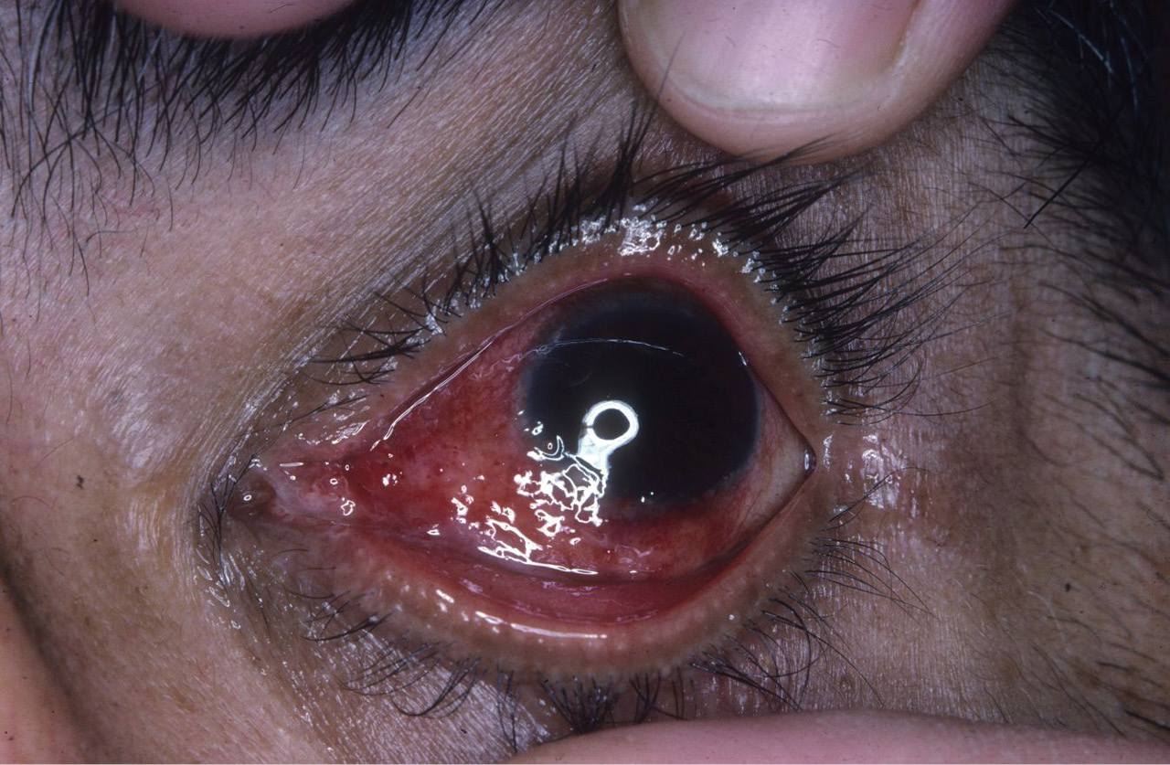

Fig. 24.1 Scleritis. A 35 year old man presents with severe pain in his left eye. He is unable to sleep as the pain is so severe. The eye is tender to touch and the sclera is a dusky red colour, typical of scleritis.
Scleritis can also occur in SLE and is most common when the disease is poorly controlled.10 These patients usually require aggressive medical treatment. A recent case series found that 5% of patients with scleritis had IBD, although the most common ocular manifestation of IBD is uveitis.11 Relapsing polychondritis can often present with scleritis, which is characterized by recurrent inflammation of type II collagen fibres present in the sclera.12

Acute anterior uveitis
Acute anterior uveitis (AAU) is inflammation within the anterior chamber of the eye. The patient complains of an acutely painful, red Page: 179
Image: med-9780199642489-graphic-063.jpg: 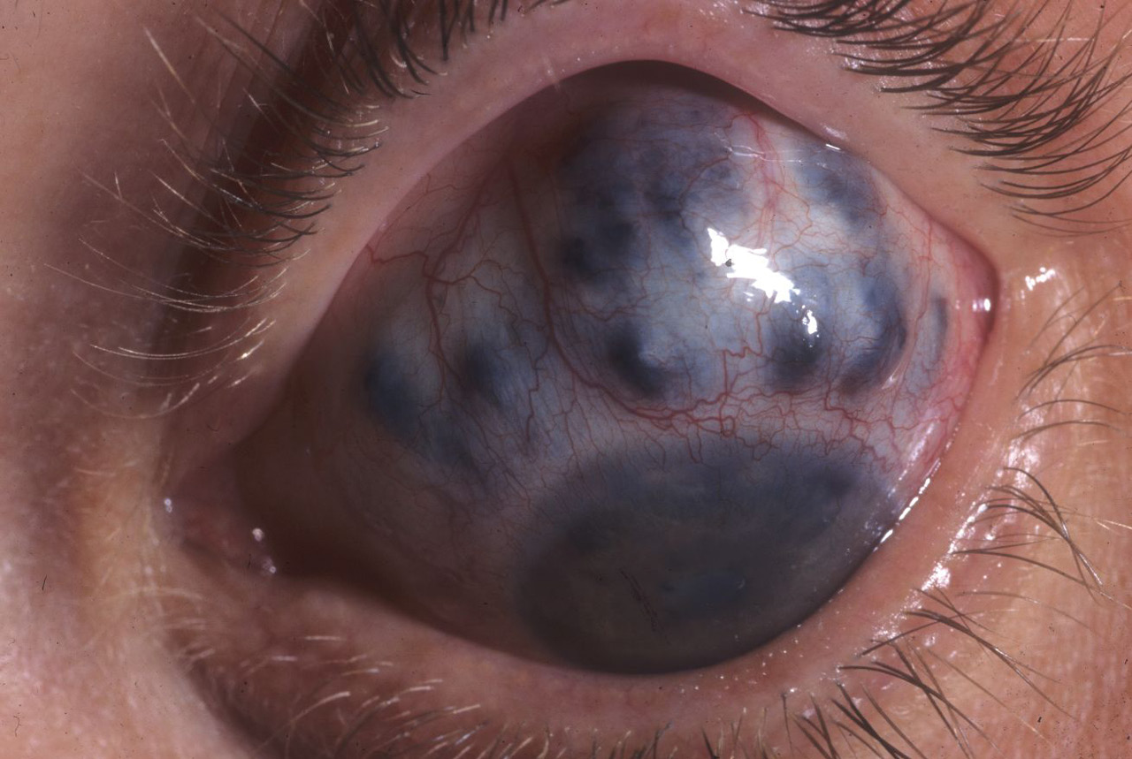

Fig. 24.2 Scleromalacia perforans. A 50 year old woman with severe rheumatoid arthritis has suffered from relapsing scleritis for over 20 years. She now has a very thin superior sclera with underlying choroid bulging through.
Image: med-9780199642489-graphic-064.jpg: 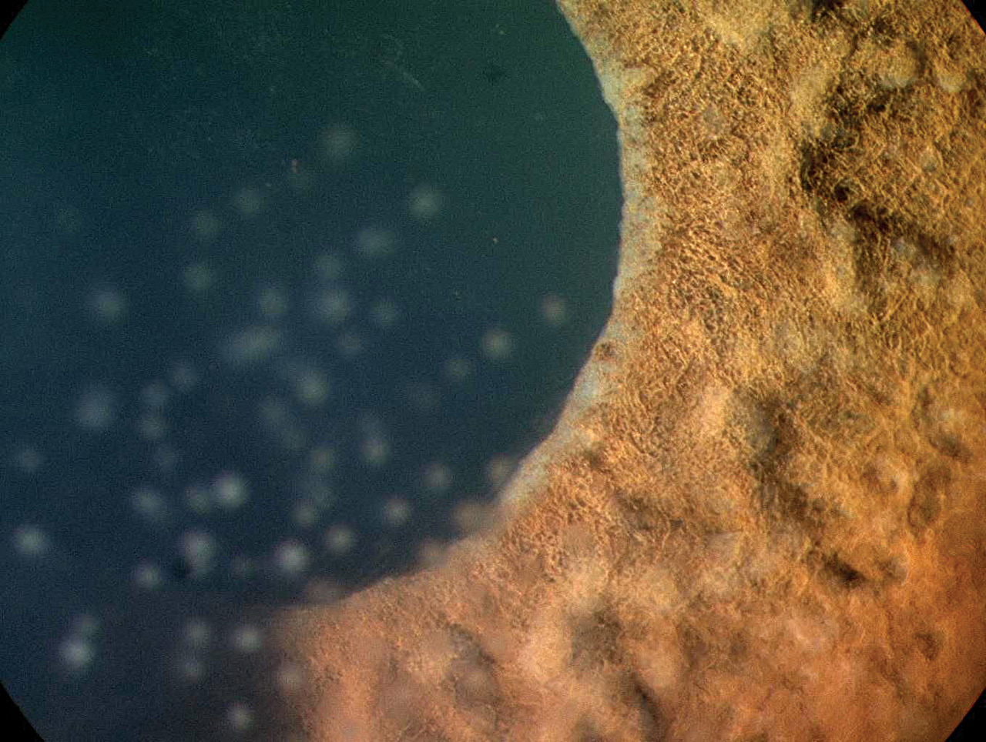

Fig. 24.3 Granulomatous uveitis. A 40 year old woman presented with photophobia and decreased visual acuity. She has had symptoms for 3 weeks and has developed keratic precipitates and Koeppe nodules on her iris.
eye with photophobia, sometimes associated with blurred vision. The condition is generally unilateral and frequently recurrent. The ophthalmological signs consist of circumcorneal redness and keratic precipitates on the endothelial surface of the cornea. Flare (protein) and cells (white blood cells) in the anterior chamber resemble ‘a shaft of light with specks of dust' when viewed through the slit lamp. Koeppe and Busacca nodules can form on the iris in cases of granulomatous uveitis (Figure 24.3) and cells can gravitate to form a fluid level called a hypopyon. The pupil is small and poorly reactive and the intraocular pressure can be either low, due to ciliary body inflammation, or high, due to blockage or inflammation of the trabecular meshwork.
The lifetime cumulative incidence of AAU in the general population has been calculated to be about 0.2%, which increases to 1% in HLA B27-positive subjects.13 Patients who are HLA B27 positive tend to be younger at the time of their first attack, have more severe ocular inflammation, and a longer recovery period than those who are HLA B27 negative.14

Retinal vasculitis and posterior uveitis
In patients with seronegative arthropathies and Behçet's disease there may be inflammation in the posterior chamber of the eye. Patients may complain of floaters and blurred or distorted central vision secondary to macular oedema. In mild to moderate cases, fundoscopy reveals focal or diffuse white sheathing of the retinal veins; in severe cases there are also scattered haemorrhages. Occlusion of the retinal veins leading to neovascularization of the optic disc or peripheral retina may also develop. The new vessels, similar to those in diabetes mellitus, generally develop as a consequence of retinal ischaemia, but may also appear as a reaction to the intraocular inflammatory process. Their walls are fragile and they frequently bleed, leading to vitreous haemorrhages, which are an important cause of visual morbidity in these patients.
In contrast, patients with systemic vasculitis do not usually develop inflammation within the eye but the vasculitic process affects the retinal capillaries and arterioles to produce retinal or choroidal ischaemia.

Optic neuropathy
Diseases of the optic nerve invariably cause profound visual loss. Symptoms range from blurred central vision and difficulty differentiating colours to complete blindness. The cardinal ophthalmological signs of optic nerve disease are reduced visual acuity, impaired or absent colour vision, a central or altitudinal visual field defect and a relative afferent pupillary defect (RAPD). The optic disc may look swollen, pale, or even normal depending on where the inflammation has occurred along the optic nerve.
The pattern of visual loss can vary from sudden and complete to slow and progressive. This depends on whether the optic nerve has undergone infarction, such as in giant cell arteritis, or slow compression from a granuloma. All patients who develop disease of the optic nerve require urgent investigation.

Specific ocular manifestations of systemic inflammatory diseases
The ocular manifestations of systemic inflammatory disease varies according to the size and type of vessel predominantly affected by the disease process. As a general rule, diseases that affect arterioles involve the cornea, episclera, sclera, and retinal arterioles, whereas those affecting the venules produce uveitis, macular oedema, and retinal venous disease.

Giant cell arteritis
Giant cell arteritis is an ophthalmic emergency and an important cause of preventable blindness in elderly people. Twenty-five per cent of patients develop ocular disease and the majority experience sudden loss of vision in one eye, with a dense, central field defect.15 The cause of blindness is usually infarction of the optic nerve, causing an ischaemic optic neuropathy and/or occlusion of the central retinal artery (Figure 24.4). About 12% of patients may also present with a cranial nerve palsy, giving rise to diplopia. Treatment is with immediate, high-dose systemic steroids (e.g. intravenous methylprednisolone 1–2 mg/kg daily or oral prednisolone 60–80 mg daily) to produce symptomatic relief of the headache and, most importantly, to prevent blindness in the other eye. Recovery of vision in the affected eye is rare.Page: 180
Image: med-9780199642489-graphic-065.jpg: 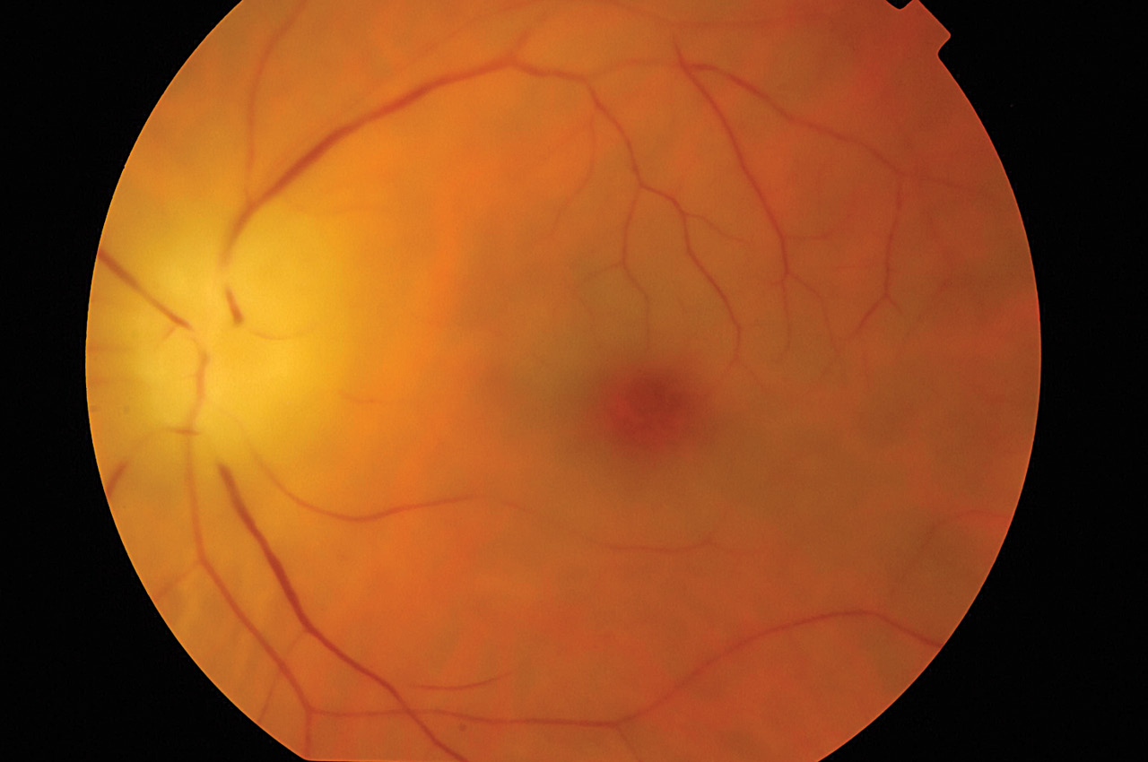

Fig. 24.4 Giant cell arteritis. An 80 year old man with scalp tenderness, weight loss, and jaw claudication presents to casualty with recent loss of vision in his left eye. The optic disc is swollen and pale, indicating an anterior ischaemic optic neuropathy (AION). There is also a secondary central retinal artery occlusion.
Unusual neuro-ophthalmological complications of giant, cell arteritis include Horner's syndrome, cortical blindness (due to embolization from affected vertebral arteries), internuclear ophthalmoplegia, and visual hallucinations.16

Systemic lupus erythematosus
Eye symptoms are common in patients with SLE and range from minor external problems to severe retinopathy.17 Five per cent of patients will develop scleritis at some time during the course of their disease, and this is occasionally seen at presentation. Scleritis indicates active systemic disease and may require adjustment of systemic therapy. Uveitis is very rare in SLE and only occurs in association with severe scleritis.18
The most important ophthalmic manifestation is retinopathy consisting of cotton-wool spots, retinal haemorrhages, and central or branch retinal artery occlusions.19 Retinal vascular occlusion in SLE is due to deposition of immune complexes within the vessels, rather than vasculitis; however, vasculitis can occur in the choroid, leading to choroidal infarcts (Figure 24.5).20 The presence of anti-cardiolipin antibodies may be a marker for the development of retinal vascular occlusion (Figure 24.6).21
Image: med-9780199642489-graphic-066.jpg: 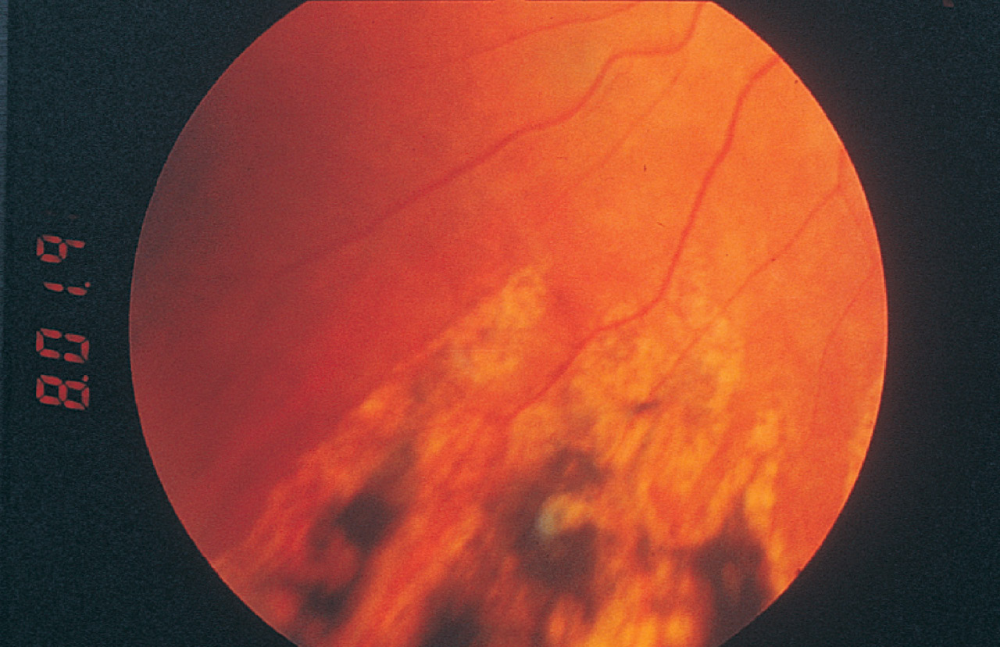

Fig. 24.5 Choroidal infarcts in systemic lupus erythematosus.
Image: med-9780199642489-graphic-067.jpg: 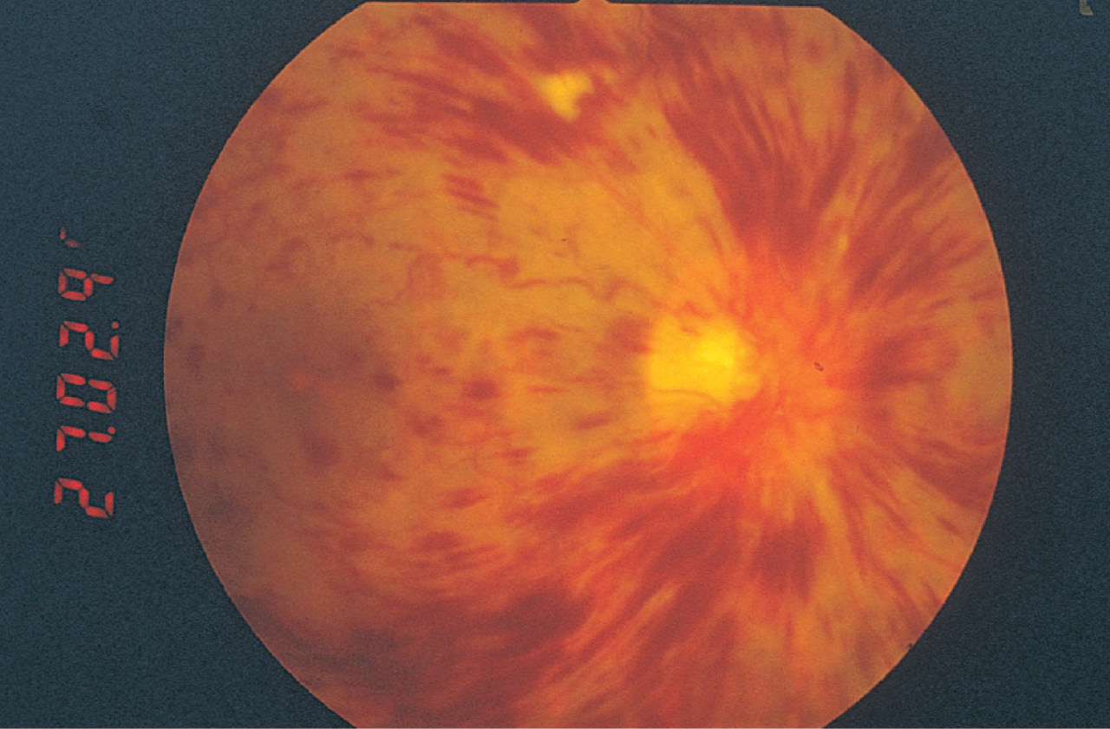

Fig. 24.6 Central retinal vein occlusion in a woman who suffers from systemic lupus erythematosus.

Polyarteritis nodosa
Ocular involvement is present in 10–20% of patients with polyarteritis nodosa.22 The most common manifestation is choroidal and retinal vasculitis, which is secondary to accelerated hypertension. It can be characterized by arteriovenous nipping, cotton-wool spots, and flame shaped haemorrhages.
Patients can also develop conjunctival infarction, keratoconjuncitivitis sicca, episcleritis, scleritis, and necrotizing scleritis associated with peripheral ulcerative keratitis. Choroidal infarcts and exudative serous retinal detachments can occur due to involvement of the posterior ciliary arteries and choroidal vessels.
The development of scleritis or retinal vascular disease in the absence of hypertension warrants investigation of the systemic disease.

Wegener's granulomatosis
Eye problems develop in 29–52% of patients with Wegener's granulomatosis, with 8% of patients suffering disease-related vision loss.23,24 It is the only systemic inflammatory disease that commonly presents with orbital disease due to infiltration of the orbit with granulomatous tissue. Patients may complain of proptosis, caused by the orbital mass; red eyes caused by scleritis; or blurred vision from compression of the optic nerve by the granulomatous tissue (Figure 24.7). They may also develop swollen optic discs and choroidal folds. Many patients also suffer from epiphora (watering eyes) due to destruction of the nasolacrimal duct in sinus disease. Of these conditions, scleritis usually occurs first, with nasolacrimal and orbital disease occurring after years of disease activity. A similar disease pattern can be seen in eosinophilic granulomatosis with polyangiitis (Churg–Strauss) and IgG4 disease.

Systemic sclerosis
The most common eye complaint in systemic sclerosis is dry eye, a loss of eyelid elasticity, and eyelid telangiectasia, which can occur in approximately 50% of patients.25 Lid changes are thought to be due to sclerosis of the eyelid connective tissue, resulting in a ‘woody' feeling and leading to difficulty everting the upper eyelids during examination. These changes tend to occur most commonly in patients who have more extensive skin involvement (i.e. diffuse cutaneous systemic sclerosis).Page: 181
Image: med-9780199642489-graphic-068.jpg: 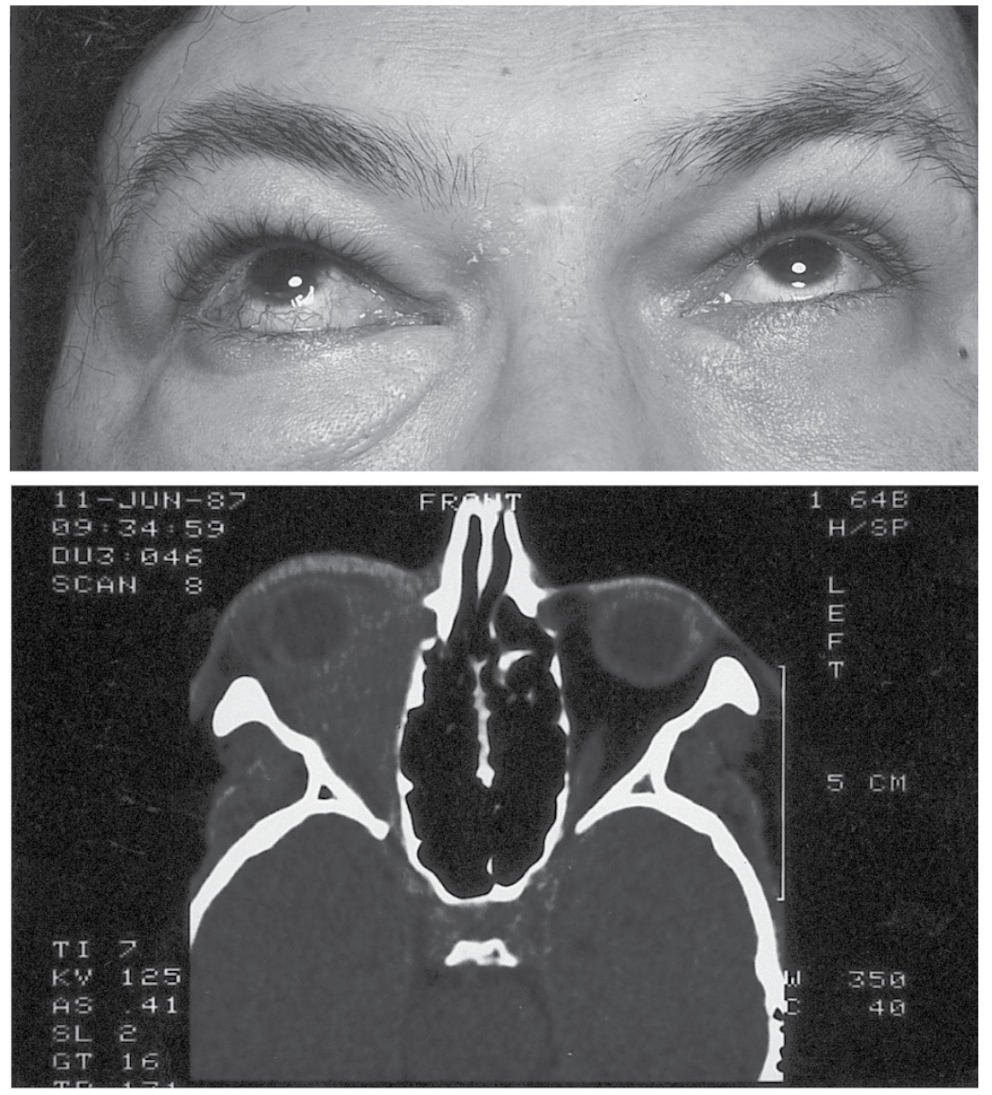

Fig 24.7 Orbital disease in Wegener's Granulomatosis.
A minority of patients develop retinopathy similar to that seen in the other systemic vasculitides, with cotton-wool spots, haemorrhages and occlusion of retinal arteries.
Recent studies have suggested that patients with systemic sclerosis have an increased incidence of normal-tension glaucoma (NTG).26 There is also evidence that the disease can lead to increased central corneal thickness, an important factor in the interpretation of intraocular pressure.27

Rheumatoid arthritis
A third of patients with RA suffer from dry eyes and in 10% this is combined with a dry mouth (Sjögren's syndrome). Five per cent of patients presenting with episcleritis and 30% presenting with isolated scleritis have RA. Bilateral scleritis, while still rare, is more common when associated with RA.28
Scleromalacia perforans (see Figure 24.2) affects elderly women predominantly. Advancing scleral disease in these patients almost always heralds a flare-up of their systemic disease (particularly the vasculitic complications).

Ankylosing spondylitis and the seronegative arthropathies
AAU is the most important ocular disease in this group of patients. It occurs in 33% of patients with ankylosing spondylitis and in 10–15% of patients with other associated seronegative arthropathies.29 The clinical symptoms and signs are similar, regardless of the accompanying disease. Attacks are usually unilateral but both eyes can become affected during the course of the disease. Severe cases can develop a fibrinous uveitis with posterior synechiae (adhesions between the iris and the lens capsule) and raised intraocular pressure.30
Image: med-9780199642489-graphic-069.jpg: 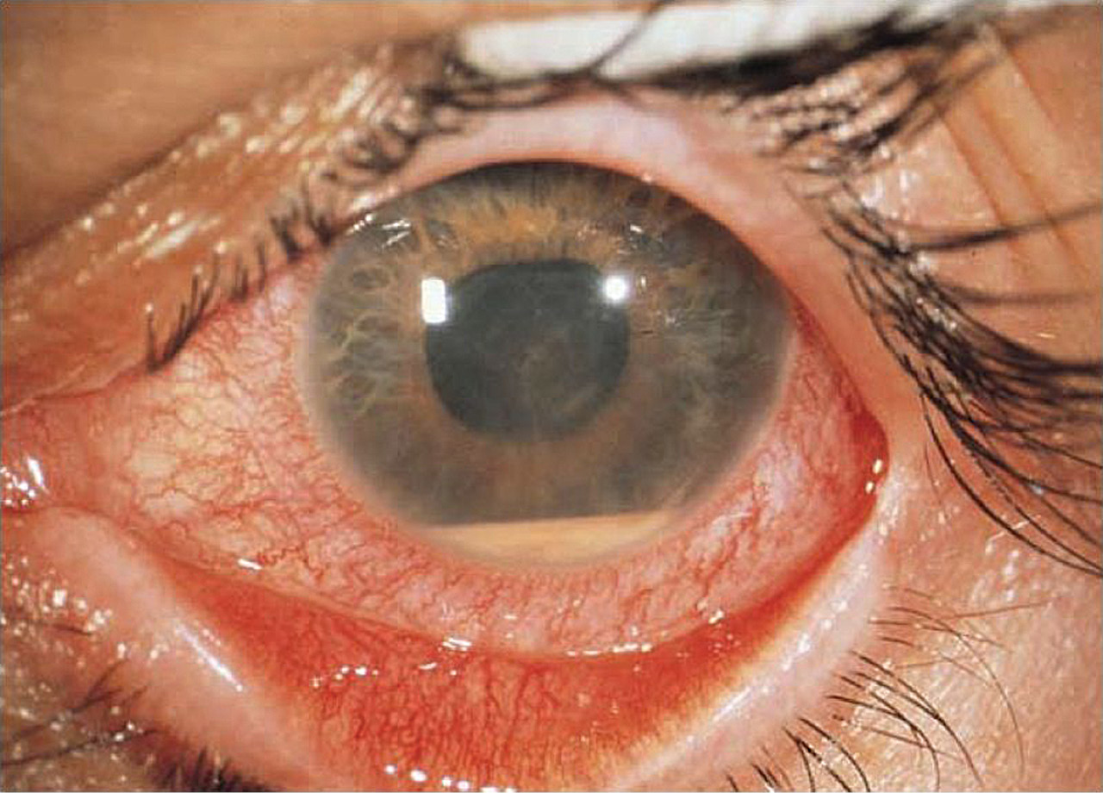

Fig. 24.8 Hypopyon in Behçet's disease. A 20 year old man with known Behçet's disease presented with a red eye, decreased visual acuity, and a visible hypopyon associated with a fibrinous uveitis.
Posterior segment disease is less common in this group of diseases. Ten per cent of these patients develop vitritis and a retinal vasculitis affecting predominantly the capillaries and postcapillary venules.

Behçet's disease
Ocular manifestations in Behçet's disease occur in up to 60% of patients.31 Severe anterior uveitis, often in a painless eye, is common and a hypopyon may form (Figure 24.8). The anterior uveitis is typically recurrent but can resolve spontaneously.
Internationally, approximately a quarter of patients with Behçet's disease go blind as a result of their uveitis.32,33 The pathognomonic features are sequential occlusions of branch retinal veins and retinal infiltrates. The nature of the venous occlusions results in progressive ischaemia and eventually the entire retinal vasculature is obliterated and results in optic disc atrophy.

Ocular involvement in rheumatic conditions of childhood
Uveitis occurring before the age of 16 years is approximately three times less common than uveitis in the general population.34 In two reviews of uveitis in childhood, systemic illnesses such as sarcoidosis, Behçet's disease, and vasculitis accounted for less than 8% of patients.35
The most common associated disorder is seronegative JIA.

Juvenile idiopathic arthritis
The chronic anterior uveitis that occurs in association with JIA deserves special mention, particularly as it does not occur in adults. Affected children are mostly girls, and are usually young at onset of arthritis (mean age 3 years). Joint involvement is usually pauciarticular, although it may spread to become polyarticular.36 Most patients have associated anti-nuclear antibodies (ANA) in their serum. Arthritis generally predates the eye involvement by 1–3 years or sometimes much longer, but 5–10% of cases present with uveitis and the ophthalmologist should therefore ask for a rheumatological opinion in any young child with chronic anterior uveitis. Similarly, because the eye disease is usually asymptomatic Page: 182until complications occur, the rheumatologist must arrange for an early slit lamp examination on all children. Regular follow up will be arranged by the ophthalmologist depending on the age of the child, their ANA status, and their age (Box 24.1).
The non-granulomatous iridocyclitis runs an uncomplicated course in one-third of affected children. The majority of untreated cases develop numerous complications such as band keratopathy, posterior synechiae, cataracts, or glaucoma. Early onset of uveitis, either symptomatic or when picked up in routine screening within the first year of arthritis, and particularly if associated with posterior synechiae at this first examination, are associated with a significantly worse prognosis for vision. Most eye involvement develops for the first time 4–5 years after of the onset of arthritis, and after this the risk is much lower. This is unlike the acute symptomatic anterior uveitis in ankylosing spondylitis, which may occur for the first time very many years later than the original musculoskeletal symptoms.

Treatment of ocular manifestations of systemic disease
Mild anterior segment inflammation such as dry eye, conjunctivitis, and episcleritis will invariably respond to local treatment. This can often be with simple ocular lubricants, but occasionally a mild topical steroid may be indicated.

Scleritis
Scleritis is an indication for systemic treatment. Adequate doses of non-steroidal anti-inflammatory drugs (NSAIDs) can often control pain and help reduce ocular inflammation (e.g. flurbiprofen 50 mg three times a day). If NSAIDs do not help to control symptoms,
Box 24.1 Current UK screening guidelines for anterior uveitis in juvenile idiopathic arthritis
The first screening visit should be carried out within 6 weeks of referral. This should be followed by a review every 2 months from onset of arthritis for 6 months, then 3–4 monthly screening for time outlined below:
Age at onset | Screening period
Oligoarticular involvement irrespective of ANA status and onset 〈11 years of age
〈3 years | 8 years
3–4 years | 6 years
5–8 years | 3 years
9–10 years | 1 year
Polyarticular involvement, ANA positive, onset 〈10 years of age
〈6 years | 5 years
6–9 years | 2 years
Polyarticular involvement, ANA negative, onset 〈7 years of age
All children need 5 years screening
Royal College of Ophthalmologists. Guidelines for screening for uveitis in juvenile idiopathic arthritis, 2009.
systemic steroids are indicated. Occasionally, steroid-sparing agents are necessary (e.g. cyclophosphamide, azathioprine, ciclosporin, or mycophenolate mofetil).
Biological agents have been used successfully in the management of scleritis. Rituximab, an anti-CD20 B-cell monoclonal antibody, has been shown to be of use in scleritis refractory to multiple other agents.

Uveitis
The treatment for uveitis depends primarily on the site of the inflammatory process. In most cases, anterior uveitis can be treated topically with steroid eye drops to reduce the inflammation and a dilating agent such as cyclopentolate 1% to prevent posterior synechiae.
If the vision drops due to occlusion of the retinal vasculature, or involvement of the optic nerve, systemic immunosuppressants are indicated. Corticosteroids are usually sufficient in the first instance, but they may also be used in conjunction with ciclosporin, azathioprine, mycophenolate mofetil, or methotrexate.
Recently trials of biologic agents such the tumour necrosis factor alpha (TNF-α) inhibitor infliximab37,38,39 and interferon alpha40,41,42 have been used with good results, particularly in Behçet's disease and JIA.
Other biologic agents have been used to treat the ocular complications of various rheumatological diseases. Etanercept43 and adalimumab44 have been used successfully to treat JIA and Behçet's disease uveitis as well as macular oedema associated with uveitis. Rituximab has had good responses in JIA patients who have failed to respond to corticosteroids, methotrexate, etanercept, or infliximab.45
Daclizumab is a monoclonal antibody that targets interleukin 2 (IL-2), it has had promising results in patients with JIA, non-infective intermediate, posterior, and panuveitis.46
Small trials have used intravenous immunoglobulin (IVIG) to treat uveitis. The use of this has been limited due to the severe side effects (thromboembolism, aseptic uveitis) and high cost.47

Antirheumatic therapy with ocular side effects
Hydroxychloroquine is a commonly used drug in the treatment of RA and SLE. It has a high affinity for melanin-containing tissue in the eye, such as the retinal pigment epithelium. The pathophysiology of retinal damage is related to a malfunction of phagolysosomes, resulting in faulty clearance of ageing photoreceptor membranes.48,49 Hydroxychloroquine has a better ocular side-effect profile than chloroquine, possibly because it does not cross the blood–retina barrier as easily.
Corneal deposits occasionally occur in patients taking quinolones, as the drug is deposited within the epithelium. The deposits, which can appear as punctate changes or whorl-like patterns, usually resolve on discontinuation of the drug.
The features of hydroxychloroquine retinopathy begin with a fine stippling of the macula and loss of the foveal light reflex. This can then produce a ‘bull's eye' maculopathy made up of pigmented and depigmented rings centred on the fovea, resulting in loss of visual acuity and visual field loss. Even if treatment is stopped, atrophy of the retinal pigment epithelium can continue for a time before stabilizing.
Page: 183The most recent (2009) guidelines from the Royal College of Ophthalmologists50 recommend that regular screening for hydroxychloroquine toxicity is not carried out. This is a significant change from the previous guidelines and is based on the following:
◆ The incidence of clinically significant hydroxychloroquine retinopathy is very low—in a large prospective study of patients taking the maximum dose of hydroxychloroquine (6.5 mg/kg) only 2 of the 400 patients developed irreversible toxicity and both of the patients affected had been taking the drug for over 6 years.
◆ There is no reliable method for detecting retinal toxicity at a reversible stage—visual fields, Amsler charts, distance and near visual acuity, autofluorescence, and multifocal electroretinography are all used to detect macular changes, but none provides a definite endpoint at which the toxicity level becomes irreversible.
Recommendations for rheumatologists are given in Box 24.2.

Corticosteroids
Both oral and topical corticosteroids may cause a variety of ophthalmic side effects51:
◆ Cataracts commonly develop after high doses of systemic steroids, but these can usually be easily dealt with surgically when the patients become symptomatic.
◆ Raised intraocular pressure. Five per cent of the population are termed ‘steroid responders' because of a significant, but asymptomatic increase in pressure. The frequency, duration, and strength of oral or topical steroid all influence this effect. Where possible, steroid-sparing agents should ideally be used in these patients.
◆ Patients on steroids are more prone to infections and their use can also worsen underlying ocular infections such as herpes simplex. A full slit lamp examination should be carried out on all patients with a red eye before starting topical steroids to rule out an infectious cause.

Immunosuppressives
Patients on long-term immunosuppressives are at risk of developing opportunistic infections such as cytomegalovirus retinitis or
Box 24.2 Hydroxychloroquine: recommendations for rheumatologists
◆ Do not exceed the maximum dose of 6.5 mg/kg (200–400 mg/day) of hydroxychloroquine.
◆ Establish renal and liver function before starting treatment.
◆ Enquire about any visual impairment not correctable with glasses before starting treatment and at yearly review.
◆ Before starting treatment, test the patient's reading vision with their reading glasses, (using a near vision chart or newspaper).
◆ If visual impairment is suspected the patient should be advised to consult an optometrist in the first instance. Any abnormality would then be referred to an ophthalmologist in the usual way.
Image: med-9780199642489-graphic-070.jpg: 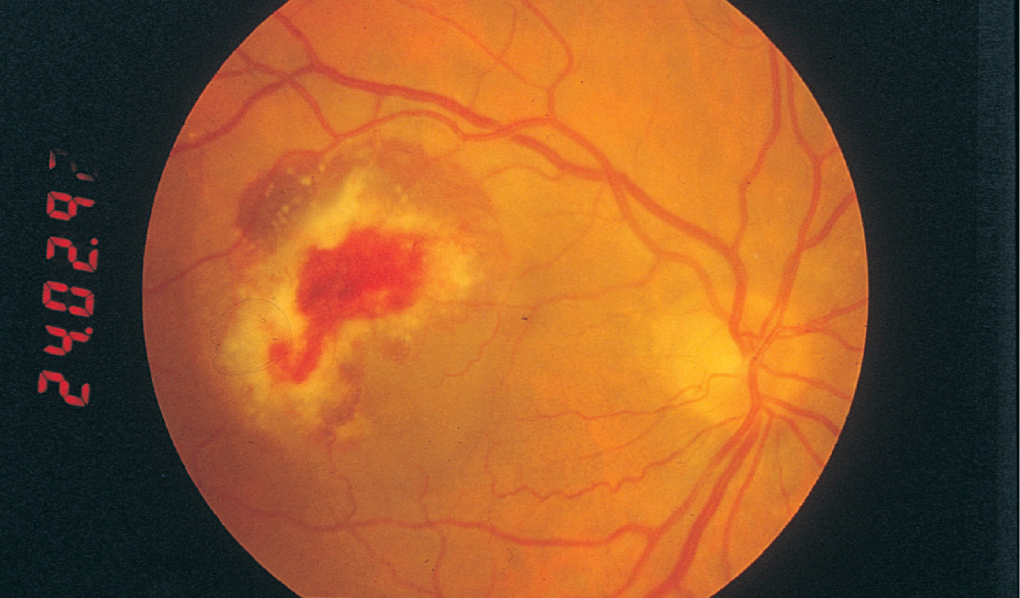

Fig. 24.10 Cytomegalovirus retinitis.
acute retinal necrosis (herpes simplex and zoster) (Figure 24.10). Any patient presenting with a new onset of floaters, red eye, visual field defect, or decreased visual acuity should have a dilated slit lamp examination.
References
1. Whitcher JP, Shiboski CH, Shiboski SC et al. A simplified quantitative method for assessing keratoconjunctivitis sicca from the Sjogren's Syndrome International Registry. Am J Ophthalmol 2010;149(3):405–415. 2. Gilboe IM, Kvien TK, Uhlig T, Husby G. Sicca symptoms and secondary Sjogren's syndrome in systemic lupus erythematosus: comparison with rheumatoid arthritis and correlation with disease variables. Ann Rheum Dis 2001;60(12):1103–1109. 3. Lemp MA. Dry eye (keratoconjunctivitis sicca), rheumatoid arthritis, and Sjogren's syndrome. Am J Ophthalmol 2005;140(5):898–899. 4. Avouac J, Sordet C, Depinay C et al. Systemic sclerosis-associated Sjogren's syndrome and relationship to the limited cutaneous subtype: results of a prospective study of sicca syndrome in 133 consecutive patients. Arthritis Rheum 2006;54(7):2243–2249. 5. Mavrikakis I, Rootman J. Diverse clinical presentations of orbital sarcoid. Am J Ophthalmol 2007;144(5):769–775. 6. Prabhakaran VC, Babu K, Mahadevan A, Murthy SR. Amyloidosis of lacrimal gland. Indian J Ophthalmol 2009;57(6):461–463. 7. Singh J, Sallam A, Lightman S, Taylor S. Episcleritis and scleritis in rheumatic disease. Curr Rheumatol Rev 2011;7(1):15–23. 8. Smith JR, Mackensen F, Rosenbaum JT. Therapy insight: scleritis and its relationship to systemic autoimmune disease. Nat Clin Pract Rheum 2007;3(4):219–226. 9. Okhravi N, Odufuwa B, McCluskey P, Lightman S. Scleritis. Surv Ophthalmol 2005;50(4):351–363. 10. Taylor SR, McCluskey P, Lightman S. The ocular manifestations of inflammatory bowel disease. Curr Opin Ophthalmol 2006;17(6):538–544. 11. Watts RA, Scott DGI. Relapsing polychondritis. In: Watts RA, Scott DGI (eds) Vasculitis in clinical practice. Springer, London, 2010:173–179. 12. Stanford MR, Graham EM. Systemic associations of retinal vasculitis. Int Ophthalmol Clin 1991;31(3):23–33. 13. Linssen A, Rothova A, Valkenburg HA et al. The lifetime cumulative incidence of acute anterior uveitis in a normal population and its relation to ankylosing spondylitis and histocompatibility antigen HLA-B27. Invest Ophthalmol Vis Sci 1991;32:2568–2578. 14. Chen, C-H, Lin, K-C, Chen, H-A et al. Association of acute anterior uveitis with disease activity, functional ability and physical mobility in patients with ankylosing spondylitis: a cross-sectional study of Chinese patients in Taiwan. Clin Rheumatol 2007;26(6):953–957. Page: 18415. Hayreh SS, Zimmerman B. Management of giant cell arteritis. Our 27-year clinical study: new light on old controversies. Ophthalmologica 2003;217(4):239–259.Page: 184 16. Watts RA, Scott DGI. Giant cell arteritis. In: Watts RA, Scott DGI (eds) Vasculitis in clinical practice. Springer, London, 2010:35–45. 17. Peponis V, Kyttaris VC, Tyradellis C, Vergados I, Sitaras NM. Ocular manifestations of systemic lupus erythematosus: a clinical review. Lupus 2006;15(1):3–12. 18. Davies JB, Rao PK. Ocular manifestations of systemic lupus erythematosus. Curr Opin Ophthalmol 2008;19(6):512–518. 19. Au A, O'Day, J. Review of severe vaso-occlusive retinopathy in systemic lupus erythematosus and the antiphospholipid syndrome: associations, visual outcomes, complications and treatment. Clin Experiment Ophthalmol. 2004;32(1):87–100. 20. Carbone J, Sanchez-Ramon, S, Cobo-Soriano, R, et al. Antiphospholipid antibodies: a risk factor for occlusive retinal vascular disorders. Comparison with ocular inflammatory diseases. J Rheumatol 2001;28(11):2437–2441. 21. Cobo-Soriano, R, Sanchez-Ramon, S, Aparicio MJ, et al. Antiphospholipid antibodies and retinal thrombosis in patients without risk factors: a prospective case-control study. Am J Ophthalmol 1999;128(6):725–732. 22. Perez VL, Chavala SH, Ahmed M, et al. Ocular manifestations and concepts of systemic vasculitides. Surv Ophthalmol 2004;49(4):399–418. 23. Hoffman GS, Kerr GS, Leavitt RY. Wegener's granulomatosis: an analysis of 158 patients. Ann Intern Med 1992;116:488–498. 24. Bullen CL, Liesegang TJ, McDonald TJ. Ocular complications of Wegener's granulomatosis. Ophthalmology 1983;90:279–290. 25. Gomes Bde A, Santhiago MR, Magalhaes P et al. Ocular findings in patients with systemic sclerosis. Clinics (Sao Paulo) 2011;66(3):379–385. 26. Kitsos G, Tsifetaki N, Gorezis S, Drosos AA. Glaucomatous type abnormalities in patients with systemic sclerosis. Clin Exp Rheumatol 2007;25(2):341. 27. Serup L, Serup J, Hagdrup HK. Increased central cornea thickness in systemic sclerosis. Acta Ophthalmol (Copenh) 1984;62(1):69–74. 28. Stone JH, Matteson EL. Rheumatoid vasculitis. In: Stone JH (ed.) A clinician's pearls and myths in rheumatology. Springer, London, 2010:15–22. 29. Gran JT, Skomsvoll JF. The outcome of ankylosing spondylitis: a study of 100 patients. Rheumatology 1997;36(7):766–771. 30. Chudomirova K, Abadjieva T, Yankova R. Clinical tetrad of arthritis, urethritis, conjunctivitis, and mucocutaneous lesions (HLA-B27-associated spondyloarthropathy, Reiter syndrome): report of a case. Dermatol Online J 2008;14(12):4. 31. Sungur G, Hazirolan D, Hekimoglu E, Kasim R, Duman S. Late-onset Behçet's disease: demographic, clinical, and ocular features. Graefes Arch Clin Exp Ophthalmol 2010;248(9):1325–1330. 32. Kitaichi N, Miyazaki A, Iwata D et al. Ocular features of Behçet's disease: an international collaborative study. Br J Ophthalmol 2007;91(12): 1579–1582. 33. Mendes D, Correia M, Barbedo M et al. Behçet's disease—a contemporary review. J Autoimmun 2009;32(3–4):178–188. 34. Kump LI, Cervantes-Castañeda, RA, Androudi SN, Foster CS. Analysis of pediatric uveitis cases at a tertiary referral center. Ophthalmology 2005;112(7):1287–1292. 35. Cunningham Jr, ET, Suhler EB. Childhood uveitis—young patients, old problems, new perspectives. J AAPOS 2008;12(6):537–538. 36. Julian K, Terrada C, Quartier P, LeHoang P, Bodaghi B. Uveitis related to juvenile idiopathic arthritis: familial cases and possible genetic implication in the pathogenesis. Ocul Immunol Inflamm 2010;18(3):172–177. 37. Tynjala P, Lindahl P, Honkanen V, Lahdenne P, Kotaniemi K. Infliximab and etanercept in the treatment of chronic uveitis associated with refractory juvenile idiopathic arthritis. Ann Rheum Dis 2007;66(4): 548–550. 38. Suhler EB, Smith JR, Giles TR et al. Infliximab therapy for refractory uveitis: 2-year results of a prospective trial. Arch Ophthalmol 2009;127(6):819–822. 39. Sugita S, Yamada Y, Mochizuki M. Relationship between serum infliximab levels and acute uveitis attacks in patients with Behcet disease. Br J Ophthalmol 2011;95(4):549–552. 40. Plskova J, Greiner K, Forrester JV. Interferon-alpha as an effective treatment for noninfectious posterior uveitis and panuveitis. Am J Ophthalmol 2007;144(1):55–61. 41. Onal S, Kazokoglu H, Koc A et al. Low dose and dose escalating therapy of interferon alfa-2a in the treatment of refractory and sight-threatening Behçet's uveitis. Clin Exp Rheumatol 2009;27(2 Suppl 53):S113–S114. 42. Onal S, Kazokoglu H, Koc A, et, al.. Long-term efficacy and safety of low-dose and dose-escalating interferon alfa-2a therapy in refractory Behcet uveitis. Arch Ophthalmol 2011;129(3):288–294. 43. Wang F, Wang NS. Etanercept therapy-associated acute uveitis: a case report and literature review. Clin Exp Rheumatol 2009;27(5):838–839. 44. Tynjala P, Kotaniemi K, Lindahl P, et al. Adalimumab in juvenile idiopathic arthritis-associated chronic anterior uveitis. Rheumatology 2008;47(3):339–344. 45. Miserocchi E, Pontikaki I, Modorati G et al. Rituximab for uveitis. Ophthalmology 2011;118(1):223–224. 46. Sen HN, Levy-Clarke, G, Faia LJ et al. High-dose daclizumab for the treatment of juvenile idiopathic arthritis-associated active anterior uveitis. Am J Ophthalmol 2009;148(5):696–703e1. 47. Rosenbaum JT, George RK, Gordon C. The treatment of refractory uveitis with intravenous immunoglobulin. Am J Ophthalmol 1999;127(5):545–549. 48. Payne JF, Hubbard GB 3rd, Aaberg TM Sr, Yan J. Clinical characteristics of hydroxychloroquine retinopathy. Br J Ophthalmol. 2011;95(2):245–250. 49. Semmer AE, Lee MS, Harrison AR, Olsen TW. Hydroxychloroquine retinopathy screening. Br J Ophthalmol. 2008;92(12):1653–1655. 50. Royal College of Ophthalmologists. Hydroxychloroquine and ocular toxicity: recommendations on screening. Royal College of Ophthalmologists, London, 2009. Available from: www.rcophth.ac.uk 50. Carnahan MC, Goldstein DA. Ocular complications of topical, peri-ocular, and systemic corticosteroids. Curr Opin Ophthalmol 2000;11(6):478–483.

